C&N Europe seminar, Oct 23: Geopolitics of central and northern Europe: historical perspectives
Introduction to the seminar series
Joanna explained that the series supported a project which had published three volumes and was now working towards a fourth, on central and northern Europe. The project looked at how democracy became a modern (as opposed to ancient) political idea. The premise was that people talked about ‘democracy’ in efforts to understand, preserve or change the world and the word changed through use. To understand what such people were doing, it was necessary to focus on their circumstances. The seminar would be exploring circumstances in central and northern Europe: speakers wouldn’t necessarily be talking directly about democracy at all, but helping to explore the context for the developments the project focussed on..
The chief place about which people thought when they first made democracy into a modern political concept was France (it became an important term in US discourse only once French sympathisers there began to call themselves democratic republicans) .French experience shaped ideas of what was entailed in being a modern democracy: being a unified nation whose will the government notionally represented; having a levelled society in which citizens were equal in the face of a centralised state. The US presented a different – federal, more participatory – model, which was influential in Latin America, but did not map well on to European forms of federalism. But most of central and northern Europe was not like France either: lacking unitary nationhood and/or a centralised state and/or a levelled citizenry. So the question facing people in that region was, what might becoming a modern democracy entail for them? Did it have to entail becoming more like France, or was there a different northern way to be democratic, building on local traditions of Germanic/Slavic democracy? She thought that they responded to this question in a variety of ways:
- It does entail becoming more like France; we’re not interested (the Netherlands)
- It does entail becoming more like France, let’s do that (quite common among ‘democrats’ across the region)
- We can be a different sort of democracy, in fact we already are one, because our government serves the people/our institutions fit our society (some people in absolutist Denmark; monarchical-aristocratic Sweden; the court of Frederick William IV of Prussia etc). Not the most common conservative line, but one sometimes taken – as by Russia and China now.
- We’re not a democracy now, it would be good to be one, but we should devise an alternative model (interesting, not so clear who does this or in what terms, but maybe some people in Switzerland at the end of our period)
- We don’t necessarily want to be like France; let’s hold judgement on what we’ll be like, focus for now just on pushing in a democratising direction (possibly the most common position among democrats in the region, she thought).
The question for today’s seminar was, how did the region come to be as it was? What was its institutional inheritance?

John Watts
Cited, with reservations, David Nicholas, Northern lands: Germanic Europe 1270-1500. Best bit of book is that region centred on Baltic: we think of a Mediterranean-centred region but not of a Baltic one. Also good on trade and commerce.
Characterisation of region as Germanic reflects an entrenched myth. Idea Germanic emigration spread German laws, which were customary and popular: made by groups in courts. Linked to more modern accounts of communalism (as in Blickle).
Myths about region expressed by Leopold von Ranke in his History of Latin and Teutonic nations.
Idea German lands have barbarian rather than Roman roots. Drew on traditions of northern or Slavic liberty. Genossenschaftrecht – community law. Tradition of self-government. Widerstandsrecht – right to rebel. In case of Scandinavia in particular said to be no feudalism; tradition of electoral monarchy. Jury systems. Strong representation of localities.
Today’s historians are more cautious. He wanted to make four points about limits of these mythic accounts
- In fact most of Europe was a mish mash of Roman and Germanic elements. Even Roman law could promote communities, associations, provinces, kin groups.
- Supposed distinctive features can also be found elsewhere, thus composite monarchies (Aragon), town leagues (Hermandades of Castile; networks of Catalan towns across Med; ditto Genoan, Venetian; elective monarchy – sort of distinctive, but in practice often followed dynastic lines, and countries with supposed hereditary monarchies had to cope with breaks in succession. And law code, as promulgated in Norway, Denmark, Sweden – but Magna Charta and others of similar vintage. Realm councils of Scandinavia were somewhat important, but royal councils could be important elsewhere.
- Developments shaped by contingency: Kalmar union only made when dynastic line ran out.
- Could arrive at a form of constitutional government from a variety of starting points. He quite likes Boucoyannis’ argument that actually it was early strong govts that tended to produce strong parliaments (by way of resistance), whereas if centre was weak you didn’t need them. She describes northern region as producing ‘second best constitutionalism’, based on alliances between kings and peasants against aristocracy.
Still, it’s possible to overdo scepticism. There was diversity in Europe, and awareness of that. And contingency and structure are not polar opposites: contingency can harden into structure. Thus low taxation in N became an expectation. (On the other hand, countries could flip low-high tax, as England did in the 15th C and then to High in the 17th C, or France, first low then high taxed).
There probably were some deep structural features. Considered in relation to Scandinavia.
- Topographical map suggests there was much high ground; low population Before Black Death, pop of Norway and Sweden just hundreds of thousands.
- Castellation came late: Denmark C12; Sweden C13. Assoc with originally comparatively free peasantry – tho was ultimately subordinated late MA, partly by choice of peasants, who fancied enjoying benefit from noble tax exemptions.
- Late to acquire monarchs: C13 in Swe, earlier in Den, complicated in Nwy (civil war from mid-12thC to mid-13th). Superimposed on previous arrangements. Jurisdiction not very penetrating. Justice often remained local. Even ‘peace’ jurisdiction, giving monarchs power in criminal cases, late in coming, and then system tended to be oath-based.
But comparisons are complicated by lack of Scandinavian evidence. Hard to go back beyond 1250 and not much before C15. Means tend to rely on relatively formal accounts; don’t have a good sense of how things really worked. Hans Jacob Orning says that there seems to have been a fairly normal amount of aristocratic feuding, which he thinks is a more important way in to understanding political society than the conventional focus on state-formation.
And if kings generally look weak, yet the Vasas did succeed in activating Sweden. How?
Similarly, Hanseatic network was gradually disempowered by kings, by end of the 15th century?

Peter Wilson
He agreed that modern ideas of democracy are bound up with what might be termed a Weberian concept of the state. Now however we lived in a post-sovereignty post-national world, and those old models no longer fit reality.
Anglo-Saxon stereotypes of Germany tended to focus on north Germany, esp Prussia. But there were other kinds of Germany to the south.
Historians have argued about whether the Holy Roman Empire can be called a state. Pufendorf called it a monstrosity. He thought it had once been more regular but had declined into an irregular corpus. But historians no longer think quite like that.
German political culture was for a long time based on consensus. That had been true even of late twentieth-century Germany, though that consensus was perhaps now falling apart.
Crucial building blocks of the complex historic polity were:
- Estates – the term can mean a piece of land; a social group; or a political body
- Elective monarchy
- Politics with both hierarchal and horizontal dimensions (though this shouldn’t be represented in terms of aristocracy vs democracy). Who could participate in what ways varied
- Ideas of German freedom or liberty, understood in early-modern-type collective rather than individual terms
- A legal framework, in which courts were crucial institutions
In terms of structures, an important distinction was between individuals or bodies who were immediately subject to the jurisdiction of the emperor (distinguished as imperial: thus, imperial cities) and those who were mediately subject.
Each social estate was internally stratified: thus nobility, clergy and towns – but this ordering was complicated by the fact that entities could operate within more than one hierarchy: thus someone might rank higher in the political than in the ecclesiastical system or vice versa. Moreover – another form of complication – new corporate groups could emerge, such as students. People didn’t have a fixed status that necessarily travelled with them when they moved: so one might be a burgher of a city but wouldn’t be in another city.
Identities were moreover subject to change over time. Numbers of fiefs changed, and any given fief might change its status – who it was subject to. You could only be noble if you owned a qualifying estate – but such estates could also be held by commoners.
The term ‘territorialisation’ is used by historians[?] to refer to the accumulation of fiefs in the hands of eg a town, a person, or an ecclesiastical corporation. The same lord might hold different fiefs which had different statuses.
This map of Germany in 1618 follows nineteenth-century cartographic conventions: it’s organised by presiding dynasty, but that’s only one among several possible ways of looking at things – the other map shows ecclesiastical divisions (circa 1500)..
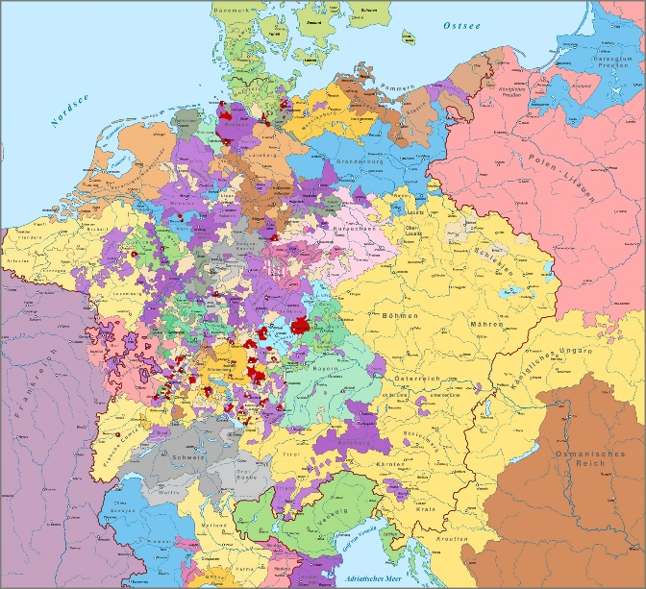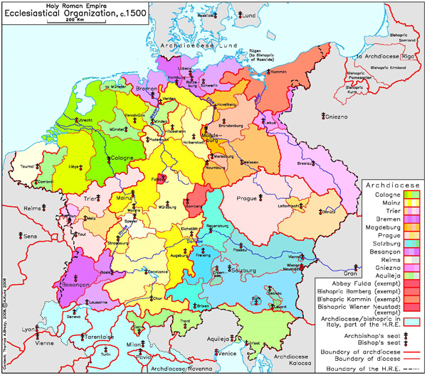

The process of territorialisation was associated with some centralisation of power, but that proceeded very slowly. Although once separate bodies might be brought together under one ruler, that wasn’t necessarily followed by the creation of shared territorial institutions.
The Habsburgs rarely summoned diets at the national level. They sometimes self-convened in a revolutionary context: thus in the Netherlands, when the Estates General were convened to coordinate opposition to Habsburg rule.
He proceeded to consider how representation worked in this context.
Assemblies of various kinds arose for the same reasons as elsewhere in Europe, notably because of the need to raise taxes to pay for warfare.
To support the developing security system, the empire developed a new intermediary level, the Kreise (circles). These grouped imperial fiefs. Contemporary maps most often showed the empire as made up of these Kreise. They’ve recurred as admin divisions, eg under Weimar.
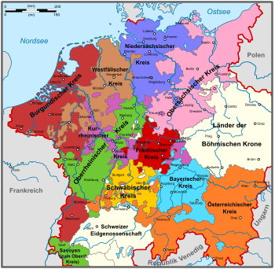
Another reason from below for meeting in assemblies was to offer taxes to stop the ruler from alienating assets to amortise debts. They could also be used to bargain for additional rights. Rights to more choice in the practice of religion were for example acquired in this context.
They didn’t all play the same role, and that role was heterogeneous, eg they might get involved in settling succession issues in smaller lordships. They couldn’t initiate legislation, and their composition varied greatly. The archetypal noble/clergy/commons arrangement was in fact uncommon There were often two noble houses, one of lords and one of knights. Some had no nobles, thus Wurttemberg represented only towns/villages. Votes were not weighed equally and speaking always followed a strict order of precedence. Different estates met separately. The object was consensus. It was possible to vote, but this was generally avoided, as exposing difference.
The Reichstag changed character as the practice developed of those entitled to attend sending envoys to represent them. Barbara Stollberg-Rillinger has written about this. Envoys were constrained by the terms of their mandate. Business was increasingly transacted in writing rather than orally.
The common people might be represented indirectly, via representatives of villages: Landschaften (as opposed to Landstände). In Wurttemberg, all villages were indirectly represented. Similar arrangements could be found in the Alpine strip. Representation at this level was linked to property ownership and households, and women could figure as heads of household.
Towns often had their own dependencies: rural people might be subject to the rule of a town, and this was especially pronounced in Switzerland, where civil wars erupted over which towns controlled which dependencies.
Legacies of this order of things included:
- The continuing importance of the imperial circles, the Kreise
- The habit of seeking consensus, which was deeply embedded in the political culture. Karl Wegert in his book German radicals confront the common people argues that the people didn’t want liberalism but a particularism that favoured them.
Classically, these habits and practices have been seen as inimical to the formation of modern states. Liberals have been seen as heroic defenders of popular liberties – though an alternative historical tradition (represented eg by Peter Blickle) emphasises the importance of custom and communalism as bases for mobilisation. More recently, the tendency has been to see princes and estates as co-constructors of forms of government. Barbara Stollberg-Rillinger sees a conflict between two representative cultures, personal and written, playing out. He agrees with her that this was a different political culture from that which developed subsequently, contra to the accounts given by Whaley and George Schmidt. The German Confederation was not a revived Holy Roman Empire, but a new kind of beast.

