Re-imagining democracy in central and northern Europe during the 1860s: crisis, division and Realpolitik
Monday 30 March –Wednesday 1 April, 2026
Emmanuel College, Cambridge
Attending in whole or part: Alvar Atterving-Blomgren (Stockholm), Birgitta Bader-Zaar (Vienna - online), Daniel Beer (Royal Holloway), Marcus Boieck (King’s, Cambridge), Chris Brooke (Homerton, Cambridge), Peter Bugge (Aarhus), Edward Castleton (Besançon - online), Camille Creyghton (Utrecht - online), Quentin Deluermoz (Cambridge History Faculty). Alvin Engström (Hughes Hall, Cambridge), Gábor Gángó (Erfurt), Niels Gruene (Innsbruck - online), Francois Guesnet (UCL), Irene Herrmann (Geneva), Anne Heyer (Leiden), Cody Inglis (Central European University - online), Joanna Innes (Somerville, Oxford), Maurizio Isabella (QMUL), Lauren Jarnach (Kellogg, Oxford), Charlotte Johann (QMUL), Jean-Michel Johnston (Fitzwilliam, Cambridge), Theo Jung (Halle), Béla Kapossy (Lausanne - online), Eric Kettmann (Peterhouse, Cambridge), Jussi Kurunmäki (Stockholm/Helsinki - online), Jonathan Kwan (Nottingham), Lauren Lauret (Leiden), Piotr Kuligowski (Historical Institute, Warsaw), Jani Marjanen (Helsinki – online), Iain McDaniel (Sussex) Beth McNamara-Dale (ex Oxford), Claire Morelon (Manchester), Mark Philp (Warwick), Atalanta Rae Neudorf (QMUL), Jim Retallack (Toronto – online), Sam Wilson (Lucy Cavendish, Cambridge)
Day 1 (Monday, 30 March)
Jean-Michel welcomed those attending and acknowledged crucial financial support from Emmanuel College, the DAAD & Somerville College. He explained that discussion would feed into the last chapter in the fourth Re-imagining Democracy book, focussing on central and northern Europe. Everyone then briefly introduced themselves.
Setting and themes
Joanna suggested that the 1860s were in our region a decade of geo-political crisis which presented contemporaries with some common experiences. In contrast to the 1848 age of revolutions, however, the decade was rarely studied as such. Or the focus was on a ‘battle for mastery’ in Germany, and not on political effects of and responses to turmoil. She would outline geo political developments and some of their political effects, and then air some hypotheses about their effects on political culture and democracy talk.
Starting with geo-politics
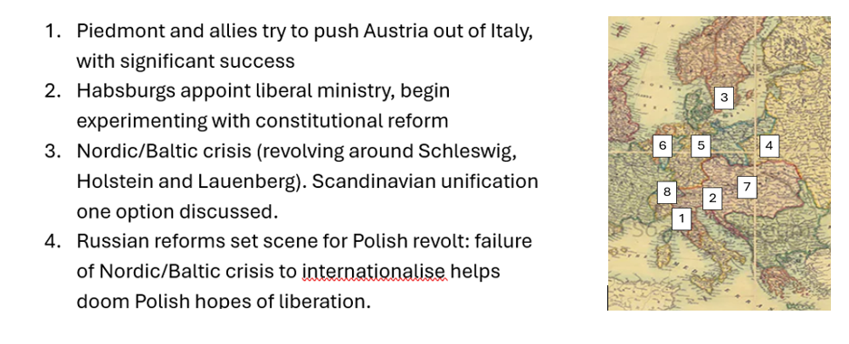
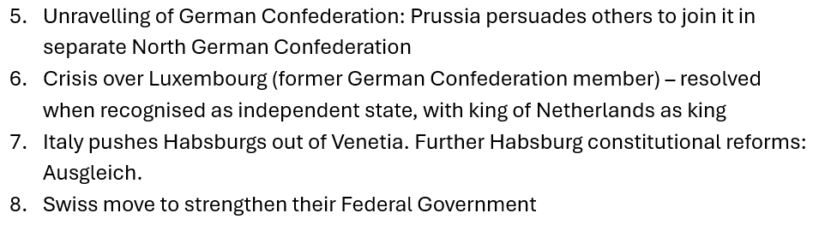
There was also much unrest in the wider political environment:
Europe: Greece – new dynasty, territory, constitution; Spain – revolution, queen ousted, brief republic; Franco-Prussian war, fall of Napoleon, Commune, French Third Republic. German Unification.
Wider world incl: US Civil War; Mexican Emperor installed and deposed; Meiji Restoration opens Japan to foreigners, fall of Shogunate, installation of emperor Meiji (‘enlightened rule’).
The scene was set for unsettlement in central and northern Europe in the preceding decade and more.
- Unravelling of Vienna settlement – which apparently survived, but was in some ways weakened by 1848 revolutions because revealed appetite for change; involved wars; brought revisionist Napoleon III to power.
- Crimean war: both reflected and enhanced the revisionist mood. Prompted reforms by Russians and Ottomans (also affecting Danubian Principalities), and upheaval in Greece
All this had significant effects on political institutions and practices:
Many new constitutions, usually either introducing or strengthening the role of representative government. Liberalising trend. (But not everywhere: franchise narrowed in Denmark; repression in Poland).
Hypotheses about what might be called ‘democratic’ practices
- Representative government and associated forms of political life increasingly the norm in the region.
- Continuing development of associational life, a site among other things for experimentation with identities.
- Associations that primarily served other functions could become mechanisms for political organising.
- Increasingly clear ‘the people’ not a unified entity
Hypotheses about effects on ‘democracy’ talk
- Increasing acceptance that long-term trends favoured democracy.
- But ‘democrats’ still marginalised. A slow evolution towards a managed democracy was preferred.
- Diversification in what ‘democrats’ wanted. Among numerous groups seeking enhanced inclusion or recognition, some were more prone than others to talk about democracy (Who? Why?)
- Uncertainty about what institutional arrangements might best serve democracy. Interest in experimenting with new forms.

Discussion

Mark highlighted that Joanna’s narrative was one of a series of geo-political disturbances followed by a response – but was there an intervening variable, involving the state becoming more interventionist (building railways, running postal services, promoting trade)? He added that when people talked about ‘democracy’ they were not necessarily talking about forms of government: it could be about other things, like equality.

Jonathan suggested that in relation to the expansion of state action, conscription was an important topic of discussion. In Austria, military conscription was brought in in 1868, immediately after the 1867 reform; this was effectively a test of whether the new legislative system could intervene in society in new and ambitious ways.

Peter asked how strongly the project wanted to focus on the word ‘democracy’: in the Habsburg Empire it wasn’t used much, but other terms are, such as ‘popular representation’, or elsewhere vernacular terms such as ‘folkestyre’ (people’s rule). Joanna responded that the word ‘democracy’ was indeed central to the project, which focussed on what people at the time thought was democracy, not on whether we think what they did or wanted was democratic. Some chapters are meant to focus specifically on the word, though their authors had also been asked to pay attention to when variants of the classical form and when vernacular equivalents were employed. But others, ‘thematic’ chapters, would be concerned more with the context in which democracy was invoked. She noted that it was her impression that in this period ‘democracy’ tended to be invoked when discussion operated at quite a high level of abstraction, when it came to specific matters of institutional design, people were more likely to use specific, technical terms such as ‘representation’ or ‘voting’.

Gabor: suggested that thinking about revisionism after 1848 might be productive, and it might have two causes: the emergence of nationalism, and the relationship between standing armies and popular participation. Joanna asked for clarification of ‘revisionism’. Gabor explained that it is the idea of somehow reversing the tide of history or at least responding to recent events by re-thinking what had been done before. Joanna was initially confused, but, reminded that she had used the term repeatedly, clarified that she had used it in a specific international relations context. In that context she took it to mean wanting to revise an agreed territorial settlement, for whatever reason. [see What is a ‘revisionist’ state, and what are they trying to revise?]

Iain wondered why Joanna had mainly spoken of ‘representative assemblies’ and not parliaments, and wondered if this was an important distinction, because ‘parliamentarism’ is often seen as ‘anti-democratic’ during our period. Joanna specified that she had preferred ‘representative assembly’ because she saw it as more general, comprehending also corporate bodies, like diets. She meant to leave open questions about the relation between such bodies and governments on the one hand, people on the other. Insofar as ‘parliamentarism’ connotes (another of its possible meanings) responsibility of ministers to parliaments, she thought that this was rarely achieved at this time.

Jean-Michel welcomed Gabor’s encouragement to think about the role of nationalism, because the idea of ‘the nation’ was sometimes used by governments to suggest commitment to popular sovereignty without conceding full ground to democracy. He agreed with Peter that during this decade ‘democracy’ often flew under the radar – making it important also to consider cognate words. Though the re-emergence of the word was one of the interesting features of the 1860s.

Theo agreed that there was a sense during this period that things had to change, but not by establishing democracy. He therefore questioned whether it became ‘banal’. He also asked if the 1860s were so different from the 50s: wasn’t the story about what happened after 1848? Joanna said she thought the 1860s were different, because they saw so many institutional and constitutional changes.

Charlotte suggested that many of the geopolitical conflicts of the 1860s were already cooking in 1848 – but were then driven from the bottom-up, later from the top-down.

Maurizio asked for clarification: was the hypothesis essentially that all the questions of 1848 are being taken up again in the 1860s? Joanna thought there was something in that. The word ‘democraacy’ itself was not as much of a keyword as it had been in 1848, but was probably also being used in slightly different ways, to talk about different things.

Peter returned to his previous question: were we using ‘democracy’ as both a category of analysis and a category of action? Joanna & Mark said not if they could help it. Since their primary goal was to chart the word’s use, they tried to find other words to do analytical work: representative, participatory, egalitarian: whatever worked best in context. In response to a comment from Quentin, Joanna clarified that she thought it could be used analytically – though, as Quentin had acknowledged. a difficulty of doing that was that it tended to carry a teleology with it; but insofar as their aim was to explore uses of the word, avoiding analytical use seemed a good idea so as to reduce scope for confusion.

Jean-Michel, responding to Charlotte, suggested that the conditions for action ‘from above’ had changed: for instance, less respect was paid to the principle of dynastic legitimacy. Joanna nonetheless liked Charlotte’s question, but thought we should resist overplaying both the bottom-up nature of 1848 and the top-down nature of the 1860s.

Irène said in Switzerland there was a quest for order, but the answer was seen to lie in a form of constitution that could deal effectively with popular demands.

François agreed with Mark that we should take into account the growing power of the state, its active involvement in the economy, in infrastructure, welfare etc., and how this ties into the constitutional changes taking place, and its relationship to society. Joanna said even if that were so, that might change the nature of bourgeois politics more than that of popular politics. Lauren suggested that there might also be a colonial dimension to the changes taking place. Peter thought that the 1850s saw important developments in state action. Chris thought we might need more of a story about what was driving such changes. He said that finance was also a key factor: as when the Rothschilds put pressure on the Austrian Emperor to reform.
Quentin agreed that this was a good period to focus on, precisely because of the institutionalisation taking place.. He also emphasised that not all those who wanted ‘representation’ were democrats. Theo agreed that in many debates the operative word was more often ‘parliament’; parliaments could be denounced by contemporaries as ‘undemocratic’.

Alvar wondered what drove the unsettlement? Joanna said she thought there was a kind of domino effect: once one or more states started playing by different rules, everyone’s perceptions changed, and they might act differently too. This affected domestic politics partly because rulers embarked on constitutional experiments to stabilise things domestically. Jean-Michel: suggested that, in an International Relations perspective, the major turning point was the Crimean War, which ended the Vienna System as described by Paul Schroeder, resting on the hegemonic powers Britain and Russia.

In relation to the growth of state power, Jean-Michel said from his work on the telegraph, he would say that the construction of networks was underpinned by diverse forms of representative politics, eg via chambers of commerce. In this context representation was a very practical matter, not linked to any kind of democratic ideal.

Theo agreed that the Crimean War was important: it provided a stage for people like Napoleon III and Bismarck [Bismarck was then Prussian representative to the German Confederation, concerned about the way Germany was being marginalised]. It helped to promote Bonapartist/Caesarist modes of government.

Piotr said that we needed to mention Socialism at this point. Polish exiles in Zurich called for the establishment of a social-democratic system. The relationship between them was up for definition

François: asked how granular we wanted the analysis to be, in terms of forms of representation. And what about the bourgeoisie, for which increased representation is about efficiency, business, and profit – are we interested in this group?

[JMI: on reading through these notes, I think it needs clarifying that our suggestion is not that at this period politics became democratic. It’s rather that there was more representative politics, and that contemporaries repeatedly (though of course, only sometimes) talked about this as embodying a democratic trend. It’s in that sense that we suggest that democracy ‘became banal’. We want to contrast that with the limits of empowerment in practice and the continuing marginalisation of those who wanted to push further, faster: of ‘democrats’. But perhaps that became clear later.]

Constitutions: Theory and Practice
Session themes: were ideas and practices around constitution-making changing in the 1860s – and if so, how? Do we find key concepts – eg sovereignty, people – being deployed in new ways?
Joanna set the scene by repeating that our region saw many new constitutions in the period [see her handout in the appendix for details] : (using the term broadly, to include constitutional decrees and significant amendments) constitutions were issued in Denmark (two, alongside other drafts not adopted, as ruling powers tried to stabilise a desperate situation), Austria (three), Hungary – the constitution devised in 1848/9 was restored in modified form, for the new North German Confederation, Sweden – though a proposed strengthening of the relationship with Norway was rejected by the Norwegian Storting, Finland, Switzerland (already in 1866, before the more significant revision in 1874), and Luxembourg. And in Europe beyond our region in Italy, Greece, the United Principalities of Moldavia and Wallachia, Spain and, latterly, France. All these constitutions provided for some sort of representative institution, either introducing one or modifying the form of an existing one in some way. Constitution-making processes followed in this period needed to be contrasted with those adopted in several (not all places in 1848. In 1848, states which already had representative assemblies, if they channelled reform proposals through these, were often able to keep a lid on change (thus eg in the Netherlands). However if they lacked representative institutions, or judged those they had insufficient for this purpose, and instead referred it to the people to elect a ‘constituent assembly’, by this very act they often unleashed or at least fuelled a revolutionary process. By contrast, in the 1860s the authorities almost always avoided that sort of resort to the people. They were sometimes able to do so now because, in contrast to their position in 1848, they had established representative institutions in being and could channel constitution-making through these: thus in Denmark, Austria 1867 and Luxembourg. In Sweden and Switzerland, change was likewise achieved through existing institutions or procedures, though with a bit more in the way of broader politicisation than is clearly evident in the other cases mentioned – yet still change was contained within already established channels. In Austria in 1860 the Emperor, in Finland in the same decade the Tsar first reconvened the diet or diets, then worked with them to agree on constitutional change. The North German Confederal constitution was the only one in the region agreed by a constituent assembly, moreover one elected (as had often been more or less the case in 1848, on the basis of manhood suffrage) but the terms on which that assembly was summoned were agreed by German princes in the North German Confederation Treaty, and the assembly was presented with a constitutional draft drawn up by Bismarck (in consultation with men representing a spectrum of opinion). Liberal mambers of the assembly succeeded in strengthening the Reichstag’s role in some respects, but not in all they sought; the treaty was submitted to the princes for approval before being returned to the assembly for final approval. The princes thus joined the people’s elected representatives as constituent powers. The fact that proceedings were more effectively steered from the top than in some cases in 1848 does not mean that the process was always easy or that the outcome fulfilled rulers’ hopes. In Austria and Hungary, new arrangements were boycotted by national groups who felt they had not been given sufficient voice or autonomy; in Denmark and Sweden, the issuing of new constitutions was politicising in the longer or shorter term in that certain social groups felt they had been short-changed. In Hungary, Denmark and Sweden, the problem was in part that aspirations aroused in 1848 remained unsatisfied; Joanna asked whether the fact that the North German Confederation established manhood suffrage help to win its acceptance among the broader population, even though some of its self-appointed spokesmen were clear from the start that this was not sufficient to make it a good vehicle for their ambitions? Overall, she thought that the fact that in this decade most ruling groups decided to focus on steering rather than opposing processes of (more or less limited) empowerment helped them to avoid radical breakdowns in political legitimacy and the development of revolutionary situations Ruling groups willingness to establish or sustain constitutional regimes, meaning in most cases constitutional monarchies, showed them mastering the art of the possible.
Charlotte proposed to talk about ideas about constitutions. She began by highlighting that in Germany, at the beginning of the nineteenth century, ‘Verfassung’ and ‘Konstitution’ were not interchangeable. ‘Verfassung’ denoted any kind of socio-legal order, past or present: it was said in 1846 that every city and village had its Verfassung. ‘Konstitution’, by contrast, referred to a written text regulating the organisation of the state, and associated with the legacy of the French Revolution. Therefore, it tended to be liberals who spoke of a ‘Konstitution’, or who were denounced for wanting one. Friedrich Wilhelm IV of Prussia, for example, rejected a ‘Konstitution’, but accepted that Prussia had a ‘Verfassung’. After 1848, that dichotomy disappeared: conservatives came to embrace the necessity/reality of written constitutions. F. J. Stahl, for instance, as early as 1840, considered how to adapt the idea of a written constitution to the monarchical principle. By the time of Bismarck, there wasn’t an issue. Debate shifted to whether constitutional monarchy (now dominant in the region) was stable, or just transient (as its republican-democratic opponents argued). Ernst-Wolfgang Böckenförde [(1930-2019) - a German legal scholar, judge in the German constitutional court and protégé of Carl Schmitt]
wrote famous essays about this in the postwar period. The argument that a constitution is a form of social order reappeared on the left in the second half of the nineteenth century: Lassalle, for instance, in a lecture to the German Civic Association 1862, stated that a a constitution should be conceptualised in ways that encompassed real power relations in society.
On Jurisprudence: Charlotte pointed out that until the 1860s this was dominated by an interest in private law – ‘Staatsrecht’ or Public Law, by contrast, was seen as political and not scientific. Although jurists were involved in drafting 1848 constitutions, they didn’t see that as an exercise in jurisprudence as such. As academic jurisprudence around public law developed from the 1860s, then from 1870s we start to see constitutional courts in Prussia, then from Switzerland from the 1870s and in Scandinavia from the early twentieth century. Academic texts included Bluntschli’s General Constitutional Law (first edn 1858) and Carl von Gerber, Grundzüge eines Systems des deutschen Staatsrechts (1865). These authors framed constitutional law and constitutions not as politics but a science. There was a shift, in other words, to constitutional positivism – which raises questions about constitutionalism’s link to popular sovereignty. E.g. for Gerber, constitutional law was incompatible with absolute monarchy: because subject to a higher law it could not be subject to the will of a monarch, but therefore it also could not be subject to popular will.
In conclusion, Charlotte argued that emerging constitutional rule/rule of law was not synonymous with democracy for jurists, because it was seen as removed from politics – perhaps they were incompatible?
[Birgitte has since looked into Austrian terminology and reports: The Grundgesetze of 1867 were called "Dezemberverfassung" right away from 1868 as newspaper articles show us, and even the Emperor spoke of "Verfassung" or "Verfassungsfrage" in his law of Jan. 1867 attempting to form an "außerordentliche Reichsratsversammlung" to discuss the relationship with Hungary, dissolve the "Austrian" diets and inititate their elections. The special meeting of the Imperial Council was never realized and the reduced Council (engerer Reichsrat) consisting only of the "Austrian" delegates was instructed to decide the "Staatsgrundgesetze".]
Beth also wanted to think about how constitutions were conceived. Did they define or locate sovereignty, or should they rather be seen as opening the door to a programme – something not expected to be done and dusted all at once, but ongoing? She emphasised that lessons were learned from the 1830s and 40s and 1848 in particular: constitutions had been seen as instruments of change, but their implantation had disappointed – rulers had sometimes seen them as tactical concessions, which could be ignored when things quietened down. In the 1860s, hope in constitutions re-emerged, but in a more tempered way. Rulers by this time accepted that disregarding constitutional provisions might cause trouble for them, but meanwhile the political public was readier to see them as merely a starting point for the achievement of aims, especially changing economic and social goals. Later constitutions also included more detail on eg municipal governance and jury courts, topics in which there was often a long history of discussion. Overall, constitutional process was less explosive – at least in Germany: she looked forward to hearing more about what applied elsewhere. At this time, the fundamentals of German legal culture came up for discussion. As Charlotte has also noted, jurisprudential discourse shifted to engage issues that had previously been understood as essentially political. Codification became a key project – and that was conceived as an ongoing process. Civil and penal codes had been a big demand during 1848 revolutions. They were expected to undergo dynamic development. Natasha Wheatley suggests that disruptors put pressure on the relationship between words and things. Political awareness of the gap between the two was greater in the 1860s. Among issues that often remained sticking points in this decade were parliamentary sovereignty and budgetary control. In the Prussian case, Bismarck successfully drew on the ‘interpretative’ culture of German legal process to argue that the constitution’s failure to specify what happened when government and parliament did not agree meant that there was ‘a gap in the constitution’, [the Lückentheorie]. which had to be filled in other ways. At the same time, governments generally came to accept that parliaments had a constitutional role and could not, as in the past, simply be dissolved when recalcitrant. [She adds now: Monarchs also became readier to see ministers fall when their policies did not command support: they accepted that this could provide a safety valve, protecting them]. Important context in terms of changing ideas about the role of legislatures was that there was less and less sense that old communal law provided a basis for action: a need for new law was accepted, especially because of the growth of commerce and industry. Old estates-based structures were increasingly seen as anachronistic. In Wurttemberg, for example, there had been much change in recent decades in the composition of the estates and in the privileges of the nobility; against that background, it did not seem so challenging to consider changes to the franchise. Similarly, it was accepted that reforming the courts would entail the unpicking of old corporate privileges. Geo-politically, when Bismarck put an end to the German Confederation, that reflected but also enhanced instability: it had been conceived as an important element in the balancing act necessary to preserve the European status quo. Warfare increased the need for and heightened the stakes of institutional reform, and exposed problems within both Austria and Prussia. But unpicking the old, legally based social and governmental order was a complicated business and a slow process, not least because everything was interconnected: old notions of citizenship had to be reworked to clear the way for new-style franchise qualifications. It was increasingly recognised that legal and social change interacted and would continue to interact in complex ways.

Jean-Michel picked up on the idea that constitutions might be viewed ‘from the top’ as fixing situations, whereas ‘from the bottom’ be seen as opening up a political horizon. In that case, the question of who was invited into the discussion about constitutions, as highlighted by Joanna, was crucial.

Chris had a question for Charlotte: it seems from what she said that Bluntschli was already saying in 1852 what he said later, so he wasn’t just influenced by the context of the Kaiserreich, he was effectively responding to 1848. Did people perhaps only pay attention to him later, when the context had changed? Charlotte agreed: in the 50s his position was a relatively isolated one; during the 60s, others piled in.

Peter also had a question for Charlotte: when/where does the word ‘Grundgesetz’ appear? The Dec. patent in Austria was a Grundgesetz, in Denmark there was similarly a Grundlov. Charlotte said that German authors used Verfassung and Grundgesetz interchangeably: these were both understood to be traditional conceptions. She didn’t know when the word was first used. [For what it’s worth, a Google ngram suggests use increased from the mid eighteenth century and more steeply from the 1860s. Though both pale before the take-off in use from the 1940s].

Theo suggested that whereas Charlotte had presented constitutions as providing an alternative to politics (and therefore to democracy). Beth saw them as opening up a space for politics. Charlotte said yes, jurists aimed to take things out of politics (though it doesn’t follow that they succeeded). Joanna suggested that the implication might be that the people could play some role via politics but some things should be beyond their grasp.

Jim raised the case of the Indemnity Law of 1866 in Prussia – was there anything equivalent in other constitutional systems? Was ‘fixing’ a status quo such that there were no important gaps one point of the 1867 constitution (of the NG Confederation)? Or what was it for? Beth thought Bismarck’s desire to be indemnified was exceptional: by this date, she thought most people in his position wouldn’t have thought it necessary, because it was increasingly accepted that interpretations of constitutions would develop in practice. Jean-Michel said the NG constitution occupied a strange space between diplomacy and constitutional law: one of its functions was to serve as a kind of accession treaty, or at least to round off an accession process.

Gabor asked whether the Verwaltungsprinzip – the administrative principle -- was not also an important way of managing change. Theo said he agreed that was the intention but that, as Beth had pointed out, it didn’t really work out in practice.

Anne H said that the Social-Democrats were also keen to look beneath the national level, to enshrine popular power locally. Beth said that looking at sub-national contexts certainly complicated the question: in Bavaria, for instance, the state engaged with these forms of state-building before they adopted a constitution. Municipal self-government had a longer history than democracy in Germany. Joanna suggested that ‘self-government’ was the more usual term than ‘democracy’ at a local level. People sometimes made statements about how local self-government related to democracy – that it was the best form of it, or preferable to it, or whatever – but she didn’t think that local arrangements were commonly discussed in those terms.

Quentin asked whether constitutional models circulated between countries? And how did international law fit? In France, in the 1860s, there were efforts to articulate these different legal levels (local, national, international - and colonial). Beth said German states did look at each other’s model. Joanna said that she thought other models were often consulted: the Belgian constitution was a favourite. She thought the question about how developments in international law fitted into the story was a good one: she was aware that citizenship was a topic attracting international lawyers (thus, could one renounce citizenship in one country when taking it up elsewhere?)
Mark asked how far this was just a German story? Many of the lawyers in contexts outside Germany were still trained there. Peter said that the Swedes would have gone to universities in Sweden, and Norway also had its own university, founded in 1811. His point was simply that Scandinavians could study law at home. How far constitutional and international law was studied within the Scandinavian Faculties of Law is another question, to which I don’t have a ready answer.
Joanna said that she was glad that Beth had put the interaction between legal and social issues on the table, and liked her stress on how hard it was to root out noble privilege (or indeed municipal privilege) when it was deeply embedded in institutions.
Jonathan thought the question of whether constitutions were an end or a beginning had no clear answer: different people would have had different expectations. Franz-Josef might have seen the Patent as the furthese he was prepared to go, but those in the diets or parliament might want things to go further.

Day 2 (Tuesday, 31 March)
The state
Joanna wanted to begin by picking up a theme from the previous day’s discussion: the theme of the possible impact of changing forms of state power on experiences of and understandings of democracy, which Mark had introduced. Her question was, what recent work could one read on this? She thought it was a difficult subject. States do many things in many ways; conceptualising state power is more difficult than historians always acknowledge. The historiography is often specific to state function: so there are historiographies of taxation, armed force, policing, infrastructure provision, education, welfare etc, but these things are often treated separately. The territories we’re considering were diverse – from free cities and confederations to large composite monarchies – and state power was sometimes highly disaggregated and dispersed within them. Moreover, states in this period often did not act through paid officials, who might in principle be enumerated and costed, but rather by issuing laws or ordinances which were supposed to be put into effect by perhaps very heterogeneous local bodies: it’s not necessarily easy to find out how or whether such directions were implemented. That’s before we get into various forms of contracting out arrangement. She herself, when she was functioning as a cutting-edge research historian and not as a synthesiser, worked on just this kind of thing in a British context, and in her view most general assessments of state power in eighteenth and nineteenth-century Britain were not worth the paper they were written on. To get to good historiography, you had to go down to the level of the particular function and jurisdiction, so look at taxation in England or education in Scotland or policing in Ireland. The best European overviews she knew were old: Peter Flora’s data handbooks on government (most useful when government activity could in principle and was in fact quantified; Charles Tilly’s early collaborative work on state formation – before he started drawing on this to write at relatively high levels of abstraction; or Theodore Hamerow’s chapter on the state in his textbook The Mdking of a New Europe. But these were all late twentieth-century works, so she’d be happy to have recommendations of serious scholarship taking into account more recent research. The following were suggested:
Thomas Mergel, Staat und Staatlichkeit in der europäischen Moderne. Göttingen, Vandenhoeck & Ruprecht 2022
Michael Mann, Sources of social power [probably more useful for conceptualisation than empirical range and depth; there is a new edn. 2012]
John Deak, Forging a multinational stat : state making in imperial Austria from the Enlightenment to the First World War 2015
Juergen Osterhammel, The transformation of the world [orig. German 2009], ch 11 Minimal Government, Performances, and the Iron Cage
Nicolas Roussellier, La force de gouverner: Le pouvoir exécutif en France, XIXe-XXIe siècles (Gallimard, 2015). [But this seems really to get going with the Third Republic]

Democratic practices: their role within political cultures
Institutionalised participation: a survey
Joanna had presented a survey of the make up of parliaments, the franchise and establishment of modern elective forms of local government in a table (see Appendix). When people talked about ‘democracy’ in this period they weren’t necessarily talking about such institutional arrangements, but these were among the things they might talk about under that name. So it’s potentially useful to take stock of what they were to understand some of what people had in mind when they talked about a general trend favouring democracy.
When institutional arrangements were called democratic, this connoted especially but not only:
- The existence of some kind of at-least-in-part elective national legislature.
- The possession by this legislature of significant power and influence to shape the conduct of government
- The organisation of the legislature and processes of election to it not by estate but according to what were taken to be more natural criteria, such as age, sex, and possibly wealth, income, or educational attainments.
- Relatively inclusive wealth and income criteria – the more inclusive, the more democratic.
- The same as all the above, at the level of local government.
National legislatures.
She said that some form of national legislature existed in every state in our region by the end of the 1860s, even in places like Austria, Hungary and Finland which hadn’t had them at the start – though excepting Poland, which lost autonomy in this decade. In Austria and Hungary the legitimacy of these bodies wasn’t recognised by all national groups (and the establishment of the Ausgleich entailed the abandonment of the attempt to establish a common imperial legislature). Being seen as ‘national’ could be important to the legitimacy of such bodies, as Austro-Hungarian experience showed. In that sense, the Finnish Diet could be seen as a ‘national’ body, serving a region of the Russian empire recognised as having its own customs and laws, even though it could also very properly be described as no more than a provincial diet.
In terms of their structure, it was by this time rare for such bodies to be organised around estates, though that was the case in Sweden until 1866, and in Finland (which continued in this respect to follow the Swedish model), also Mecklenburg and one or two other German statelets. Austria developed something like a modernised version of an estate system for provincial diets, which then chose members for the national legislature, though that legislature was not itself structured along curial lines.
Other than in these few cases, legislatures were mostly bicameral (except in the smallest statelets).
In the Swiss and North German Confederations, upper houses represented member territories. Elsewhere, upper houses they were sometimes in whole or in part non-elective\; thus, in Austria, Hungary and Prussia (and perhaps other German states), they were hereditary, ex officio or appointive. In Denmark, Sweden, the Netherlands and Belgium, upper houses were largely elected but indirectly or on a narrower or heavily weighted franchise. In Norway the legislature was elected on a uniform franchise but then divided itself into two parts with different roles: one proposing one disposing.
Lower houses were almost always wholly elective, and elections were often direct – but not always. Norway preserved until 1906 a not uncommon early nineteenth-century arrangement combining a relatively open franchise with indirect voting. Direct voting became standard in individual German states only in 1918: it survived through our period in Baden, Bavaria and Prussia. In Austria voting was indirect in the sense that representatives to the lower house were chosen by provincial diets until 1873.
The national franchise was always (with only tiny exceptions) restricted to adult males, often males over 25 or 30, though in Switzerland 20 or 21. After 1848, the Swiss in principle gave the vote to all adult men (subject to residency requirements), as did the North German Confederation likewise from its inception. Restrictions elsewhere commonly included the requirement that the men be independent householders, and perhaps met some other property, tax-paying or educational criterion. Proportions of adult males estimated to have been enfranchised are given in the tables: they ranged from over 40% (Denmark and Norway) to 10% or less (the Netherlands and Belgium). Voting was usually public, but in the Netherlands it was made private in the reforms of 1849; in the 1860s secret ballots were introduced in Sweden and the North German Confederation.
Most legislatures met annually by this point – not the case earlier – but the Norwegian parliament met only every three years and the Finnish Diet only every five years, suggestive of the limits of their restricted role (note that both served only subordinate parts of larger states).
It was rare for ministers to be understood to be directly responsible to legislatures, and bound to resign if they lost their favour. She said she had quite limited information about this but in the case of the Swiss Confederation, the Federal Assembly elected the Federal Council, but there was no mechanism for them to dismiss them. In Sweden ministers didn’t generally appear in the Riksdag at all until 1860. In the Netherlands after a clash in 1866 it was however accepted though not formally laid down that ministers were responsible to parliament.
At the level of local government there was definitely a trend towards the election of councils in large districts, usually generically termed by historians municipalities, though their official names differed from one place to another. Changes in that direction – initially influenced by French models - took place between 1818 Bavaria and 1870 Hungary (see the table again for details) with all states in our region having such arrangements by the end of the period, except that Polish versions, established in the early 1860s, were dismantled after the Rising. These sometimes replaced older systems of town and parish self-government. The local government franchise often roughly mirrored the national franchise, with some census element, except that voting was more likely to be weighted, larger tax-payers were keen to retain control over local spending chiefly financed by them. Sweden presents an extreme case in that there was no limit to how many votes a single wealthy tax-payer could command: it could be over 100 and amount to over half of all votes. In Luxembourg, unusually for our region, the municipal franchise was wider than the parliamentary franchise. Women with property rights were sometimes enfranchised at this level.
Central administrative oversight over local government varied from place to place: it was particularly onerous in Hungary, where counties had traditionally been a site of self-assertion by discontented nobles.
She said she thought these patterns helped to explain some of that contemporaries may have had in mind when they talked about democratising trends, though there was clearly still plenty left for democrats to object to: legislatures’ only limited hold over executive government; the role of upper houses; limits to who could elect to lower houses, and various devices to restrict the power of the more popular element of the vote; weighting of votes in local government and the sometimes contentious relations between elective elements at the local level and centrally appointed and controlled administrators. She thought that local government arrangements were not commonly talked about in terms of ‘democracy’ (though they might be): self-government was the concept more commonly deployed. Contemporaries sometimes discussed whether local government could be seen as a school for democracy (as JS Mill suggested) or whether it represented the best way of giving power to the people (a view sometimes adanced from both right and left). Even if these could be understood as democratising trends, they were also open to criticism as not providing good vehicles for popular demands. Some thought corporate forms had advantages, again a view that can be found on both right and left.
As more people in more places gained experience of trying to work within these institutional set ups, they gained more practical experience of how they might work, and that helped to produce new kinds of debate about what through the decades was increasingly commonly termed democracy. Concern about the adequate representation of religious or national minorities from an early date provoked concern about the limits of majoritarianism. In Denmark an early attempt to address that kind of issue – very relevant to the mix of German and Danish populations in Schleswig – took the form of a weighted preference or single transferrable vote system, included in the abortive constitution of 1863 and retained in the constitution of a now-reduced Denmark in 1866 – catching the eye of John Stuart Mill. Experience of such problems gave spurred international interest in devices that might mitigate them.
Maurizio asked if Joanna could elaborate on corporate ideas and practice. Joanna said that this was a point at which rethinking of social and political orders were intimately linked. Traditional corporate systems presupposed people having social identities as members of some social body: nobility, city as it might be. Reduction of elimination of legal privilege in favour of an understanding of society in which people were distinguished by wealth, income, education etc was associated with a rethinking of the bases of representation. There were attempts though to devise forms which retained some features of the corporate order but in a way that was more compatible with new ideas of social ordering: thus Austria’s curial system or Prussia’s three-class system.
Jussi noted that Joanna mentioned Finland’s own system of political representation, but said that the Finns did not have a diet of their own under Swedish rule: rather, they sent representatives to the Swedish diet. Joanna said her phrasing had been vague but also she hadn’t been clear in her head on that point, so she welcomed the clarification.

Women in state and civil society
Birgitta began by returning to the ‘querelle des femmes’ of the eighteenth century and the works of Mary Wollstonecraft. These works were widely known in Europe: Wollstonecraft was translated into both French and German. Hippel’s Über die bürgerliche Verbesserung der Weiber (On Improving the Status of Women), also 1792, praised female rulers and proposed women’s inclusion in administration. Yet these early arguments were cautious about political inclusion, such that the French Revolution appeared as a caesura/step change. Still they drew criticism: Fichte, in 1796 emphasised the legal subjection of women. Karoline von Woltmann Karoline von Woltmann - Wikipedia emphasised the ‘natural’ differences between men and women, centring on themes of sympathy, motherhood, etc, making them unsuitable for political life. Support for women’s enfranchisement was therefore limited, and in the Habsburg Empire and Germany their grievances were little voiced until1848/9, when French women’s protests against political exclusion set a new model. The Wiener Demokratischer Frauenverein demanded recognition of the inalienable rights of women, equality of all rights, and women to be voters and deputies. Louise Otto Louise Otto-Peters - Wikipedia called for the vote in her Frauen-Zeitung. In the 1850s, women were excluded from associations. Those of the mid 60s centred on ‘acceptable’ activities In Prague, Vojta Náprstek, who had emigrated to the US in 1848, founded the American Ladies’ Club which had a library and offered lectures, especially on American and English feminism. In Leipzig, Louise Otto-Peters and Auguste Schmidt formed the General German Women’s Association (Allgemeiner Deutscher Frauenverein). In Vienna, Betty Paoli and Marianne Hainisch formed the Women’s Employment Association (Wiener Frauenerwerbsverein); like the Berlin Lette-Verein this provided training in eg cooking, sewing, and embroidery for lower middle class women. Another targeted poor Jewish girls. Schools like grammar schools were founded for girls, eg in Hungary by the National Association for Women’s Education (Országos Nőképző Egyesület). Teachers’ associations began to represent women teachers, e.g. in 1869 the Verein der Lehrerinnen und Erzieherinnen in Österreich.But this didn’t translate into demands for a more active role. Even Louise Otto Peters, favoured a step-by-step approach to prove women’s fitness for the vote. Still, what explains her reviving these demands two decades after 1849: universal male suffrage in the North German Bund, or Mill’s On the Subjection of Women (translated into French, Danish, Swedish and German)? An effect was the „Politische Frauen-Zeitung“, or Political Women’s Journal (1869), aiming to educate women on political issues. It referred to women’s movements elsewhere, in France, Britain, or the USA, and tended to focus on the family as the foundation of social order. Women’s organizations were dominated by middle class/intellectual women. In contrast to Germany, women’s journals in the Habsburg Monarchy only began to be published in the 1870s. Workers’ movements for women were not developed, and workers’ demands for suffrage didn’t usually push for universal male or women’s suffrage.
In many European regions, women lacked full legal autonomy: their legal guardian was their husband or father, and this affected their property rights, and so right to vote. Unmarried women or widows were sometimes exempt from this, and in Denmark (1857) and Sweden (1863) coverture was abolished and in Sweden women got the right to attend University for medical training. In some German lands, women had some political rights at the local level based on income and ownership of taxable properties, although in some towns they had to act through male proxies. In Habsburg Austria, the Civil Code 1811 allowed women to manage businesses and own property, even after marriage, though in practice they often let husbands manage their property; in other regards law was as elsewhere, e.g. giving hubands custody rights. In 1849, the deputies’ objected to women participating; nevertheless, the local government law was not based on the vote as an individual right but tied it to Interessen (interests) based on higher education and/or property. Women who qualified in these ways could vote by male proxy, with exceptions. In Vienna, Prague and other statutory towns women were explicitly excluded. The fact that there was no secret ballot was also cited. Voting in municipal elections was weighted; and voters for diets were grouped into four curia; women could vote except in the curia for commerce and industry, but in national elections only in the curia of great landowners. In diets, voting had to be in person, but municipalities were confused about how to interpret this in relation to women. The trend was to insist on women voting by proxy, or to allow them only in great landowner curia, or exclude them altogether. In Hungary, regulations for elections were introduced only in 1871. And in some German states (such as Bavaria) very wealthy women could vote. See Ute Rosenbusch’s Der Weg zum Frauenwahlrecht in Deutschland (Nomos, 1998) for diverse regulations. In Switzerland, Sweden and Finland women sometimes had local votes. But at the end of the century there were concerted attempts to restrict women’s voting. Women’s participation in municipal elections was clearly controversial, but it did happen.
It is unclear when demands for suffrage came to be framed in the language of democracy. In 1870, the Staatslexikon explicitly stated that women ought not to take part in politics. In 1872 the journalist Ferdinand Gross published an article in a Viennese newspaper on “Democracy and Women”, a call for women’s emancipation. The 1870s saw a slow, expansion of these demands, notably with the famous call of German feminist Hedwig Dohm in 1873: “Human rights have no gender.”
Peter asked about the role of Catholic charitable associations for women, to which Birgitta replied that there were indeed some, as well as Jewish charitable associations, but that they didn’t really talk about women’s enfranchisement.
Joanna mentioned two issues that interest her but that don’t seem to happen: why were women’s rights an issue in 1848 but not in the 1860s? And ditto re democratic language. Birgitta replied that, even in the 1840s, there were only a few explicitly democratic voices raised in favour or women’s participation, and by the 1860s in Austria at least laws explicitly began to forbid women from discussing things publicly (women were banned from political associations and could therefore not form a suffrage association in Habsburg Austria or Prussia).
Francois asked about any other, less public sources, documents written by women in a private context, that might be helpful. Birgitta replied that the Czech archives had collected a good deal of material on women’s estates and personal writings, German archives much less. It would be interesting to hear more from Czech historians
Theo asked whether interventions were framed in terms of equal rights on the basis of equality between men and women, or on the basis of difference? Birgitta replied that there was little talk of women’s rights, but that generally the special expertise developed in the domestic sphere was invoked more from the late 1880s.
Daniel asked if women’s activities were discredited partly because they were linked with extremism eg petroleuses. Birgitta said in the Austrian estates, no.
Maurizio asked whether women intervened publicly on other questions, such as was, or patriotism, as in Italy? Birgitta replied that there was some involvement of women in patriotic societies; but even women’s associations were often founded by men. Mark added that there was also a pacifist strand to the women’s movement: e.g. Bettina von Arnim saying that women needed to resist the militarism of the Austrian state. Chris B said that was in 1889.
Anne asked how these associations were being organized internally, and did the word ‘democratic’ appear there. Birgitta replied that these were often organised by men, women were members but didn’t determine their structure or hold leadership roles.
Jean-Michel asked whether there was a bigger issue here about the gendering of democratic discourse more generally, the definition of citizenship as explicitly male, and therefore the exclusion of women from democracy talk in a more profound, cultural sense. Mark added that in that sense, things would get worse – there was a masculinization of democratic language in the 1860s: democratic space was ironically becoming increasingly male. Gustave Le Bon’s misogynistic language was a good example. Joanna added that a shift towards the idea that society is naturally structured lent strength to the argument that women’s participation was against this natural order. Chris thought Le Bon might be reacting against the presence of women in the pacifist movement and the higher visibility of eg Rosa Luxembourg.
Birgitta closed the session by suggesting that, in the 1860s in Austria, corporate rather than democratic representation was the issue.

The Nature and Character of Parties
Anne H said she would focus on German Social Democrats. Gechichtliche Grundbegriffe had a significant section on the term, and notes international influences on German usage. Partei has a long history and was often used in relation to common sympathies or (Gesinnungsgemeinschaft). The Marzverein of 1848 is sometimes seen as the first party organization; there were more such in the 1860s. Partei could be seen as negative, associated with Faktion, ‘partial’, biased, etc.
In 1863 Lassalle’s Offenes Antwortschreiben led to the formation of the Allgemeiner Deutscher Arbeiterverein, often called the first ‘party’. Lassalle spoke of democratische Schichten (democratic strata) rather than Klassen. Within a few years Bebel & Liebknecht established the Verband Deutscher Arbeitervereiner. Often forgotten is the Volkspartei which emerged in the 1860s in southern Germany (Württemberg, Saxony), which Liebknecht used as a platform to campaign for elections. In their programme. they describe themselves as a demokratische Partei and speak of the Förderungen der Demokratie: self-determination for the people, secret ballots, universal suffrage at all levels, from the municipal to the national, and a people’s militia in place of a standing army, the abolition of estates, and for legislature’s involvement in decisions of war and peace. Liebknecht’s German Social Democratic Workers Party/Sozial Demokratische Arbeteir Partei merged with the Lassalllean ADA in 1874). Liebknecht was a member of the North German Reichstag after 1867, and then the German Reichstag to his death. In a speech in 1869 he insisted that socialism and democracy were inseparable and could never contradict each other. He also claimed that the Reichstag would always merely be used for agitation but not for reform. He was against Caesarism. They had to find ways to act in a rapidly changing landscape and distinguish themselves from rivals. At the first Party Conference, there was a row over the checking of delegates’ mandates and arguments about whether proceedings were ‘democratic’ or ‘dictatorial’. They all saw suffrage as an initial first step, but with the view that once they had that, then more things could be put on the table. It was not enough to have it just at the level of the Federation: it needed also to be municipal. In 1869 they claimed to represent 150,000 workers – by the 1870s they are no longer of that size. She noted that continuing interest in key figures and the later importance of the party meant that the early years of German Social Democracy were particularly well documented and much studied. In the Netherlands, the sources were less good and they were less studied. We perhaps exaggerate the importance of the German movement in its time.
Jean-Michel asked whether social democrats’ interest in internal organisation as democratic or not was echoed by other parties? Did they continue the ‘bourgeois’ associational model that Thomas Nipperdey described as being ‘crypto-political’ in the Vormärz? Anne replied that the Nationalverein by contrast didn’t give workers any kind of voice.
Cody asked how ‘party’ functioned within parliament at this time. In the Habsburg empire parties really referred to factions that were always shifting and potentially unstable, very internal to the parliament and without strict formal organization. Anne said that she distinguished between inside and outside parliament. Parliamentary groups were not organised like parties outside, nor did they have mechanisms for connecting to them. Even the Fortschrittspartei didn’t always act as a bloc. The Social Democrats had very few members in parliament initially. They did talk about strategy, but the challenge became greater when they grew.
Joanna wondered how we might generalise Anne’s model: did parties not just emanate from politics, but also come out of an associational world, each being shaped by interaction with the other. In which case, we ought also to distinguish associational cultures. In the UK workers’ associations had their own culture, distinct from traditional parliamentary culture, with its own vocabulary, in which a key term was ‘delegate’ and meetings could be either open to all, ‘aggregate meetings’ or for delegates only, delegate meetings. This culture had formed by the end of the eighteenth century and then endured, but historians haven’t shown when and how it took shape. Anne said that the relationship was not well thought through at the time. An early idea was that there might be a big workers’ festival, like those in the 30 or the Turnfesten [last one 1860], but on reflection they decided that workers would struggle to find time or money to attend. This idea appeared in relation to the Nationalverein’s plan to send a workers’ expedition to the London World Exhibition. (Na’aman: Die Konstitutierung der Deutschen Arbeiterbewegung describes this without being able to clearly pinpoint who was the first to developed the idea)The SDAP (this is after 1869) did consider whether their Congress might organise a referendum. But that particular issue disappeared quite quickly.
Piotr emphasised that ‘party’ in Polish politics in the 1820s and 1830s was still an accusation. The Government of the Kingdom of Poland, for instance, labelled the liberal opposition a ‘party’. But later it acquired more content, eg with the manifesto of the communist party - making ‘party’ became a coherent political current (hence ‘communist party’, ‘liberal party’, ‘Catholic party’, and so on). Developments in party organisation in Germany were reported in the press even in Russian Poland, making that an important moment beyond Germany.
Chris agreed that the 1860s looked like a hopeful moment, dashed by the wave of patriotism of 1870. Anne added that the two groups split, and members declined. The late 1860s was a very specific moment. One [Vereinstag Deutscher Arbeitervereine] then developed in a less political way, emphasising the training of workers. Conceptions of class were also fluid: It was possible to claim that all those who worked for a living, including the bourgeoisie, were members of the working class.

Organising at the Grass Roots
Austria/Bohemia. Claire aimed to discuss the Bürgerkorps of the Habsburg Empire, but would first reflect on associational culture. This was often seen as a point of continuity with 1848. Pieter Judson argues political associations didn’t suddenly flourish when legalised in Habsburg lands 1867, because existing cultural associations were already quite political. They did educate people in practices such as discussion and voting. They aimed to shape a new middle-class culture, outside the old corporate order. Examples of activities practiced by the different associations included reading, singing and athletics. Her Bürgerkorps don’t fit this model because they were rooted in the old corporate order, so perhaps not all associational models were liberal.
In Bohemia interest organisations outside the assembly included the Union for the Promotion of Industry (Jednota pro povzbuzení průmyslu v Čechách) and Burgher Beseda (Měšťanská beseda – burgher society). The 1867 Law stipulated that you had to register for approval of the association’s statutes, which left much discretion to the authorities and, in practice, shut out workers. \ Before the Association Law, associations didn’t call themselves democratic, but the police used the term to monitor the ‘democratic’ aspects of some associations. In the 1850s in Bohemia, for example, some behaviours were considered ‘democratic’ as then understood by the police, including styles of hat and beards, and not attending patriotic demonstrations. For example, associations of craftsmen were considered as potentially dangerous and potentially democratic. Guilds were in the process of disintegration, but new forms of associations took their place. The police noted that they used practices such as voting and election, accustoming people to the democratic system. National associations include the Czech Gymnastics Association Sokol founded in 1862, in which members addressed each other as ‘Brother’.
The Bürgerkorps were based on the model of early modern urban militias and therefore the estate system: they defended a local definition of citizenship based on limited rights, as against universalist understandings of citizenship. They could be seen as offering a disciplined alternative to the chaos of mass politics. In 1848 there were both newer, more liberal National Guard and the more ‘conservative’ Bürgerkorps in many towns, and often these merged, until the National Guard was disbanded in 1851 and only the Bürgerkorps allowed to continue. They played a key role in maintaining order in 1848 and in the 1866 war. Though typed as conservative, they could provide a context for the expression of nationalist sentiment: in the Czech case, from the 1860s there was argument over what should be the language of command.
Arguably the Bürgerkorps acted as a bridge between old and new elements of social identity,
Sweden
Sweden
Alvar explained he would be discussing workers’ associations in Sweden. Although absolutism ended in 1809, there was little by way of organisations and associations outside Parliament until the 1840s: they weren’t tolerated by the regime. Even in relation to Denmark and Norway, Sweden seems ‘behind’. The first appeared in the 1850s. They did many things – like clubs and friendly societies: welfare, burials etc; the Stockholm workers’ association . (see also Carl Rudolf Löwstedt: the first Swedish democrat? | Centre for Intellectual History). had a ‘democratic’ model of self-government, including use of secret ballots, in which men and women have equal rights. He thought they were the first to call themselves Democrats. Their newspaper The Democrat drew on ideas of the French Revolution and 1848, and also looking back to early Christian communities. They included communists, socialists and anarchists, ’democrat’ was a compromise identity. They tended to be very republican, and celebrated the French revolution and American independence – but also tended to be pacifist.
In the 1860s things changed in the context of geo-political crisis. There was concern that Sweden might be gobbled up by Russia – and a sense that the Scandinavian powers needed to consolidate to face this threat. Another major issue was Parliamentary Reform. This pacifist movement in this context morphed into a 40,000-strong sharp-shooter/rifle movement that was bigger and better equipped than the professional army. It was dominated by the middle classes and the workers, both poorly represented in the estates system, aiming at Scandinavian union and parliamentary reform. Sharpshooters were hyper royalist, patriotic, committed to arms to defend their country, masculinist and tolerant of violence. They claimed the right to vote and to bear arms, denouncing both an outer and an ‘inner’ Russia. They were often the same people as in the 1850s but had dramatically changed tactics. In the 1860s it became an umbrella idea. Sharpshooters saw themselves as democratic, and elected their officers. The effect on the workers’ movement was that it split over parliamentary reform – one wing wanting one-man one-vote; the other being willing to accept pragmatically the multiple vote system that gave companies and the wealthy greater numbers of votes; the Stockholm association split over this. When it became clear that the reform was not going to move on quickly towards manhood suffrage, democracy was again rethought as a political cause.
Francois noted how striking it was that military conflicts were impacting democratic practices: were their activities influenced by outside models?
Peter raised the example of the Czech gymnastics society (Sokol) f. 1862), which interestingly used an informal mode of address between members – thou rather than you. It adopted a number of Slavic and revolutionary influences: brown Russian trousers, a Polish revolutionary jacket, a Montenegrin cap, and a Garibaldi red shirt. A Sokol flag, red with a white falcon, was designed by the writer Karolína Světlá and painted by the artist Josef Mánes. It also introduced membership for women in the 1860s. It had its own journal with articles on cultural and political matters as well as gymnastics. Its members were known as the Czech national army. He noted that there were also sharpshooters in Denmark in the 1860s, mostly from the left-liberal side of the constitutional conflict.
Alvar said that there was lots of overlap with societies elsewhere – in France, but also Switzerland, and elsewhere (people had often travelled abroad as part of their occupational training or commercial activity). Swedes become involved in the 1863 Polish rebellion. So they had some military experience.
Beth wanted to hear more about the legacy of guilds and crafts associations. Alvar said that these associations saw themselves as successors to guilds, for example moving guild regalia into their clubhouses.
Theo said the German historiography tended to present the idea of the Volk as in dispute between nationalists and democrats, but he wasn’t sure he agreed with that. Alvar said there was only dispute over the term after 1866.
Daniel asked to what extent associations were self-consciously enacting democratic ideals. Claire said she didn’t think it was self-conscious. Alvar said that in his case it definitely was.
Mark asked whether there was overlapping membership of different associations, and what was being learned from outside experiences, for instance the 1863 uprising that was mentioned. Alvar said yes there was overlap. Among the Sharpshooters some had been young participants in 1848 risings. They borrowed some imagery from Poles, eg maypoles.
Francois pointed out that in 1830 in Warsaw there had been both a city guard and a national guard – there was a longer history to these different groups. Claire agreed that there was more differentiation in the societies that were formed in large cities than in those in smaller places – size tends to produce differentiation.
Lauren asked how these pacifists reconciled themselves with feeling the need to exercise in this way. Alvar stressed how rapidly the sharpshooter movement developed. It really was a sudden explosion in the 1860s. Joanna said that such organisations could be very fluid: in Britain, volunteer forces started 1794 as loyalist, then became more broadly patriotic and in the early nineteenth century a vehicle for radicalism. Some people stayed loyal to the movement and changed their own politics, others adhered or not depending on the politics. She thought the presentations showed that the 1860s was a distinctive moment, but not always a hinge of change.

Introduction to the theme of the pragmatic turn.
Joanna said that the decade was often suggested to have seen a turn towards pragmatism or realism in contrast to the utopianism of 1848, and such claims can be supported by references to things people said at the time: thus to the emergence of the new term Realpolitik. This supposed new pragmatism or realism is in turn sometimes suggested to have links to positivism, to a supposedly scientific rather than idealistic outlook. A shift in mood is suggested to have played a part in making political compromises possible. Without entirely dismissing these notions, she wanted to identify some problems with them. First, she thought that pragmatism, realism and positivism should not be taken either to be simple concepts in themselves, or conflated. Realism in international relations often connoted a kind of adventurism: if not idealistic, it was by no means always prudent. Many thoughts can be cast in a scientific or ‘positivist’ idiom, including utopian ones; accounts stressing the inevitability of progress at this time arguably aimed precisely to give a scientific gloss to utopianism. Secondly, rather than taking such words and expressions of related sentiments as reflecting underlying ways of thinking, she suggested (as other historians have done) that it might be better to approach them as discourses: as fashionable idioms, used to do certain kinds of work. Claims that’s one’s proposal represents a realistic, perhaps the only realistic option may be believed by those urging them but they’re also intended to persuade, or to delegitmate other views. The historian Roberto Romani suggests that in Italian politics in the 1850s supposed realism expressed a rigid, partisan position. One might say the same of Danish or Austrian liberals in the first part of the decade: they presented themselves as offering practical solutions to problems, but because their solutions were not broadly acceptable, they were in fact unrealistic. Contrasts between the mood of the 40s and the 60s were sometimes made by those who had been young in the first period: their discourse partly reflected their own perception of a maturing process they had gone through. But that was not the only possible generational perspective: she thought it would also be worth trying to establish the perceptions of the young – their perception of the options, and their perception of the mindset of their elders. Insofar as something more than rhetoric was involved: a real willingness to look for solutions acceptable to rulers, she suggested, thirdly, that this was made much easier by the fact that rulers were increasingly willing to work with representative institutions. What reformers proposed was not necessarily very different from what they’d proposed in the 1840s, but it was now better received so longer looked unrealistic. She thought, fourthly, that we shouldn’t underestimate pragmatism in 1848. Some of the 1848 constitutions were still in force at the start of our period, thus Swiss and Danish. Ideas from others were resurrected later as a basis for further work at this time (thus Austrian fundamental laws; the Hungarian constitution and the Frankfurt constitution). In 1848, a lot of hard work was done in committees to try to hack out political arrangements which might suit enough people to stick. Fifthly and finally, she stressed that utopianism was not extinct in the 1860s. The age of Bismarck was also the age of Mazzini, who regretted the cult of facts, and of Garibaldi. Admirers of Garibaldi in our region included militant Poles Hungarians and Swiss/ The Czech Sokol, gymnastics movement, made a Garibaldean red shirt an element in its uniform. In what might seem to have been the less militant atmosphere of Sweden the liberal newspaper Aftonbladet in 1860 raised significant funds for Garibaldi. Mazzini and Garibaldi stood for the dream of remaking Europe, for the flowering of nations: they suggested that dreams could be made real. The Poles repeated efforts to make their dreams real attracted admiration elsewhere (eg again in Sweden). And some people in Europe, including Poles, and as our decade ends Parisians in besieged Paris, did find themselves in revolutionary situations, and in need of leaders who would address practical needs but also offer charisma. The balance of ethnic identities in exile circles narrowed and shifted at this point: would-be reforming Poles and Russians loomed larger than ever before. The geography of possibly lost causes shifted, but such flames continued to burn. She concluded by suggesting that ‘realism’ sometimes just means succumbing to the illusions of the present, and that sometimes unrealistic intransigence the only thing that ultimately opens doors.
She invited people to keep these interpretative issues in mind during the remainder of the workshop. There would be opportunities to reflect on them in the final discussion.
Discourses of democracy
Intro and Germany. Jean-Michel said that the Geschichtliche Grundbegriffe, endorsing a standard narrative, suggests liberal and democratic visions divided in 1848; the cause of democracy was marginalised, and then from the 1860s subsumed by social democracy. Then in the early twentieth century, liberals tried to broaden their base and reclaim democracy. In this kind of narrative, democracy figures as a political football. In fact, though, the character of the football also changed. During the 1860s, the idea that democracy was such a dangerous idea that it must be suppressed had faded. It was supposed in many quarters that a shift was taking place whereby government was gaining a new kind of grounding in the people. Treitschke said that monarchs were no longer regarded as of divine institution. In a more relaxed climate, the left re-emerged into politics, and democracy was invoked to various ends. In Switzerland, Becker said that social democracy was true democracy; parliamentary democracy was bourgeois. Jacoby, Schultze-Delitsch, Waldeck and others tried to find a middle way: to develop a form of democratic politics that could bridge classes. Schulze-Delitsch sought to solve the social question through a system of cooperatives and more inclusive trade union legislation in the Reichtsag. So we have a few democrats scattered in various associations and parties during the 1860s, from the Fortschrittspartei, to the grossdeutsch Reformverein and the kleindeutsch Nationalverein. Droysen saw the Nationalverein as a form of organised democracy, only marginally less dangerous than anarchical democracy. J-M thought the North German Confederation a more important new entity than was usually recognised. The introduction of universal suffrage in 1867 was explosive; it was seen at the time as democratic. In the opening sessions, its implications were discussed at length, and some identified themselves as democrats. Some conservatives saw universal military service as the acceptable face of democracy – the point was made a number of times. Bebel, however, saw it as Caesarist: democracy’s unacceptable face. On the left, the view tended to be that universal suffrage was not cnough: what was also needed was the secret ballot, Grundrechte and the payment of deputies’ salaries (though in practice social democrats were happy to pay costs to any elected under their banner). The socialist von Schweitzer Johann Baptist von Schweitzer - Wikipedia said that elections would not be truly democratic until there was freedom of the press. Developments at the federal level interacted with an inspired developments in local states, eg in Saxony the Volkspartei aimed to bring Saxon arrangements more into line with new federal standards by marginally extending the franchise. There was broad agreement that ground was being ceded to democracy. The question was, had enough now been achieved, or should more change follow?
Prussia. Theo said that everything he wanted to say had already been said at some point – but not by him, so he would now say it. He said that after 1848 democracy remained a burnt concept. The cause of democracy was associated with the past: its day was done. Conservatives weaponised the word against liberals; liberals said they weren’t democrats. Amnesties meant that 1848 democrats were able to return, but they had little hope of making headway in Prussian parliamentary politics under the three-class suffrage (and they tended to boycott such elections). Some did re-engage, but weren’t able to set their own terms. Jacoby stressed that he was not opposed to monarchy. Democrats sometimes aligned themselves with the old liberals, but the constitutional crisis of the early 60s shattered that alliance. The liberals themselves split, throwing off a Progress Party, whose founding programme eschewed the term (after debate between those in favour of and against including it). At the local level, equality and self-government were more potent words. Prussian victory in the short war against Austria 1866 set the scene for Bismarck to win support for an Indemnity Bill, drawing a veil over his past actions. Two new fault lines now appeared. Within conservatism, as the Gerlach brothers Ernst Ludwig von Gerlach - Wikipedia Ludwig Friedrich Leopold von Gerlach - Wikipedia emerged as critics of Bismarck from the right; the split between National Liberals and Progressives endured, the power of the latter being diminished. For a while it seemed possible that a People’s Party might emerge [it had a base esp in SW Germany; also briefly in Saxony: Jacoby tried to launch one among left Progressives 1868], but if failed to get a foothold in Prussian elections [Jacoby joined the social democrats, who also subsumed the Saxon party]. Lasalle’s German Workers Party identified itself as democratic, but oscillated between emphasising the word’s political and social sense. And even Lasalle thought it necessary to accommodate monarchy. He thought it conceivable in principle that a monarch could champion the cause of the people against that of elites – but didn’t think that was likely to happen in practice. Waldeck said it was important to aim at the possible; one cound’t hope to attain the future all at once. He did not think the time was ripe for the introduction of universal male suffrage in Prussia.
Austria and Bohemia Franz Fillafer was ill and unable to contribute.
Hungary and Slovakia. Gabor said that political discourse in this period was dominated by the search for some sort of accommodation with Austria, and about the values that should inform any new system (thus esp Eötvös). Issues included the role of the Habsburg monarch and the rights of those who were not ethnic Hungarians. The final rejection of their bid for political rights, in 1869, left space for Kossuth to occupy on the left [almost 70 at this point, he would live another 20 years]. He has only found one invocation of democracy in this context that isn’t negative, his second extract:
“But even this does not complete our task, for there is a third consideration of which we must not lose sight – one which requires that, when we speak out in defence of our country’s constitutional liberty and lawful independence, we should at the same time reassure all the inhabitants of our homeland, of every rank, tongue and confession, that we do not forget their interests either, and that we intend to act towards them as well in accordance with the demands of democracy and the requirements of full equality of rights. (Hear, hear! Agreed!)” (House of Representatives Journal, 1861, Vol. I, 6 April – 1 June 1861, 16 May 1861, XXIII National Sitting, p. 126. Kálmán Tisza)
Nonetheless, we can find some figures beyond the political centre who tried to integrate democratic aspirations into the grand narrative. One context for this was talk about a Danubian Confederation, to give more rights of self-government to nationalities other than Hungary. As he would explain in more detail later, Kossuth associated himself with this, but his first priority was liberation from Habsburg rule. But potential supporters tended not to like the plan’s democratic elements. Serbians saw themselves as having been offered democratic rights in return for subordination 1848, but thought it important to reject that bargain. Some ideas were expressed in the newspaper press: thus, the Slovak Daxner Štefan Marko Daxner - Wikipedia. He said the term democracy was abused for all sorts of purposes: even southern US slaveowners called themselves democrats. But true democracy must entail self-government. Eötvös thought that democracy had most potential insofar as it connoted individual liberty. He thought there was a long-term trend in favour of democracy in this sense [echoing French thought]. He saw 1848 and 1867 as moments in a long democratic transition. But no one thought that what existed in the Hungarian part of the Ausgleich in the late 1860s constituted democracy.
Discussion
Joanna said that now that we were exploring similarities and differences between different national discourses around ‘democracy’, one hypothesis we might bear in mind – which had been suggested to her by these presentations – was that differing memories of 1848, the work ‘democracy’ had been used to do then, and the outcomes of those revolutions – were probably among factors conditioning what people thought they could do with the term a decade and more later. In Germany, democracy was associated with willingness to push popular radicalism to insurrectionary extremes, in the Habsburg lands, with nationalist fragmentation.
Francois said [I think a propos an earlier comment about the nobility in Prussian politics not recorded] that surely Prussian and Hungarian nobilities don’t have much in common, because Prussian nobles were few and rich whereas Hungarian nobles were many and often not rich.
Cody said that the historian Miklós Szabó suggested in his study “Nemesi és polgári liberalizmus” (Noble and Bourgeois Liberalism) that in the late nineteenth century a split opened up between civic and noble liberalism. He wondered if that didn’t develop earlier, around 1848, perhaps mapping on to the German/Habsburg distinction.
Gabor said to Joanna that there was considerable resistance to the terms of the Ausgleich even among ethnic Hungarians. There were splits among nobles and also between nobles and non-nobles: all had several options in terms of how they conceived their identities. A Catholic identity also had some mobilising potential – given that the ordinary nobility were often Protestant. Nobles often wanted to safeguard what they saw as an ancient constitution, whereas there was also an emerging variation on bourgeois liberalism in which an enlightened aristocracy played the part of the intelligentsia. Then there was a German middle class that had somehow to be assimilated. Some Hungarians, followers of Guizot, thought it crucial to construct one.
Theo agreed that there were big differences between Prussia and Hungary. In Prussia at this time the political and social role of nobles was not problematised. In their rhetoric, they used concepts like self-government, rather than noble privilege. Democrats were not especially anti-noble. Later, Junkers were denigrated, and seen as a block on liberalisation, but not at this point. The Catholic Centre party was dominated by the Catholic nobility.
Gabor said that one also found such stories among Hungarian Slavs (Slovaks and various southern Slavs?). In that way, a political language was created that shared key terms with western political discourses. There were conflicts between those comfortable with older political discourses and those who wanted to modernise them. The shift in the language of the Diet from Latin to Hungarian in the 1830s foregrounded the need to decide on the terms of discourse. He also noted that there was a generational shift in the 1860s. An older generation, represented by people like Kossuth and Szechenyi, had worked at linking old elites with modern values
Peter said that nobles made up about 1/10 of the population in Hungary, but in Bohemia only about 1/860. In Prussia he thought it must be smaller still. He said that one should be cautious about talking about pan-Slavism: that was a term mainly used by those who opposed Slavic self-assertion. Slavs tended to talk about the need for mutuality among Slavs. The 1848 Slavid Congress was not so much pan-Slav as Austro-Slav. In relation to Daxner, whom Gabor had mentioned, he was quite an extreme figure in a Slovak context: an evangelical who was sentenced to death by the Hungarians in 1848. Most Slavic movements were loyal to the Habsburg crown and sought above all cultural rights.
Francois said that he was only a part-time Slavist, but he thought there was much invention of Slavic tradition in the early nineteenth century. Joanna said there was a lot of inventing of old democratic traditions everywhere: the Germans said their old democratic traditions had been undermined by the Romans and Romance peoples; the Slavs said theirs had been undermined by the Germans.
Jim Retallack wanted to address the question of what if anything was left of an 1848 tradition of radical liberalism in the 1860s. He had been discussing this with Jim Brophy in recent months. He thought that when it survived that tended to be at the local level: liberals might retain some political presence there even at times when that was impossible in national politics. Leopold Sonnemann’s career in Frankfurt would be an example. Or Johann Jacoby in Königsberg. In Leipzig, there was a Stammtisch, the ‘Verbrechertisch’, where old 48ers met, where Liebknecht and Bebel were also welcome. Jean-Michel thought that people continued to see themselves as having established their credentials in 1848, but that was compatible with seeing a need to adjust to changing times. Theo agreed that when people were able to shift level they could find new opportunities. Joanna reiterated that she would like to hear more about the perspectives on change of the young who hadn’t been of political age in 1848. Anne H suggested that being active in a local context might itself give you national visibility. But one problem was that the 48 generation no longer agreed on anything.
Jean-Michel said that he agreed with Theo that noble status was mostly not an important identifier in German politics. Democrats did bang on about privileged classes excluding others from politics (eg by not paying wages to deputies), but they didn’t conceive of privilege in terms of nobility in such contexts. Theo said that in the French revolutionary period, a key counterconcept to democracy had been aristocracy. By this period that was not the case.

Denmark, Anne Engelst Norgaard was ill and unable to contribute.
Sweden Jussi Kurunmäki [online] He said Joanna’s scheme, as set out in her scene-setting remarks, fit quite well with what he thought about the Swedish case. The years 1848-9 brought deep radicalisation. Many key figures from that period were also active in the 1860s, eg the editor of Aftonbladet had been a volunteer on the Danish side in the first Schleswig war, 1848-9 August Sohlman - Wikipedia, the free encyclopedia . There were some communist organisations in the 1840s, and some of their members were later involved in New Liberal organisations. Political representation was a topic of debate in both periods. In the 1860s, international developments played a key part in setting the scene. Italian unification encouraged pan-Scandinavianism. There was also great interest in the Polish uprising, which was well covered in the Swedish press. Bakunin visited Sweden to mobilise help for the Polish cause; he came twice in 1862-3. The most vocal Swedish liberals were the national liberals. Some of their leading men took part in sharpshooting associations. They said they would help Denmark against the Germans. When they failed to do that, that was a blow to the monarch’s prestige, and fatal to pan-Scandinavian dreams. Invocations of democracy were indeed very diverse. The dominant issue was the reform of representation. This was discussed throughout 1863-5, before coming into force 1866. In place of the old estates, a bicameral system was created. In debates in the Riksdag the term ‘democracy’ was mainly used by its opponents. They suggested that proposed reforms would jeopardise Sweden’s own distinct democratic tradition – their aim was to defend estate privileges. [This notion is based on the search (demokra*) in the People and Parliament interface. See Pasi Ihalainen et al., ‘Building and Testing a Comparative Interface on Northwest European Historical Parliamentary Debates: Relative Term Frequency Analysis of British Representative Democracy’, in CEUR Workshop Proceedings, ed. Matti La Mela, Fredrik Norén, and Eero Hyvönen, vol. 3133 (Digital Parliamentary Data in Action (DiPaDA 2022) workshop, Uppsala, Sweden, March 15, 20, CEUR-WS.org, 2022), 52–68, http://ceur-ws.org/Vol-3133/paper04.pdf.] De Geer defended his proposal by talking about the forward-reaching nature of democracy. It was common to argue that democracy lay in the future, whether one wanted it or not, though rare for people to cast themselves as democrats. It was not supposed that the reforms would bring in ‘democracy’ as such. Arguments in favour of democracy were made in national liberal newspapers, sometimes with republican or socialist undertone. He had written his master’s thesis on Bakunin in Sweden. Aftonbladet published several of his letters under the name of ‘a democrat’. Once the reform had been enacted, it was no longer possible to see Swedish institutions as resting on distinct local democratic principles, though that didn’t mean that a modern version of democracy was widely supported. The New Liberal press was the main platform for pro-democratic expression, some of which had some republican, if not socialistic, undertones (such as Politisk tidskrift för Sveriges allmoge, ed. Samuel Ödman). [see Kurunmaki thesis, Representation, Nation and Time, 175–177, along with pamphlets such as Hedin’s https://en.wikipedia.org/wiki/Adolf_Hedin 15 letters from a democrat, setting out a kind of New Liberal prospectus. He argued for universal suffrage and a parliamentary system. Women’s political rights were not mentioned until the 1880s. A liberal member of the new Riksdag, Per Siljeström, wrote in 1869, that ‘the hour of democracy has struck for Europe’. [Per Siljeström], ‘Demokratien i Sverige,’ Framtiden. Tidskrift för fosterländsk odling, Band 2 (1869), 873; see also Jussi Kurunmäki and Pasi Ihalainen, ‘Hur demokrati blev nationell identitet i Sverige – en begreppshistorisk analys,’ Historisk Tidskrift för Finland 109:1 (2024), 1–33, 11–12.]. This followed British reforms and universal suffrage for the North German Reichstag – it was less reflective of developments in Sweden.
Finland Jani Marjanen [online] said that the 1860s were usually seen as a turning point in Finland. The Finnish historian Tommila said that everything happened then, including the introduction of railways and a great famine in 1866-8 [subject of the modern novel, White Hunger]. Changes in public life also gave more people the opportunity to participate in politics. New newspapers helped to diversify public debate. Political discourse took place in both Swedish and Finnish: Finnish developed as a political language. New associations were founded with the aim of overcoming divisions between classes, including voluntary fire brigades and educational associations. In 1865 a new law on local government separated local government and congregations. Elections were to be held every three years. Another law required all municipalities to found a five-year school. In 1863, the Landtag was summoned, on an estate basis, which thenceforth met regularly, and distinguished Finland within the Russian empire. The Russians saw it as a test case for local self-government. In relation to the word democracy: it was not associated with the estates-based diet – newspapers did not discuss that in terms of democracy. It was also rarely used in discussions within the diet, and then only in the noble estate. When it was used, also in newspapers, uses were mainly critical. Thus, In the 1863 Diet the House of Nobility discussed a proposition to abolish some of the privileges that the nobility held. Delegate Furuhjelm criticised the proposal by referring to time constraints:
“…the petitioners have positioned themselves far outside the timely considerations, believing that they could introduce such a significant changes following a democratic spirit … during this parliamentary session.” … [He continues that i]t “must be clear to any reasonable citizen, upon even the slightest reflection, that such proposals for radical political upheavals are not only untimely but can also become obstacles to an independent development of our current social conditions.” ”Sedan de tvenne föregående talarene granskat och tillfredsställande belyst denna fräga tili dess inre väsende, inskränker ja.g mig till den anmärkning, att de värde petitionärerne ställt sig vida utom tidsförbållandena, då de trott sig kunna vid denna landtdag inleda frågan om en så ingripande omhvälfning i demokratisk anda af Finlands nuvarande statsskick. Det måste vid ringaste eftertanke framställa sig klart för en hvar sansad medborgare att sådane förslag tili radikala politiska omstörtningar hos oss icke allenast ej äro tidsenliga, utan kunna tili och med blifva hinderliga för en sjelfständig utveckling af våra närvarande samhällsförhållanden .” (O. W. Furuhjelm, p. 433-434, Adelns protokoll, II, 1863.
People pushing for the modification of certain privileges were said to display a democratic spirit. It was a future-oriented word: critics associated it with a vision of the future, The above-quoted Furuhjelm, again talking about noble privileges at the Diet of 1867 stated that
“In cases where the privileges have involved restrictions or affronts to the claims of the non-noble estates for equality in real benefits, their renunciation can be considered to have been and still be justified by the general striving of the times towards democratic forms of government.” Ridderskapet och adeIn har redan härförinnan afsagt sig så många af förfädren ärfda privilegier, att ganska få af dessa företräden numera återstå, - Uti de fall, dä privilegierna innefattat inskränkning eller förnärmande af de ofrälse ståndens anspråk pä likställighet uti reala förmoner, kan desammas afstående ansea hafva varit och ännu vara motiveradt af tidehvarfvets allmänna sträfvande till demokratiska statsformer. Men emedan bland ridderskapets och adelns ännu innehafvaude få priviIegier i detta land oekså förekomma sådana, hvilkas åtnjutande måste anses vara likgiltigt för de öfriga stånden, såvida de icke på något sätt inskränka dessaa medborgerliga rättigheter och förmoner, sl\. förefinnes förty också intet plausibelt skäl, hvarken på den ena eller andra sidan, till siika privilegiers afhändande,” (O. W. Furuhjelm, 72, Adelns protokoll, I, 1867)
He said he had also found a more positive take on a potential democratic path among the Finnish nobility. Delegate Linder presents two paths for dealing with the state. One that has to do with being right without taking public opinion into account, represented by Emperor Joseph II and the other is Norway. Linder stated

“In Norway, as everyone knows, the constitution is based on very democratic principles; it is even so democratic that the educated have complained about the so-called peasant tyranny, which excludes reason from legislation. However, it has been shown that precisely because the educated have not been able to enforce any decision other than through persuasion, Norway has developed more rapidly than many other states, and above all, that its development is supported by a solid and stable foundation. We have here to choose between the two systems. I believe one should not hesitate in making the choice.”
”Herr Linder, E.: Det uttrycket om förhällandet i Österbotten, hvilket herr Furuhjelm ansäg vara fäldt af herr Silfversvan, fälldes af mig. Jag känner icke huru det förhåller sig med skrifter, som af bondeståndets ledamöter blifvit tili senaten inlemnade. Jag vet endast det, och detta torde icke vara ens herr Furuhjelm obekant, att lönbränneri, lurendrejeri och väldsbragder i Österbotten tilltagit i en mycket betänklig skala, hvarföre jag icke anser nyssnämnde ledamöters uppgifter på nägot sätt vara af herr Furuhjelm vederlagda. Hvad vidare det beträffar, som herrarne Furuhjelm och Ehrnrooth yttrat att man icke borde gifva vika för ett stånd, så har jag redan uttalat min åsigt att det är just detta stånd, som verkligen representerar den stora massana äsigt. Man har också sagt att man endast borde hålla sig vid det rätta, men hvad gifver historien för en ledning i detta fall? Vi känna att det i föregäende sekel fanns en regent, som var lifvad af de bästa afsigter och sökte att utan konsiderationer för den allmänna opinionen genomföra det rätta; det var kejsaren Josef II. Resultatet vet hvar och en af historien. Vi hafva i nyare historien ett annat exempel, der det följts ett motsatt system. I N orrige är som hvar man vet statsförfattningen grundad på mycket demokratiska principer; den är t. o. m. så demokratisk, att man hos de bildade klagat öfver det säkallade bondetyranniet, som utestänger intelligensen från lagstiftningen. Emellertid har det visat sig :1tt, just derigenom att de bildade icke kunnat genomdrifva nlgot beslut pä annan än öfvertygelsens väg, N orrige utvecldat sig snabbare än många andra stater och framför·allt att dess utveckling är stödd pä en fast och stadig basis. Yi hafva här att välja emellan de tvenne systemerna. Jag tror man icke bör tveka i valet.” (E. Linder, p. 58, Adelns protokoll, IV, 1863-1864).

By making Norway a model, Linder expressed approval of moving in a democratic direction, without nonetheless referring to democracy as a goal itself.
On the basis of newspaper material, and in terms of parts of speech, he said ‘democratic’ was more common than democracy or the by-this-time-almost-obsolete ‘democratism’. References tended to be to foreign places, esp the US. What happened in those places was not represented as relevant to Finland, in contrast to discussion of some other developments elsewhere, which was presented as having local implications. It was associated with both socialism and liberalism – which were characterised in perhaps surprisingly similar terms.
Finnish political discourse tended to triangulate Finand in relation to Set Petersburg, Sweden and Poland. St Petersburg was seen as a potential source of repression; the worry was that if Finalnd tried to be like Sweden it might end up like Poland.
Poland, Piotr observed that with the next three papers we shifted attention to places that were republics in the early modern period. He said that Polish historical accounts usually take the January 1863 uprising as a break point, so considering the decade as a whole challenges tradition. He would first say something about Galicia (the Austrian part of Poland). He hadn’t found references to democracy in the 1860s proceedings Diet of Galicia and Lodomeria, a unicameral parliament Diet of Galicia and Lodomeria - Wikipedia [established 1861, alongside other Austrian crownland diets], though he had found some in newspapers in the capital of Galicia, Lviv/Lwów/Lemberg. A National Democratic Society was founded in 1868 in Lviv. The later National Democratic Party from the turn of the 20th century was an extreme nationalist movement, but this one was liberal; national in the title meant that it aimed to address Polish needs rather than to embody foreign ideas. It was practical and non-utopian. In 1862, the exile-supported Polish Democratic Society, established in 1832, dissolved (the Society had been virtually non-active for a couple of years).. The journal ‘Głos Wolny’ (‘The Free Voice’) took up the baton, and continued to disseminate democratic ideas from 1863. It opposed diplomatic solutions and favoured insurrection. It looked favourably on democratic initiatives elsewhere, in France, Italy and Germany, in the form of people’s parties. These could be seen as normalising democracy, even if they attracted criticism. In a Polish context, some criticised the opposition of democracy to aristocracy on the grounds that this divided the nation. This was visible in various types of sources, including second-rate novels from the period. For instance, Paulina Wilkońska in her book ‘Na pograniczu: opowiadanie z przeszłości’ (‘On the border: A story from the past’) presented a dialogue in which one of the figures asks why the other one always frowns on hearing the words ‘democracy’ and ‘aristocracy’. The answer is “Because they divide us! Because enemies of our cause sow them among us as seeds of fraternal discord!”. The National Government established in Russian Poland during the Rising did not use the term during the rising, neither in its official pronouncements nor in its journal. He had however found some references to it in other periodicals from the period of the uprising. It was argued that democratic principles should be simple, building on the principle of equality. All great Polish patriots were said to have been democrats. Even those who didn’t like it saw it a coming thing: ‘democracy reigns’. Democracy was presented as the only possible social system even by conservative authors, such as Paweł Popiel (in 1864).
Switzerland. Irene said that the 1860s represented an especially revealing moment for the history of democracy in Switzerland. International developments shaped how democracy was re-imagined. Italian unification raised the question of whether the Swiss might get Savoy, and highlighted the importance of its neutrality. The American Civil War showed the United States to be unstable – and suggested the fragility of democracy. Switzerland experienced economic downturn. Social discontent helped to produce a so-called democratic movement, involving a demand for pure as against representative democracy. In an attempt to improve trade, 1862-4 the Swiss sought trade treaties. One effect of these was to expose the unequal position of Swiss Jews. Popular discontent culminated in revolt in Geneva 1864, at the same time that the Geneva Convention was being signed First Geneva Convention - Wikipedia [itself a response to the return of warfare to Europe]. She suggested that what happened thereafter reflected a desire to avoid revolution by accommodating discontents. It was agreed to affirm the equality of Jews. However, a proposal to extend voting rights, by relaxing the residence requirement, was rejected: the right to vote was still widely regarded as a privilege that had to be earned. The American Civil War, because it exposed weaknesses in the American model, encouraged the Swiss to reflect more imaginatively on ways forward for their own institutions. Among those cited in discussion were Fourier, Considerant and John Stuart Mill: Mill was abundantly cited, sometimes in relation to proportional representation. But ultimately the most important changes made took a different form, involving the introduction of instruments of direct democracy at the cantonal level. They were seen as safety valves. The Geneva convention can be seen as a parallel attempt to address problems
Netherlands-Belgium. Camille Creyghton [online] said that in the 1860s the trajectories of the Netherlands and Belgium were dissimilar. The Netherlands was relatively calm politically: after political reforms in 1848, there were no acute pressures until the 1870s, though the relation between parliament and the king was adjusted in that decade. From the 1840s, one can find people saying that probably universal suffrage would ultimately be instituted, but no concessions were made in this period. The dominant idea was that representatives should decide without hindrance or consultation of voters of party. As Thorbecke, architect of the 1848 reforms saw it, this made the liberal system different from democracy. The Dutch House of Representatives had very few members, about 70, and this helped to make open discussion a possible mode. As Marnix Beyen and Henk te Velde have agreed, Belgian parliamentary culture was different. Lauren Lauret has argued that that was already true when they were united in one kingdom. There was continuing development in Dutch civil society. The Dutch public were much involved in church affairs. After 1848, there were two organisational reforms in the Dutch Reformed church; ties between the church and the state were loosened, and the power of local church councils was strengthened. It was intended that they should ultimately be elected by all church members, and in 1867 the first such elections were held. Many who participated had no prior experience of voting. Orthodox Protestants did best in these elections: they proved better at mobilising. The very vigour of the electoral conflict made the elites wary, and made them hesitant to see the experiment repeated. The Belgian story was very different. When Belgian attained independence, popular sovereignty was affirmed and ministerial responsibility to parliament enshrined as a principle. Contrary to Dutch ideas, in Belgian it was thought proper for members to raise their constituents’ concerns in parliament. Lauren Lauret suggests that this reflected French influence. Some differences were apparent during the revolutionary and Napoleonic eras: Brabant favoured more decentralisation than Batavia. These differences in culture were evident when the united kingdom came under strain 1828-9, as a mass petitioning movement challenged the centralist policies of William I. Representatives of the north saw this protest movement as dangerous and said that it was too much like democracy. Similar differences were evident in the later nineteenth century. It was easier for discourses of democracy to gain a foothold in Belgium. Among members of parliament, ‘young liberals’ [first so termed around 1848] began to complain that notional popular sovereignty was not given effect in practice. They started to call themselves democrats. They formed links with the workers’ movement and took up social issues. Belgian patriotism involved a romanticisaton of the Belgian past; it was spurred by fears that Napoleon III might annexe Belgium. Belgium was said to have been democratic from the earliest times, especially its urban communes were said to have stood up to the French king, especially in Flanders. There were calls to treasure non-French elements in Belgium’s own culture. Those who took this view cannot at this point properly be called Flemish nationalists; among other things, they wrote in French. Rather, for them Flanders stood for the whole country, although there were seeds here from which a Flemish nationalist movement would grow.
Discussion
Joanna suggested that one might think of there being some ‘political neighbourhoods’ in Europe, in which the political culture of neighbouring countries served as a point of reference and self-definition. The Nordic countries formed one such neighbourhood: in that region, Denmark was seen as the most democratic state, though it wasn’t famed as such beyond the region. Similarly, the Low Countries formed a political neighbourhood [to some extent also comprehending the Rhineland]. Her impression was that by contrast Poland and Switzerland did not define their political cultures in quite the same way. Piotr said Poland’s primary reference point was France. Also in the case of religious ideas. [Though Russia presumably provided a point of contrast. Still, Russia provided a despotic foil for most of Europe]. Irene said indeed the Swiss tended to be quite self-referential. When the US succumbed to Civil War, there was some sense in Switzerland that now we are the only model democracy, and in that context we should look to our own traditions, and not elsewhere. Camille said in fact in the 1860s it was remarkably rare for the Dutch and Belgians to refer to eachother. In the 1860s, the Belgians much more commonly looked to France as both model and threat. This changed a bit in the 1870s, when eg they faced similar controversies over education. Joanna suggested that perhaps the development of national democratic histories in this period (‘we have always been democratic’) can be seen as a cultural effect of more interstate competition.
Gabor said he was surprised to hear that the Swiss feared revolution. What exactly were they frightened of? Irene stressed the French revolutionary invasion and civil conflict, in the 1830s and 40s. All these episodes were violent by Swiss standards
Francois Francois said he thought the material about church councils interesting. He had spoken before about self-government within the Warsaw Jewish community, where adult contribution-paying male members voted for electors appointing the community board.
Quentin agreed that the formation of national histories in this period provided interesting opportunities to imagine or reimagine national traditions, and to try to link them to a particular political form (democracy, for example). Jussi said that in the case of Nordic countries, their shared history was partly a history of being at war with one another.
Theo asked Piotr what he made of such vague statements as ‘democracy reigns today’. He had found similarly vague statements in Prussia.
Thus, In a campaign speech in Königsberg, Johann Jacoby told an audience that the democrats aimed at “constitutional monarchy based on the truly democratic basis of self-government and equality“, stressing that the opposition of democracy and monarchy was nothing more than a “bogeyman”. “Selfgovernment and equality before the law”, he said, constituted the “real soul of democracy, - of democracy, which doesn’t originate in 1848, but – a strong spiritual bond – has always existed everywhere.” Jacoby, Johann: Die Grundsätze der Preußischen Demokratie. Zwei Reden des Dr. Johann Jacoby gehalten in der Königsberger Urwähler-Versammlung am 10. und 11. November 1858, Berlin 1859,
Piotr said that he saw the speaker as exaggerating to make a point.
He asked Irene, in what way she saw the Geneva convention as parallel. She said in both cases the question was how to avoid violence.
Iain wondered whether political exiles in Switzerland, of whom there were still many in the early 1860s, had an impacdt on local political culture. Irene said that in the 1830s they were seen as useful, esp because they could fill teaching positions in newly established Swiss universities. In 1848-9 there was more concern about them because they might attract unwelcome foreign pressure. In the 60s, the French loomed larger as exiles. They were seen as very picky, unwilling to get involved with Swiss realities, though equally the Swiss middle classes didn’t want them to get involved. They played an important role in the development of railways but not in politics. Mark noted Austrian pressure on Switzerland not to protect Hungarian exiles – which the Swiss dealt with by moving them around from canton to canton.
Alvar wanted to hear from Jussi and Jani about how they saw ‘neighbourhood’ comparisons working in the 1860s. Jussi said that his sense was that Finland was seen as lagging behind on a putatively shared timeline. Also that discussions of the possibility of some pan-Scandinavian polity emerging encouraged comparison [eg Sweden would need to modernist to take Danes on board]. Jani said that in Finland, Sweden was always the key comparator. Finss saw themselves as essentially Swedish in political culture but happening to e under Russia rule. It was normal for Fiinns to travel to Sweden, and some political writing was done there. Norway passed from Danish to Swedish hands in the early nineteenth century. Its relationship to the two states was different. They wanted to keep their distance from Sweden.
Jani noted that there were quite a lot of serialised novels in newspapers which contained a ‘democrat’ as a character.
Lauren wondered wht it meant to be a democratic country. She thought it could be treated as one feature of modernity, alongside say railroads.
Anne H said she had a mission to convince her Dutch colleagues that Dutch history in this period wasn’t quite a peaceful as they assumed. She noted that one of the men who founded the Association Democratique in Brussels came from Groningen, and in 1848 had been involved in violent demonstrations in the Hague. Camille ssaid she agreed there were disturbances in the Netherlands in the 1840s but thought less so in the 1860s.

Multiplication of democratic options
Caesarism. Iain said that in the 1860s the term ‘Caesarism’ was used both analytically and polemically. It was initially used in relation to the ancient world or Bonaparte. By the mid 1860s it was also used by Germans thinking about their own states. A key idea was that this kind of democracy was based in the fourth estate. It raised the question, is an election sufficient to qualify something as democratic. Bluntschli and Ahrens Heinrich Ahrens - Wikipedia saw it as illegitimate and unfree. Froebel Julius Fröbel - Wikipedia [a 48er like Ahrens] became notorious as a German Caesarist. In the 60s he moved to Bavaria and edited a newspaper in Munich. Bavarians said that he was smuggling in Napoleonic theory. He distinguished American democracy [he had lived in the States] from European democracy, which he saw as more socialistic. Hellwald Friedrich von Hellwald - Wikipedia was more explicitly Bonapartist, including approving of French adventures in Mexico (and on which he published a work, Maximilian I, in 1869); he was hostile to liberal projects and “liberal ideas.” Fröbel’s Theory of Politics, published in two volumes 1861-1864, was a subtle work, presented as the “result of a renewed examination of democratic doctrines”. He wrote that parliamentarism tends to become oligarchic, and this development may drive ordinary people into the arms of a usurper. Caesarism became especially important in a German context because of its perceived link to militarism. Its critics saw the introduction of universal suffrage for the parliament of the North German Confederation (and subsequently the empire) as a cynical move – thus esp. the Social Democrats). Critics said that Napoleon III was corrupting political language in Europe. Iain thought we hadn’t yet spoken enough about the social question. Accounts of Caesarism were often linked to accounts of change in German society They saw the passing of the old regime as having created social atomisation, and created a Geldwirtschaft, preparing the way for Caesarism. Germany was becoming another centralised state, within a more competitive European order. The world was still dominated by Roman political concepts, including notably sovereignty.
Discussion
Maurizio asked whether the story was that Caearism was a response to anarchy. Iain said that Froebel thought Caesarism was a functional response to a chaotic society.
Quentin asked whether anyone other than the French was positive about Caesarist democracy? Iain said not really, or at least not obviously so in this period. Though English positivists admired Cromwell – that might be seen as a parallel.
Anne H wondered if this wasn’t continuing a long tradition of blaming the susceptibility of ordinary people for certain kinds of political development. Joanna suggested that in the eighteenth century a keyword in this kind of context would have been ‘deamagogue’ Iain said that references to demagogues were certainly still present in the discussion in the nineteenth century, but the more familiar eighteenth-century connections between democracy and demagoguery were being rethought and became more complex (indeed, the “demagogue” could even be counterposed and contrasted with the “Caesar”). Joanna said that she was struck by the theme of a problematic imposition of Roman categories – recalling von Haller’s theories, about which Bela Kapossy has been writing. Iain said that a similar argument was made by Eötvös: saw Romans as having reified the state and not left room for individual freedom. Ahrens was (like the Swiss Bluntschli] another transnational figure: he spent most of his career in Brussels. He criticised the Romans for what he saw as their unhelpfully absolutist ideas of property, leaving a problematic legacy to the modern world.
Chris B observed that Froebel ended up somewhere different from his starting point. When he was in the US, that was before the Lincoln presidency, but he was writing during it. He wondered whether Froebel saw Lincoln as an example of a good Caesar figure. Iain said that he did say that the US was an example of a monarchical republic – he used monarchic and polyarchic as terms of analysis.
Francois wondered whether those who wrote about Caesarism saw Russian or Ottoman models as relevant. Iain said no, because they lacked the democratic element. Bruno Bauer Bruno Bauer - Wikipedia did write about Russia, contrasting French and Russian approaches to what Bauer called “imperialism” (Imperialismus).
Jean-Michel said he thought we hadn’t spent enough time talking about perceptions of the social basis of democracy. The social democrats saw themselves as representing the proletariat. Plain democrats were vague about their social base. Iain said that Liebknecht came close to formulating a critique of Froebel’s claim that representative government was oligarchic. \he recognised the power of the Caesarist claim to represent everybody. He developed the idea of the Volkstaat [which gave its name to the SDAP newspaper, published in Leipzig from 1869]. He recognised the importance of making the state serve the people’s interests [which he didn’t think the in-his-eyes persistently feudal Prussian state did], but thought the object had to be not to give a Caesar figure but the people control.
Jean-Michel suggested that finance was also a theme: the willingness of social elites to accept a token representation of the ‘people’ writ large in exchange for the economic stability that the period witnessed (relatively low volatility of markets compared with 1848 and 1870s: although this is perhaps a chicken and egg question)

Social democracy
Jim Retallack [online] observed that the historian Gustav Mayer Gustav Mayer - Wikipedia said that the separation between bourgeois and proletarian democracy occurred in the late 1860s. Critics have said this is wrongheaded – more on that shortly. Ideals promoted by the American and French revolutions – or liberty, equality, fraternity and the pursuit of happiness – inspired both forms of democracy, though the liberal ‘Progressive Party’ emphasised liberty and fraternity, understood as nationhood, and didn’t have manhood suffrage in their programme; the National Liberals were even less eager. Social democrats were critical of a version of fraternity that was exclusive, which omitted Austrians outside the borders of Kleindeutschland and didn’t acknowledge Poles within. After 1871, Bebel linked democracy to self-determination, opposing Bismarck’s annexation of Alsace-Lorraine. The Lassalleans joined with liberals in thinking unity would open the way to freedom. Bebel was sceptical: turning to the Lassalleans in the Reichstag, he said: “Now we have unification, and we will see what happens with liberty.” Bebel and Liebknecht from 1866 aimed at a Freie Volksstaat; one that would sustain liberty and the people’s will. But how could the people’s will be ascertained? The socialist movement too was divided on the merits of universal suffrage. Lassalle had declared for it in 1863. Marx, Bebel and Liebknecht thought that workers could not rely on anyone but themselves and must emancipate themselves. Bebel concluded two things during the 1860s: that universal suffrage was not necessarily a trap and that Progressives would not grapple with the social question: though they might support equality of voting, they were not for social equality. In the 1860s he said he was moulting his liberal outlook, but that process continued into the 1870s – so contra Mayer there was no clear parting of the ways in the 60s. Bebel kept trying to keep the petty bourgeois in his social coalition. But he was even more determined to expand social democracy by sharing central power with Lassalleans, centering the executive in Braunschweig, where they were strong, not in Leipzig. He did not want to concentrate power or become the object of a cult, like Lassalle or Garibaldi. He came round to thinking that the Reichstag might be a springboard, generating further leaders like him. Liebknecht, by contrast, thought the Reichstag a farce, not really good for anything. Marx and Engels also came round to Bebel’s view, praising his courage in the House. Circling back to his opening comment, Retallack’s main point was that the nature of the Freie Volksstaat remained indeterminate. There was no well-defined proletarian or bourgeois democracy: each was divided and fluid. Marx’s “Critique of the Gotha Program” (1875) showed how uncomfortably Lassalle’s conception of a class-based party coexisted with Bebel’s and Liebknecht’s insistence that a true Volkspartei had to be expansive and inclusive.
Cody Inglis [online] said that in June 1863, the Hungarian court chancellor in Vienna, Antal Forgách, wrote to István Privitzer, the head of the viceroyal council (helytártótanács), in Pest warning against allowing the formation of too many workers’ associations under the influence of Lassalle or Schultz-Delitsch—calling them “social democrats” openly—for those associations would allow them to escape from their ties of dependency. There wasn’t much of a workers’ movement in Hungary immediately after the Ausgleich. There were just a few strikes and smaller, short-lived attempts at organization. When Hungarians took up the concept of democracy more openly in the 1870s, their focus was above all on individual liberty. They looked to the US, UK, and the national independentist traditions in Hungary as reference points. The early workers’ movement was not conceptualised as a mass political movement yet, but rather one of intellectuals, artisans, and the small amount of urban industrial workers. Great stress was laid on ‘freedom’ as a key political concept, pointing in republican directions, with open calls for the transformation of Hungary into a szabad népállam (free people’s state). Links had long been drawn between democracy and the social movement, initially under the influence of French ‘utopian’ socialism and British liberalism, with the first program of the General Workers’ Associaiton (Általános Munkásegylet) citing John Stuart Mill’s criticism of technological progress only leading to “the same life of drudgery and imprisonment” for industrial workers. In a way, the worker question was first conceptualised in Hungary before industrialisation. The Hungarian social democratic movement arose in 1868–1869, self-consciously labelling itself so. In their political discourse, the need for new laws was stressed rather than revolution, with a focus particularly on suffrage, as nearly 95% of the adult male population was disenfranchised. This also meant that the workers and their leaders did not have a high opinion of electoral politics, which they saw as a hot bed of demagoguery, linking back to earlier conceptual equivalents made between democracy and demagoguery by the Hungarian conservative and liberal nobility during the nineteenth century. The term ‘social democracy’ had a few different expressions in this early period of the 1860s and ‘70s, as ‘szociál demokrácia’, then as ‘társadalmi demokrácia’ (societal democracy), which was a more Magyarized term, before finally consolidating in the 1880s and ‘90s as ‘szocialis demokrácia’ or the still contemporary ‘szociáldemokrácia’, which retains its more Latinate roots.
Discussion
Gabor said he was happy to have someone to discuss Tancsics with – the only Hungarian political prisoner freed by the mob in 1848, who then hid for a decade under the floor of his house, and there wrote at length during the 1850s, though his writings were published only in the 1860s. Cody (who wrote about him in our democrats blog, here Democracy or Popular Government? The Political Thought of Mihály Táncsics in the Vormärz | Centre for Intellectual History) said he was imprisoned again later and returned to active life only in 1867, when he Munkások Újsága (The Workers’ Paper), and then Arany Trombita (The Golden Trumpet), which served as the first organ of the General Workers’ Association. It wasn’t until the 1880s that such ideas were more broadly received..
Jussi wanted to know whether early workers’ movements operated on the basis of imperative mandates. Jim said they didn’t originally have that conception. Bebel however acted out a vision in which representatives should be highly responsive to their supporters. He knew the plight of impoverished weavers in his Saxon constituency as few others could. At the end of each Reichstag session he would always visit his constituents to report to them—and learn from them. Cody said that didn’t become an issue till the interwar period.
Quentin wanted to know whether there were efforts to incorporate the rural masses. Cody? noted that there was a larger agrarian socialist movement in the 1890s. Jim said that although the 1868 Congress of the First International in Basel, Bebel voted in favour of the expropriation of landed property, afterward he did his best to contain and bury the question when it was raised. French socialists were very aware that targeting landholders would lose them rural support.
Joanna said that she didn’t think that we should equate the ‘social question’ with industrialisation. She thought that the fact that we did that was partly an effect of the role we gave industrialisation in historical narratives. She thought in fact it had diverse intellectual roots, including in the thought of post French revolutionary thinkers, such as Saint Simonians, trying to theorise the new form of society that emerged following the attempt to dismantle legal privilege. It cross-fertilised with European debates around pauperism esp in the 1830s and 40s – she noted that Piotr had written about the take up of this concept in Poland and Russia: Kuligowski, Piotr. ‘Discussing Pauperism in Mid-Nineteenth Century Poland and Russia: A Study of Conceptual Transfers to the Imperial Heartland and Peripheries’. Global Intellectual History (Abingdon, England), 2023, 1–18. https://doi.org/10.1080/23801883.2023.2258465. Then it also cross-fertilised with other debates, eg English and French debates about the ‘factory question’. Which social issues were brought into focus varied from case to case. Gonzalo Capellán de Miguel had brought together a collection of texts focussing on Spanish debate: Enciclopedia del pauperismo. Univ de Castilla La Mancha, 2007. The form that social democracy took as a political movement was shaped not only by local socio-economic circumstances, however, but also by who it was possible to mobilise and what their concerns were.
Theo wondered if Geschichtliche Grundbegriffe was right to think that social democracy was the hegemonic form of democracy in the later nineteenth century. When did they become a big enough force for that to be possible?
Jim said that Bebel once declared that he understood only one social question, though it wasn’t clear what he thought that was. It seems likely he meant social inequality. Joanna suggested that the challenge of inequality had to be reconceptualised in post-privileged societies. It was above all to that in some ways new problem that she thought the ‘social question’ related. [Though of course in eastern Europe, the dismantling of legal privilege was still in train].

Day 3 (Wednesday 1 April)
Multiplication of democratic options cont’d
The intention was to continue to explore the ‘pluralisation’ of visions of democracy, looking at how the demos was envisioned, and whether people with strong senses of belonging to something other, or more than just a state found ‘democracy’ a useful concept.
Democracy and nationality -- Peter Bugge (handout in appendix)
He said that from 1848 it was accepted in the Habsburg lands that nationality had to play a role in all political discussions. As Ivor Jennings said, the premise that the people should decide presumes some prior determination of who the people are. But who was to decide that and how? JS Mill in Considerations on Representative Government, published at this time, said that it was next to impossible to establish representative governments effectively in multi-national states, because there tended not to be a united public opinion. Given that challenge, there were three main options in Habsburg lands: they could remain autocratic; or some kind of overarching Habsburg nation might possibly be created – respecting multifarious cultural rights; or some form of federal solution might be experimented with.
The Czech lands were mainly inhabited by German-Austrians and Czechs. The leaders of the two groups were very similar, having experienced similar formative processes. They had often attended the same schools and universities, and they all spoke German. Both saw nationality as at once primordially given and as malleable. They agreed to that rights to be represented should be allotted on the basis of Bildung und Besitz: educational attainments and/or the possession of property.
JMI: Google ngram for this phrase (proportion of all texts in German – so German as well as German-Austrian -- in Google books containing it)
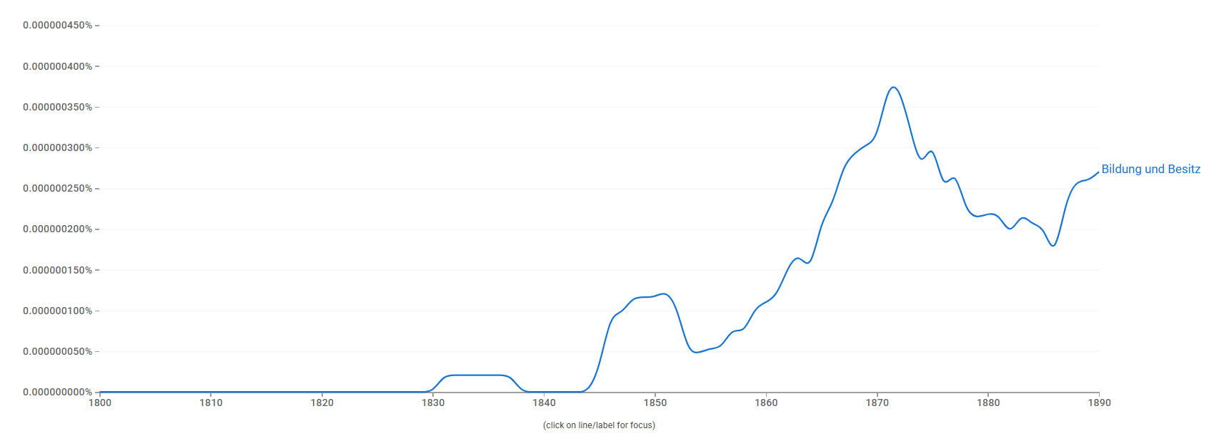
The word ‘democracy’ was largely avoided at the start of the decade even by left-leaning radicals. There were a variety of words designating the people, including Volk and Volkstamme, but no clear conventions as to how they should be used.
He dislikes the word nationalism, which in this context is often used to distinguish some political actors from others. Both Austro-Germans and Czechs agreed that what they wanted to create was some kind of multi-national monarchy. Historians often distinguish German liberals from Czech nationalists, but he thinks this tendentious and unhelpful: both wanted to see both liberal and national values respected. Equally, one can find within both groups some who favoured more centralist and some more federalist solutions.
When the Kremsier constitution was being drafted in 1848, Palacky proposed that to accommodate nationality the empire should be redistricted, but in fact, it was agreed to operate with existing crownlands.
Another matter on which views differed was whether or in what sense Slovaks under the Hungarian crown belonged to the same national group as Czechs. In 1860, a bid to treat the two together was implicit in a request for permission to establish a political newspaper in the Czech language to serve both Czechs and Slovaks; the high level of Bildung in these groups was stressed. However, no Reichsrad member saw themselves as representing both groups – given that any claim the Czech nobility might have made to do that was not generally supported. Although the newspaper was published from December 1860, it addressed the Slovaks as ‘brothers’, accepting their location within Hungary.
What was urged at this point was that the Bohemian crownland (within the Austrian portion of the monarchy) should enjoy a significant measure of autonomy. British and Swiss precedents for this kind of arrangement were identified. Arguments made intertwined liberal and national themes. It was claimed that in rejecting this bid the government in Vienna was failing to respect the traditional constitution. The Czech leaders hoped that Austro-Germans in the crownland would join with them in pressing for this, but that didn’t happen: they saw working at the level of the monarchy as more advantageous to them. Bohemian nobles were also not keen. [Headds that these nobles were politically divided into two groups, one favouring crownland autonomy based on updated versions of the old Constitutions of the Crownlands (akin to the Hungarian nobility), the other siding with the more ’centralist’ position of the Emperor and the German-Austrian liberals. At times in the 1860’s, the Emperor/the Court put pressure on members of the nobility to align with one or the other side in the Bohemian Diet to ensure that a majority supporting either a centralist-liberal or an autonomist-conservative position on Austrian Constitutional matters could arise of Diet elections. The Moravian nobility was keenly aware of representing their own crownland independently of Bohemia.] The government continued Schmerling’s [Anton von Schmerling - Wikipedia] policy of gerrymandering in ways that advantaged Bohemian Germans.
After the Ausgleich definitively failed to recognise Czech claims to significant autonomy, Czech leaders adopted the new tactic of mobilising the people. At this time they embraced some radical-democratic elements. They organised popular gatherings, called Tabor. By 1869, they were urging universal suffrage and boycotting of taxes and conscription so long as rights were not granted. If on the one hand those keen to promote national claims had to learn how to use democratic and even socialist language at this time, conversely those with democratic or socialist political roots had to learn how to use the vocabulary of national rights in ways that advanced their own ends.
Discussion
Joanna said that from the point of view of the project, what happened in the final years seemed to be the most interesting part (though of course it’s interesting partly inasmuch as it represented a change and a learning process). She wondered if Peter could do a bit more to unpack what went on at that time: who the players were; how they managed collaboration; could he say more about the use of democratic language in this context? Peter said that it took them a couple of years to work out how to operate in this new environment. The leaders often had relevant experience from 48. Thus, Palacky’s son-in-law Rieger [František Ladislav Rieger - Wikipedia] was the author of the Declaration of Rights as that appeared in the first Kremsier draft. Though there were also other factions among those who emerged at this time as key promoters of Czech nationhood. Some democrats returned to the fold at this time; some younger radicals also emerged. What was later to be an important distinction between ‘Old’ and ‘Young’ Czechs began to form at this moment. He said that popular mobilisation behind the cause grew through the 60s and just climaxed in its closing years. This was in part a reflection of the impact of new developments in the press and education. The December constitution of 1867 moreover provided more scope for this kind of opinion-forming activity. He noted that within the Austrian part of the monarchy, there were also distinctions in opinion between Bohemian and Moravian Slavs. The Moravians were not necessarily keen on being swallowed up by Bohemia, but wanted separate institutions. The constant redesigning of districts had by the end of the decade taken a form that facilitated mobilisation. These years saw a sincere attempt to equip the lower middling strata to exercise political rights.
Cody asked about the term ‘radical democrat’. What did it mean? He also wondered how Landespatriotismus related to the various nationality positions Peter had outlined. Peter said that radical democrat wasn’t a contemporary term – it was introduced only in the 1890s, but was now enshrined in the historiography, thanks to the work of Karol Kosig in the 1950s. https://en.wikipedia.org/wiki/Karel_Kos%C3%ADk) [– though the Wikipedia entry does not discuss his influential works on radical democracy from the 1950s].Radical was a term in use at the time, but not radical democrat. The ‘radical democrats’ were in practice a fluid grouping. As to Landespatriotismus, as he had said the crownland was accepted as a unit, although it was multinational. [He has since elaborated that in his view it is problematic to see Landespatriotismus only as a ’non-ethno-aware’ precursor to ’ethnonationalism’ as it is sometimes argued even in contemporary historiography. In the 1860s, we see both among Czech politicians in the Bohemia and in Moravia and in the broader population a coexistence of strong feelings of Landespatriotismus (in the sense of patriotic feelings for one’s Crownland as one’s natural Heimat) along with an awareness of being a member of a Czech ethno-linguistic community. Bohemian Czech politicians like Rieger more that once appealed to Bohemian German politicians in the name of a shared love for their shared fatherland, Bohemia. In Moravia, even the leaders of the Czech national movement fought to preserve Moravian political autonomy against the ’centralising’ ambitions of the Bohemian Czechs, who stressed the unity of the Lands of the Bohemian Crown.]
Theo he wanted to pursue the question that Beth had raised in her talk, about what people understood a ‘constitution’ to be. Also, when Napoleon III espoused the principle of nations, he saw that as essentially an anti-Habsburg position: it was a tool for breaking down their realm. Did the Czechs think about the international implications of the position they were pushing? Peter [adds now in relation to constitutions that he has found in the source material a rich collection of Czech political programmes and statements from the 1860, unfortunately only in a printed version, references to a Czech preference for Swiss or British models of self-government and a rejection of French centralism.] He said that there were lots of debates about what it meant to promote Czech nationality. It was important to note that the Czechs experienced heavy censorship, fines etc. This helped to make them dubious about German ‘liberalism’. They started to prefer the term freisinnig, freethinking. ”Svobodomyslný” in Czech. Even though in practice they continued to share common ground with German liberals. [He adds, the word became part of the official name of the Young Czech Party as this left-liberal faction of the National Party officially split with the moderate-liberal Old Czechs. The two factions were visible from the early 1860s, but the split was only formalized in the 1870s.] As to international implications, in the late 1860’s, Czech leaders like Palacký and Rieger sought to conduct an informal ’foreign policy’. Rieger did have contacts in France. They made visits to Moscow and Paris. Not too much importance should be attached to the Czech visit to Moscow: this was not a declaration of allegiance. Later, when the Czechs got control of the Prague City Council in the 1880’s, they used this institution as a foreign policy tool. He thought that the Austrians drew conclusions from their experiences with the Czechs which they thought they could promote elsewhere. It was the Austrians who insisted on including in the 1866 treaty which ended the Austro-Prussian war, and left Schleswig-Holstein to the Prussians, provision for a plebiscite to establish whether some Schleswigers might not prefer to remain part of Denmark, even if others went to Prussia (Schleswig being more divided between Danish and German speakers).
Anne Heyer wondered how in practice patterns in the use of German and Czech changed. And did ‘the same’ terms in different languages have the same valence? Surely not always. Peter Instanced Czech words for Volk. There was Narod, people as in the nation, the whole, but also Lid, the common people. Czechs tended to cast Germans as elitist, see themselves as having readier entre into the world of the masses. Anne said that Kuyper [founder of the Protestant populist ‘Anti-Revolutionary’ party used a similar word, Luiden.

Democracy and confessional divides -
said he had been doubtful that there would be much to say about Catholics and democracy talk, but it turned out that there was something. Discussions often involved the drawing of distinctions between what were characterised as true and false democracy. The institutional church didn’t approve of the 1863 rising: a barrier to them being enthusiastic about democracy. The Pope had condemned the 1830-31 rising in an encyclical of 1832, Cum Primum. That had a lasting influence on the attitude of the Polish hierarchy. Some individual priests were supportive: one Stanisław Brzóska - Wikipedia, the free encyclopedia led the very last unit to surrender (crashed only in December 1864). But the engagement into insurrection was not supported by the hierarchy. Similarly, Catholic periodicals told priests to stay away, and criticised nobles for not doing enough to discourage people from supporting the rising. They sometimes suggested that democracy was an imported concept, not suited to Polish circumstances. It was said to be possible to establish a fraternal relationship between nobles and peasants without the aid of democracy. However, building on pronouncements by French priests in the first half of the century, such as Buchez Philippe Buchez - Wikipedia [briefly president of 1848 French Constituent Assembly], some Poles (for instance, Ludwik Miłkowski and Kornel Ujejski) tried to reconcile Catholicism and democracy, or Lamennais. But there was no stark opposition between those in favour or and against democracy. Conservative writers, even while criticising democracy, might label what they criticised ‘false democracy’, asserting that there was a more Catholic ‘true democracy’, whose essence was the idea that popular happiness was the key to good government. Democrats were sometimes portrayed ironically, eg in dramas or novels, which often figured one or more ‘democrat’ characters, who might be suggested to have more complex motives eg being in reality nostalgic for the old order. For instance, in the drama titled “Dramat spraw obecnych w kilku odsłonach” (‘The drama of current affairs in several versions’, published in the journal Kalendarz dla Rodzin Katolickich na rok 1863, no 10), one of scenes contrasted a dogmatic democrat with another who genuinely wanted to promote a union of estates. In writings like this, democracy was not dismissed entirely; rather, people were encouraged to look beyond democrats’ superficial pretensions, and to suspect that they might have ulterior motives or be more dangerous in practice than their rhetoric suggested. In 1862, an émigré democrat Wiktor Heltman published a long essay https://sites.ohio.edu/chastain/dh/heltmann.htm), arguing that early Catholicism in Poland had been compatible with traditional folk paganism, until the Germans introduced a more intolerant Jesuitism appeared. This author turned the accusation of ‘cosmopolitanism’ against Jesuitism, suggesting that it alienated people from their cultural milieu.
Theo Jung (Protestantism) said that his chief source was the Protestant press. He said that many Prussians saw democracy as anti-religious. However, though there were atheistic democrats, most democrats were religious in some fashion, though they might be anti-clerical. An article by a member of the German People’s Party in Schleswig Holstein, by Carl Bruun von Neergaard, argued that democracy, socialism and Christianity had the same goal: brotherly love.
Drei Brüder […] von denen jeder den hemmenden Damm ebnen möchte, welchen der Cäsarismus und Materialismus – die Herrschsucht und Habsucht einzelner Begünstigter – dem wohltätigen Strome des Zeitgeistes entgegengestellt haben, die aber, weil keiner des andern Sprache versteht, auf Leben und Tod mit einander ringen in dem Wahne, die andern seien seine Widersacher und wollten den hemmenden Damm noch höher bauen. Während die wahren Gegner sie in diesem Wahne bestärken, sie weiter gegen einander zu hetzen suchen, um nach dem Wahrspruche: divide et impera (theile und herrsche), ungestört weiter zu herrschen, würden sie trotz allen Machtaufwandes den vereinigten Brüdern gar bald das Feld räumen müssen, sobiald diese sich nur verständigen würden.” Neergaard, C. B. von: Die Demokratie, der Socialismus und das Christenthum. Sind dies Gegensätze oder nicht?, Kiel 1869.
But this was an exceptional, marginal voice. In Prussia, just about all religious groups rejected democracy. Protestants and Catholics accused each other of being democratic. Protestants suggested that democrats were revolutionary: they noted a meeting at Mechelen in Belgium [1863 saw the most notable of a series of would-be politically modernising Catholic congresses Malines Congresses - Wikipedia] in which Catholics and democrats sought to forge an alliance. In such contexts, ‘democracy’ was often very vaguely conceived, being conceptualised as a ‘spirit’ that could inform almost anything one wanted to attack. Because they were so vague, such accusations were not very powerful: they could easily be shrugged off or met with a ‘tu quoque’ response (in the 1840s, they might have been more damaging). Conservatives used the term with particular abandon. Those attacked sometimes tried to narrow its application, or suggested that in some other sense, conservatives could also be seen as democratic. Thus in In the Märkische Kirchenblatt, a major catholic publication from Eastern Prussia, Protestantism was denounced as inherently democratic.
Quoted in: H. * *.]: Ansichten aud Aussichten des römischen Katholicismus in Norddeutschland, in: Protestantische Monatsblätter für innere Zeitgeschichte. Studien der Gegenwart für die evangelischen Länder deutscher Zunge 23/Jan.-Jun. (1864), 244-259, 245, 254. "Ist nicht in der protestantischen Kirchengeschichte die Geschichte und die Schule der heutigen politischen und socialen Demokratie principiell als Protestgeist? Ist nicht das Prinzip zur Revolution in einer Scheinreformation an Haupt und Gliedern, ist nicht die ganze protestantische Kirche demokratisch angelegt? Ist nicht die katholische Kirche und besonders das Papstthum die einzige feste Basis der Ordnung einer Gesellschaft und eines Staates, mit Obrigkeiten und Gesetzen auf dem Boden der göttlichen Vermittelung und des Gehorsams und Gottes willen nach katholischer Auffassung des vierten Gebotes?"
In France and Belgium at this time, democratic language being somewhat more positively typed, one can find examples of churches trying to associate themselves with democracy. But in Prussia, Protestants were much more likely to present their cause as that of religious freedom. Two areas of debate within Protestantism provided distinctive contexts for discussion. The first was the relation of the official state church to politics. More liberal Protestants might argue that by hurling charges of democracy at critics, those in charge effectively sought to stifle all discussion. Another context was church reform. The Prussian state church had since 1817 tried to bring together Lutheranism and Calvinism. That effort was complicated by the acquisition of new territories in 1864 and 1866 wars, which didn’t share that union tradition. In any case the merger had never taken complete effect even in Prussia. Partly to manage tensions arising from that, it was agreed to give more self-managing power to local church councils. In contrast to what happened in the Netherlands, these councils did not in practice engage much public interest. This was said to demonstrate that Prussian Protestants were not interested in democracy. Overall, what emerges is that political terminology was not infrequently applied to church affairs, but, as in a political context, democracy was generally a negative term, used more to criticise than to advocate. And Prussian Protestants old and new did not show great interest in taking up new ‘democratic’ opportunities offered to them in a church context.
Francois Guesnet (Judaism). He would be focussing on Russian Poland. The Jewish question appeared on the political scene at that point, but not in association with ideas about democracy. The focus was on ways in which Jews should or shouldn’t participate in political life. In 1856, when the new Tsar visited Warsaw, he told Poles to forget their dreams of independence: point de revéries, messieurs. There was not much talk about democracy in Russian Poland (in his paper in Warsaw he had talked about those few who did talk about it). That language was much more characteristic of the emigration, of Poles in Paris or Brussels. Jews became more visible in Russian Poland in this period, partly because numbers grew, due to emigration from other parts of Russia. The population grew over the 1860s from about 1m to 3.5m. In warsaw, there were 40,000 Jews at the start of the 1860s, 80,000 at the start of the 1870s. Their status was problematic. When Poles told stories about their longlost primitive democratic state, Jews figured as itinerants who bribed nobles to improve their own position. This period saw the so-called ‘Jewish war’, a controversy about the presence and behaviour of Jews in concert audiences. Some Jews mobilised in support of the 1863 rising, though most remained indifferent. A small but visible minority took the chance to show that they were full members of Polish society. Thus, Dov Berush Meisels (1798-1870), the chief rabbi of Warsaw presented himself as a Polish patriot at this time – but he was not typical. In 1862, the head of administration in the kingdom, Count Aleksander Wielopolski, offered the Jews the chance to participate in new systems of local self-government; some were elected as local councillors. After the rising, when Poland was more directly governed by Russian administrators, these were keen to cater to Jewish aspirations. The period of Russification left Poles with little room for maneouvre; ‘organic work’ was the name for a form of adaptation to those circumstances. Jews like others lost opportunities to participate politically, but retained important economic roles. Some worried that it was bad for their image to be seen as partners of the oppressor. The scale of Jewish immigration from Imperial Russia also spurred reaction. Jews deferred to Russian rulers, without feeling much enthusiasm for them. As targets of popular anti-semitism, their experience was not great. In Galicia the arc of development over the decade was very different. The Ausgleich brought the Jews full rights of partition in the Habsburg empire. They were also allowed to enter into the Polish-language education system. This more liberal treatment inspired to loyalty to the Habsburg Empire on one hand, and strengthened trends to embrace Polish culture among urban educated segments of the Galician Jewish community.
Discussion
Maurizio had questions for all three. To Piotr: was it argued that Catholicism had the potential to tame democracy? To Theo: how did Protestant-Catholic tensions play out in politics. To Francois, he would have expected Jews to be pro-Russian before 1863: were they not? Piotr said the main Catholic line was that what was valuable in democracy was already to be found in Catholicism. Theo very briefly outlined the Kulturkampf: a hostile official response to the rise of the Catholic Centre Party. Francois said one might have expected it, but the Russian empire blew it, notably by forcing Jews into military service.
Daniel wondered why more Jews didn’t throw themselves into the Polish national project. Francois said there was more enthusiasm among Jews in exile circles. Later alternative frameworks developed, such as universalism (Rosa Luxembourg’s position) and Zionism.
Joanna wanted to know in relation to Poland, how ‘organic work’ fitted into the story. Did that not provide a basis for a closer relationship between democrats and the Catholic church? And in relation to Prussia, in 1848 there were significant religious movements among both Protestants and Catholics closely linked to the democratic cause: the Lichtfreunde and the German Catholic movement. Both died very quickly after 1848, but she wondered how to think about why such movements existed then and not in the 1860s? What role if any did their former adherents play in the 1860s? Piotr said that the term ‘organic work’ was coined by liberals in Prussian Poland in the 1840s. Forging this term, they searched a method for shortening a way for the advent of the ‘organic epoch’, deriving this from Saint-Simonianism. Maciej Janowski has described the relations between liberals and the Church as a marriage for convenience https://apcz.umk.pl/KH/article/view/KH.2017.124.SI.2.02 . From the point of view of the Polish nationalists, it represented a recognition that only by working in a lowkey, local level could their cause survive. After the failure of the 63 uprising, this approach became more important, and the Church was more involved with nationalists in these low key ways, including eg giving them access to church premises (hence the popularity of, for instance, Polish choral groups, that were also an element of the realisation of the ‘organic work’ social programme). Theo said that leading Lichtfreunde went into exile after 1848, and weren’t visible in the 1860s. The only reform movements visible in the Prussian church in the 60s were the two he had mentioned: the creation of grass roots organisations – though that was if anything a conservative initiative and the attempt to strengthen the union of the two parts of the Prussian church.

Democratic internationalism -
Gabór Gangó said that he wanted to explore four interrelated developments among Hungarian democrats in relation chiefly to Kossuth. First, in a London-centred movement, Kossuth rubbed shoulders with Mazzini; secondly, he was engaged in discussion about a possible democratic Danubian federation; thirdly, he had his own position within international democratic circles, and finally, the workers’ movement challenged what they called ‘bourgeois democracy’. Gabor thought that what happened in the early 1850s should be seen as an aftershock from 1848. Then there was something of a break, till new activity commenced in the 1860s. In relation to the claim by Peyrou and Simal (in their chapter on ‘democratic internationalism’ in the Mediterranean volume of the Re-imagining democracy series) that ‘the term “European democracy” was constantly used in letters and manifestos, and not only in exile circles’, he found this to be true only of Italians and in the early 1850s. (His handout supplied some examples:
Respectant en vous le premier champion de la Démocratie Européenne j’ai écrit franchement” (Adriano Lemmi to Kossuth, Constantinople, 18.11.1850); „que nous sommes, nous deux, regardés comme les chefs de la démocratie européenne active” (Mazzini to Kossuth, 24.4.1852); „der Dienst den der H[err] Gouverneur der europäischen Democratie […] erweist” (Pietro Fortunato Calvi to Kossuth, Torino, 22.10.1852); „Le moment nous paraît venu pour la Démocratie Européenne de se reconstituer en une puissante unité, de se poser en face de ses ennemis et d’agir.” (Kossuth, Ledru-Rollin, and Mazzini, Manifesto to the Republicans, 26.9.1855).)
Although Kossuth initially hoped that developments in Italy might provide a springboard for Hungarian action, and Mazzini dreamt of a Danubian federation [a way of dealing with the nationally fragmented map of central Europe], by 1864, oontrary to what Spanish envoys reported, plans for a rising in Hungary had already been abandoned. Though Mazzini brought him into the Central Democratic Committee, Kossuth was keener on the principle of nationality, though he talked a lot about democracy; anyway their relationship ended in 1860. After Austrian defeat by the French at Solferino (1859), Kossuth began to champion alternative approaches, but always primarily with an eye to preserving the integrity of Hungary. Mazzini and Kossuth had different ideas about the form a Danubian confederation might take. Mazzini thought Transylvania should pass from Hungary to Romania. Kossuth did not support that. In Klapka’s schemes György Klapka - Wikipedia , which focussed on constitutional mechanisms, the key idea was that a federation should block Russia. It was imagined as strongly confederal, with eg electoral systems being determined by member states. In the federal assembly, delegates would be able to speak the language of their choice; interpreters would mediate. Each member would incorporate democratic principles in their public law. The Venetian journalist Canini Marco Antonio Canini - Wikipedia, the free encyclopedia was more concerned with enabling the emergence of nations. Kossuth lent his name to this plan, but ir proved divisive, both among emigres and between the domestic opposition and emigres By 1862, the democratic wing of the Hungarian emigration were increasingly oriented to the US. Kossuth, Mazzini and Marx all wrote disparagingly about each other. Marx and Engels’ writings did much to create the image of unified democratic movement, but in fact reconciling national and working class emancipation was not easy. In east central Europe, the democratic cause did not prove a good vehicle for local ambitions. Emigres who espoused it were detached from the realities of their homelands.

Edward Castleton [online] wanted to talk about some general issues. He wondered why we were ending in the 186s. From his perspective, that is, from the perspective of a historian of the European left, the Paris Commune was a key watershed. He’s been working recently on Proudhon’s critique of the principle of nationality in the early 1860s. This involves looking at the Francophone reception of the Polish question. In this context it had occurred to him that between the defeat of the Polish insurrection and the defeat of the Paris Commune, something happened. The hopes of the 1848 generation died. After 1865, the French perception was that Russia had triumphed, and not much could be done about that. The defeat of the Paris Commune marked an end to the idea that the French could lead the transformation of Europe. It also of course marked the death knell of Bonapartism, including his principle of nationalities – it became clear that that wasn’t going anywhere. To participants, the Commune revisited the left version of 1848, prioritising the social alongside the political. Its defeat put an end to that view of how European politics was supposed to work. The French Third Republic was a product of defeat: that wasn’t how it was supposed to happen. The unification of Germany showed that conservatives could make the national principle work for them. National, social and republican causes no longer seemed to overlap. The late 1860s saw meetings of the League of Peace and Freedom and of the First International – both met in Switzerland, brought together a mix of nationalists and democrats, and some of the same people attended both, including Bakunin. Bakunin had been radicalised by the end of the 1863 referendum. Thenceforth he made the social question central to his thinking. Marx had favoured Polish independence. He was doing a lot of journalism throughout this period, including about the Crimean War, much of which has never been translated into either English or French. He had wanted support for Polish independence to be written into the charter of the First International. In fact, the Polish issue played a part in the origins of the First International, because it was to aid money-raising for the Polish cause that French delegates came to London. In 1866, that idea was however voted down. Marx tried to reconcile the cause of nationalities with the social question. Marx himself was more nationalistic than Marxism was to be. Questions posed by the French revolution ceased to set the agenda from this point. By the 1880s and 90s, French references were no longer central to thought on the left. When the Belgian lawyer and economist Laveleye Émile de Laveleye - Wikipedia wrote his Le gouvernement dans la démocratie (1891) [arguing that democracy was both inevitable and precarious – text in Google Books], his references were primarily English, to people like Mill and the Scottish jurist James Lorimer, or German. His basic point was that he thought 1871 marked a more natural break point.

Discussion
Chris Brooke to Gabor, said that he agreed that the early 1850s marked the end of something, including hopes of establishing a Danubian federation, and yet that idea continued to be discussed. So he wondered what ended and what persisted. Gabor said he thought discussion was divided into two phases. He said that above all he wanted to express scepticism about Kossuth. He thought that even when Kossuth endorsed democracy as an ideal he was not in fact a democrat; that was just a means to an end.
Quentin said that he saw the 1860s as a decade marked by a series of attempts to operate across borders without much success. He agreed with Edward that the First International was not just about class. Its members were also preoccupied with the freedom of nations, and with. the abolition of slavery.
Gabor said he was indebted to Cody for showing that the idea of a working class movement had any foothold at all in Hungary at this time. He asked Edward if Marx did really reject the nationality element of the European democratic movement at this time. Edward said perhaps not. He did think some kind of state was needed to interpose between Germany and Russia, and Poland looked like the best candidate for that. But in general many delegates to the First International were keen not to let geopolitics distract from their focus on the betterment of working men.
Cody said that he had liked the discussion of the Danubian federation, and agreed that it both died out and yet somehow lingered on. Its continuing grip is shown by the fact that Tancsics Democracy or Popular Government? The Political Thought of Mihály Táncsics in the Vormärz | Centre for Intellectual History, during the long period in which he hid under the floorboards of his house, also wrote about it. The idea pops up randomly in various places. In general, the 60s marked a low point in terms of thinking about federal solutions to how or what to do with the Habsburg lands, though. Some Hungarian democrats were tried for high treason for supporting the Paris Commune in this period, though the attempt to brand their activity as treasonous failed, and subsequently their orientation did change in relation to the democratic and federal questions Edward noted that many Poles died in the Paris Commune. Against this background, Rosa Luxembourg would set her face against the principle of nationality.
Joanna said that she had found Edward’s remarks very helpful in terms of thinking about periodisation and its significance, though she didn’t think all that much hung on the distinction between 1869/71. Insofar as it was necessary to go into the 1870s to illuminate something about the 1860s, of course any contributor could do that. The bar was only to considering things whose centre of gravity lay in the 1870s. It seemed to her that it was largely because Edward was focussing on the international level that he saw 1871 as the end of something – though that was a useful perspective. From within our region, in terms of domestic politics, it seemed to her that the 1860s felt much more like a new beginning (if in some respects an abortive one), and the argument for focussing a chapter on this decade was precisely to show how things were changing. Arguably domestic and international levels of democratic politics were articulated in one way in the 1860s and then had to be rearticulated, but she’d have to think more about it to formulate an opinion on how it was different in the two periods. Edward said he wasn’t trying to dictate the form of the book, just explaining how things looked to him.
Jean-Michel suggested that what happened in the 1860s were that nationalities issues were resolved by force of arms.
Peter remarked on a bibliographical point that Jana Osterkamp’s book listed just about Danubian federal proposal ever made: Vielfalt ordnen: das föderale Europa der Habsburgermonarchie (Vormärz bis 1918) [2020] (It was suggested that this book has been translated into English, but I haven’t found evidence of that].

How to bridge divides Swiss, Dutch and Belgian and Austrian experiments
Joanna, chairing, said the three countries being focussed upon all faced particular challenges in terms of internal divisions.
Irėne said that Switzerland was a multiply divided country. Long standing divisions, were between Catholic and Protestant – these had given rise to civil wars, and also linguistic divisions, resulting mainly from the westward expansion of the Confederation, in the sixteenth century and after the Napoleonic treaties. She had listed these in the handout. Fortunately, as her maps showed, these divisions did not perfectly coincide.
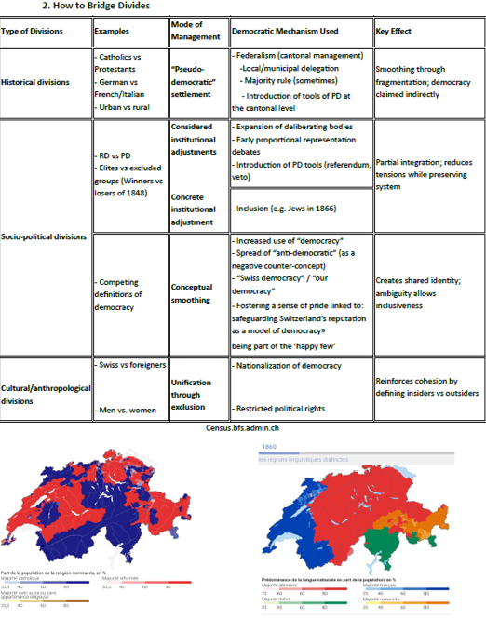
Democracy as such rarely resolved these divisions, Instead they were mitigated by contingency and sometimes by institutional engineering. Federalism helped: delegating power downwards often meant moving it on to a level where there was more common ground (this could also be represented as democratic). But these devices didn’t solve everything. Especially they couldn’t be relied upon to resolve problems arising from the presence of large minorities. In the 1860s, the most problematic divisions were socio-political and urban/rural. The heirs of 1848, imbued with what contemporaries called the ‘spirit of 1848’, saw the representative democracy they had championed for decades as the way forwards. This entailed a form of elite rule: a gentrified politics. ‘Pure’ or direct democracy tended to be favoured by their conservative opponents, in Landesgemeinde cantons which has been on the losing side in the Sonderbund war. But in the 1860s the cause of direct democracy was also taken up by some forward-looking reformers, who thought that it might provide a means of addressing current problems: they framed it not as tradition but progress. Three possible ways forward were discussed: one would have involved expanding the role of bodies such as the General Council, to offset majoritarian tyranny at the local level; a second involved proportional representation; a third, direct democracy. The third option was the one that was carried forwards. It had been hoped that constitutional revisions in 1866 might address these issues, but in fact what was agreed was something else: full equality for Jews (partly under international pressure [France, Neths and US threatened to cancel trade treaties if not granted]). Further constitutional change took place only in 1874. In the 60s, democracy played a smoothing role largely conceptually and symbolically. She drew on newspapers to make this argument. She had found that the word was used increasingly: there was a 50% increase in its use over the decade, with peaks in 1865, when revisions to the federal constitution were agreed, and 1868-9, when some cantonal constitutions were revised. The reading public consequently encountered the term more. The term ‘anti-democratic’ was sometimes used in the 1850s, by those who favoured direct over representative democracy at the cantonal level. In the !860s, this use spread to the federal level, and was used to criticise the central authority. Democratic was in both contexts typed as good and associated with Switzerland. The trend was both to naturalise and to nationalise the term. She found a 4-fold increase in occurrences of the phrase ‘Swiss democracy’ and a 9-fold increase in the phrase ‘our democracy’, Sometimes democracy was used to mean Switzerland. What kind of democracy was rarely specified: the term was used to emphasise inclusion. But there were also exclusive implications. The Swiss were implicitly enjoined to behave in ways appropriate to a democracy. Democracy was presented as a privilege. It was nationalised: foreigners did not participate in it. And it presupposed exceptional citizens, who could defend the Swiss model: so women were excluded, and when they petitioned and protested about this, that was seen as further proof that they were unworthy of inclusion. [ In 1868, Marie Goegg-Pouchoulin founded the Association Internationale des Femmes (AIF) in Geneva. It explicitly demanded "complete equality" between men and women in areas such as salary, education, and political rights. The issue was explicitly raised in the context of the constitutional revision of 1874].
Chris Brooke noted that in 1861-2, when initiatives to change constitutional arrangements in the Habsburg monarchy were first launched, two high-level English texts commented on Hungarian circumstances: JS Mill’s Considerations on Representative Government , especially in his chapter on nationality, and John Dalberg Acton’s ‘Essay on nationality’. The Habsburg monarchy was clearly seen, reasonably enough, as posing questions about how to govern multinational states in a particularly acute form. The commentators were both liberal MPs in the 1860s (though only Acton at the time of writing), but with significantly different political instincts. Mill’s chapters both on federalism and on nationality in fact both primarily addressed the Italian case. Mill suggested that a problem for liberty in multinational states was that soldiers of another nation in the state might be mobilised to suppress others who they did not keenly identify with: Italians within the Habsburg realm were vulnerable by virtue of that. He thought it best that states and nations should coincide. His views may have been shaped partly by his friendship with Mazzini. However, he noted that in some places nationalities were so mixed up with each other that no neat delineation was achievable. He picked out Hungary to illustrate this. In such cases, people could not hope for more than to enjoy equal rights and laws. Acton’s essay was published in 1862. Unfortunately it’s not completely clear when he wrote it, so what had happened and what not at that point. Acton, a Catholic, worried about the implications of Italian unification for the Catholic church. He also thought about Austria, but was optimistic that the Habsburg empire, like the British (as he saw it) would find a way round the difficulties it faced, and deliver liberty to its inhabitants. Given that we can’t date the composition of his essay, we can’t know exactly what gave him that confidence. Around the period they wrote, there were three significant constitutional changes in Habsburg lands, arising from the October Diploma (1861), the February patent (1862) and the Ausgleich (1867). Mill can’t have been responding to anything later than the October Diploma, if he was responding to that. In Acton’s case we don’t know if his views reflected his reading of the 1850s or one or both subsequent developments. It’s worth nothing some things they weren’t talking about: democracy (in Hungary that cause was associated with Kossuth) or Transylvania, the Schleswig-Holstein of Hungary (even Kossuth wanted to hang on to it, not hand it over to the newly united Danubian principalities). ). In Transylvania, the Hungarians and Germans were treated more favourably than the Romanians. The Romanians were interested in a possible Danubian Confederation; most Hungarians not. Hungarians saw a more viable way forwards in what’s been termed ‘non-territorial autonomy’. Kossuth at one point favoured some version of this, and the idea is certainly to be found in Eötvös’s Dominant Ideas of the Nineteenth Century and their Influence on the State, and later among Austro-Marxists and Oskar Jaszi. The idea was to replace collective ideas of nationhood with a conception of nationality as an individual right: people would affirm their nationality in the census and that would determine state funding for cultural institutions. Political power would be distinguished from cultural and educational power. If that idea had gone somewhere the twentieth century would have been different. In fact, however, other approaches triumphed. When after the Habsburg loss of Lombardy, the Rothschild bankers refused to loan more money to the Habsburgs unless they established some form of representative government, October 1861saw an experiment with a form of diet-based federalism, then February 1862 a change of direction towards the liberals’ favoured solution: a pan-imperial legislature. When that proved unacceptable to the Hungarians, and the French carved more land from the Habsburgs (Venetia, 1866). The Ausgleich divided power very much on Hungarian terms. Chris Clark suggests that because it entailed very cumbersome procedures to move the Dual Monarchy into action, it allowed the Serbian crisis to escalate into the First World War.
Lauren Lauret
She would be exploring Dutch experiments with political practices, drawing on her work on Dutch politicians with a colonial background. In the 1860s, liberal politicians remained dominant in the Netherlands, but with confessional conflicts lurking in the wings. She would look at how politicians used the concept of democracy to bridge divides both at home and in the colonies. The system they devised at this point lasted until the 1890s. An interesting debate was precipitated 1863 by the ageing liberal leader Thorbecke’s plan for a new palace for the legislature. Critics – such as the conservative intellectual Groen van Prinsterer -- said that this exemplified foreign ideas of popular sovereignty. Thorbecke himself on the contrary saw it as enshrining the idea that the legislature rose above the people – though he regretted that speeches in parliament were increasingly being delivered with a popular audience, rather than other representatives, in mind. Thorbecke’s influence was increasingly challenged by a younger generation. JT Buijs Johannes Theodorus Buys - Wikipedia, the free encyclopedia a constitutional law professor and editor of the liberal literary periodical De Gids (The Guide) De Gids (magazine) - Wikipedia, the free encyclopedia developed his own critique of the political order. He thought that majoritarianism did not provide enough legitimacy to government, and that it encouraged social division; he worried especially about the power it had the potential to give to religious majorities, if the social base of politics broadened. Democracy, understood as majority rule, in the context of democracy, understood as a political order grounded in a wide franchise, was potentially despotic In 1869, two seismic changes confirmed the democratising trend of the decade. In March 1869, parliament debated the abolition of the newspaper stamp duty (in exchange for higher tax on distilled liquor), or ‘wisdom tax’ as it was dubbed. The minister defending the bill was equalled to a tribune, speaking to a popular meeting and aiming for popular approval in the press.¹³ MPs had received a booklet and one critical MP quoted the key rhetorical question: “[I]f there were reason to expect that the entire Pandora’s box of democratic levelling concepts would be scattered over the Dutch population, – what – we dare ask boldly – so what?”¹⁴ One proponent of the abolition related the importance of cheap newspapers to the upcoming elections. In the current situation, politicians ignored the electorate, withholding the male citizen the brainfood he needed to arrive at a wise vote. With the upcoming elections, however, time had come to overfeed the electorate with newspaper articles; yet the voter was unaccustomed to it and did not understand the political advice, hence time had come to abolish the newspaper tax and educate voters politically throughout the year.¹⁵
Buys published his essay ‘Our Electoral Law [Ons Kiesregt]’ in the same year. He was worried about proposals to lower the census qualification for the franchise [ which didn’t in fact take place until 1887]. He was not altogether opposed to this, but thought the best way forwards would be to lower the census requirement in the cities (which were currently disadvantaged by qualification rules which enfranchised more people in the countryside. [In fact, when change did come in 1887 it further strengthened the influence of the rural electorate].) The results of the 1869 elections did accelerate the development of a politics of interest, producing representatives who associated themselves on the one hand with Catholics, on the other hand with ‘anti-revolutionary’ Protestants. The liberals found themselves generationally divided, making it hard for them to deal with challenges from elsewhere. In terms of substantive political issues, the 1860s were dominated by the colonial question, as the 1870s would be by the social question. A key question was whether Dutch settlers in the East Indies were to have access to representation. In 1854, that question was answered in the negative. It was argued that they should be content with civil rights and an independent judiciary. However in 1866 (three years after the abolition of slavery in the Dutch West Indies) Surinam was given a form of representative government, copied from the Netherlands. An argument in favour of that was that emigration to the colonies would be checked by lack of political rights. JS Mill’s arguments about the need for a significant population to support representative government were cited against – showing that it was assumed that all that was in question was the rights of the white population. As between the Dutch metropolis and the colonies it was therefore assumed that there was and should be no divide in political culture. Though also invoked against the extension of Dutch political arrangements was Henry Grey, 3rd Earl Grey, who argued that representative institutions were a source of division and should be removed from a racially fractious colony [which was what happened, following the Morant Bay rebellion and its brutal repression, in 1865/6].

Discussion
Francois asked Irene whether Genossenschaft had a role in democratic discourse. Irene said she didn’t remember it appearing. ‘Our democracy’ was said to be rooted in the middle ages, but also to be forward looking. At this time the emphasis was more on its progressive character. Only in the 1890s was more emphasis laid on the history.
Quentin said the Netherlands was the only place with significant colonies in the region under discussion. He wondered how important the theme was in this context. Lauren said that she thought it could form an element in a comparison. She was currently working on patterns in relation to other colonies. Joanna noted that Sweden and Denmark also had Caribbean colonies: and Iceland and Greenland might be seen as colonies of settlement in relation to Denmark. Alvar said he didn’t think colonies played an important role in Swedish politics, but the topic was poorly explored after the abolition of slavery in the 1840s.
Daniel said that he had expected to hear more about race. Lauren said that 1848 had led to the codification of racial difference. In the 1860s, its role in Dutch East Indian politics was in a way already determined.
Camille wanted guidance on whether she needed to write about colonial politics. Joanna said she and Mark had agreed that they would need to say something about the colonial and global context in the introduction, not least because it provided one framing for ways people across Europe thought about themselves (eg Zayarnyuk had shown that the idea of a hierarchy of races figured in Ukrainian schoolbooks, where its role was to suggest to young Ukrainians that as Europeans they had a potential to progress). Jean-Michel said they might need to think more about empire, a concept that applied both inside and outside Europe. Joanna said that whereas in English the same time was applied to both, she wasn’t sure that that was the case in all languages. Quentin said that colonies complication the imperial/metropole divide.
Gabor asked Chris what he thought he achieved by rehearsing things already known [to Hungarian historians, anyway]. Joanna said that if he had added something different, it had been in framing his account in relation to Mill, and Acton. Mill had often been mentioned in the workshop. This was his moment: the issues he addressed especially in Representative Government were attracting attention throughout Europe at this time. Chris said that later in his life, after the death of Harriet Taylor [in 1858], he lived in Avignon, so his viewpoint was as much continental as British. During the 1860s he was associated with anti-Bonapartist writers, and was in touch with Bluntschli.

Concluding discussion: re-imagining democracy - Realpolitik?
Joanna said that at this point everyone was of course very tired. But a few minutes remained in which it was possible to exchange some concluding thoughts. She invited people first to revert to the ‘pragmatism’ theme, which she had introduced but which had not been opened up to discussion at that point. Another way of framing that would be to say, what differences did people see between this decade and the era of the 1848 revolutions?
Maurizio said that this was partly a question about generations: what older people made of the experiences of their youth, or the young of the experience of their parents’ generation.
Francois said things could be framed in terms of responses to defeat.
Joanna said that one thing that struck her was that maybe those who wanted reform had more of a sense in the 1860s that one needed to strategise to achieve it. Like the feminists who think, first we lay the foundations like this, then in the longer term we aim at that. Or democrats who said, first we have to educate our masters. Political action was plotted over time.
Mark said one shouldn’t perhaps think of people embarking on change with different goals, so much as adjusting their goals as a result of what they learned through being involved in trying to bring about change. The Swedish democrat Löwstedt, described in a blog post by Alvar Carl Rudolf Löwstedt: the first Swedish democrat? | Centre for Intellectual History , provides an illustration of this kind of learning through life experience. Joanna said she thought it was also important to look at the perceptions of a generation who came to maturity only in this decade: how did they see things?
Iain said that during the 1850s and 60s there was a debate about the role of force vs ideas in history, esp in relation to French and German history. Discussions of democracy raised questions about popular agency. Jean-Michel suggested that there was a developing idea that some things – like science and industry – needed to be free to operate outside politics.
Joanna said perhaps one should think about people undergoing a process of reflection about the potential for acting to shape one’s political environment.
Quentin said that, when he was putting together a textbook on this period of French history, he had found several sources suggesting that, at the time, people were well aware that things were changing, without clearly understanding what they were changing into. A recurring image in contemporary texts was that of the Sphinx posing its riddle: a wrong answer merited death.

APPENDIX: HANDOUTS
Day 1: Scene-setting and themes (Innes)
Geo-politics
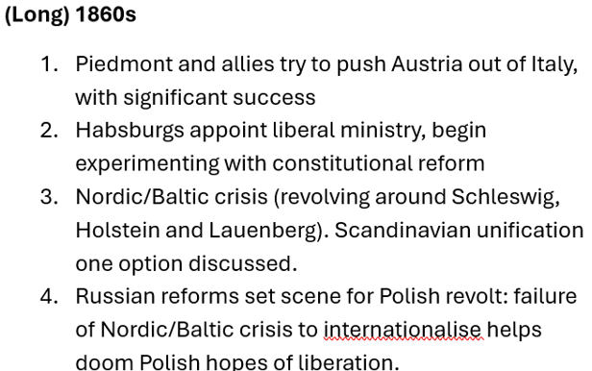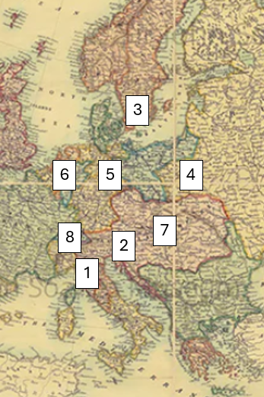
Wider developments:
Europe: Greece – new dynasty, territory, constitution; Spain – revolution, queen ousted, brief republic; Franco-Prussian war, fall of Napoleon, Commune, French Third Republic. German Unification.
Wider world incl: US Civil War; Mexican Emperor installed and deposed; Meiji Restoration opens Japan to foreigners, fall of Shogunate, installation of emperor Meiji (‘enlightened rule’).

Some background causes of unsettlement in central and northern Europe
- Unravelling of Vienna settlement – which apparently survived, but was in some ways weakened by 1848 revolutions because revealed appetite for change; involved wars; brought revisionist Napoleon III to power.
- Crimean war: both reflected and enhanced the revisionist mood. Prompted reforms by Russians and Ottomans (also affecting Danubian Principalities), and upheaval in Greece
Effects on political practices
Background
Many new constitutions, usually either introducing or strengthening the role of representative government. Liberalising trend. (But not everywhere: franchise narrowed in Denmark; repression in Poland).
Hypotheses about what might be called ‘democratic’ practices
- Representative government and associated forms of political life increasingly the norm in the region.
- Continuing development of associational life, a site among other things for experimentation with identities.
- Associations that primarily served other functions could become mechanisms for political organising.
- Increasingly clear ‘the people’ not a unified entity

Effects on ‘democracy’ talk
Hypotheses
- Increasing acceptance that long-term trends favoured democracy.
- But ‘democrats’ still marginalised. A slow evolution towards a managed democracy was preferred.
- Diversification in what ‘democrats’ wanted. Among numerous groups seeking enhanced inclusion or recognition, some were more prone than others to talk about democracy (Who? Why?)
- Uncertainty about what institutional arrangements might best serve democracy. Interest in experimenting with new forms.

Day 1 – Constitutions, theory and practice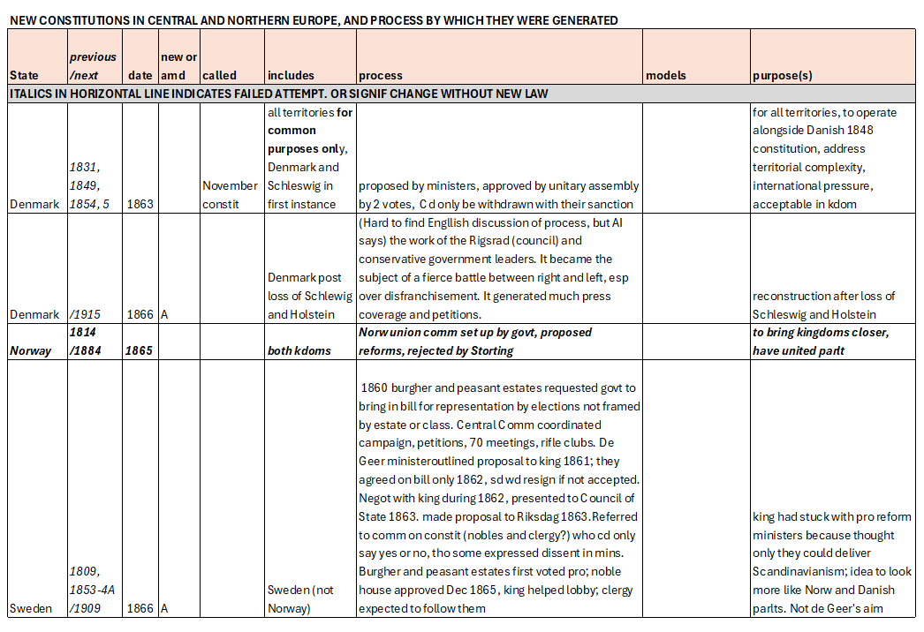 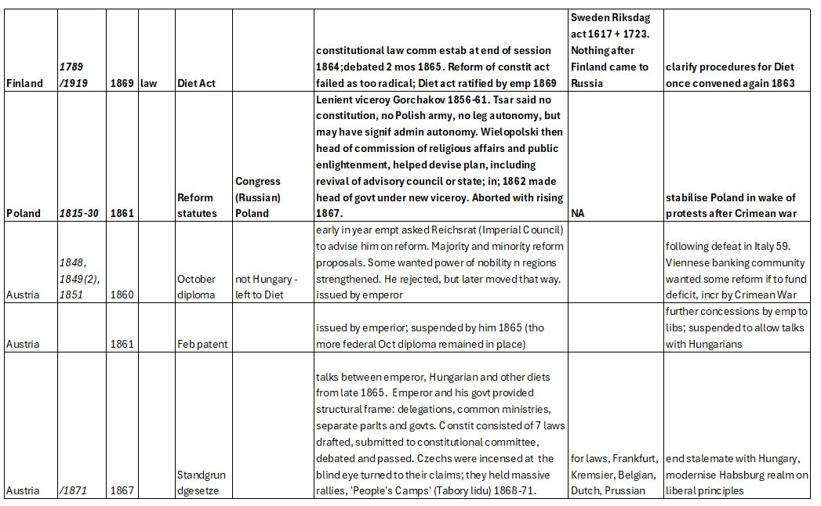
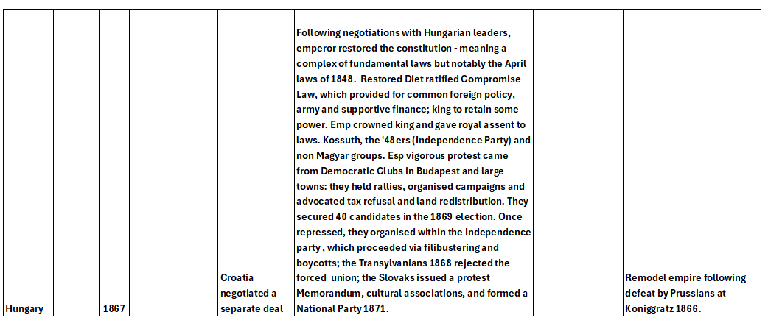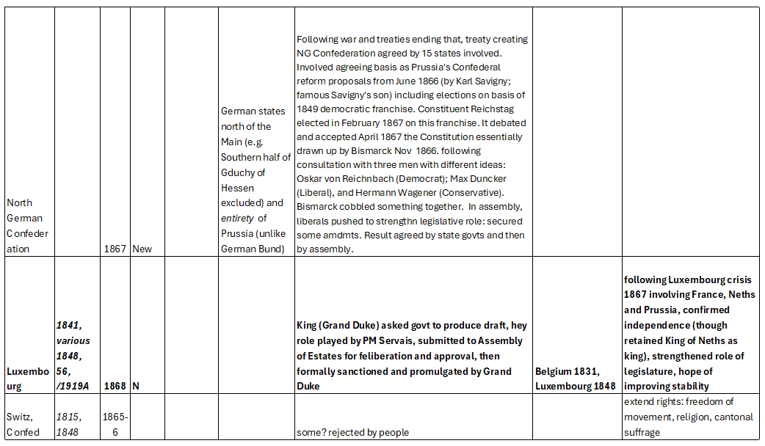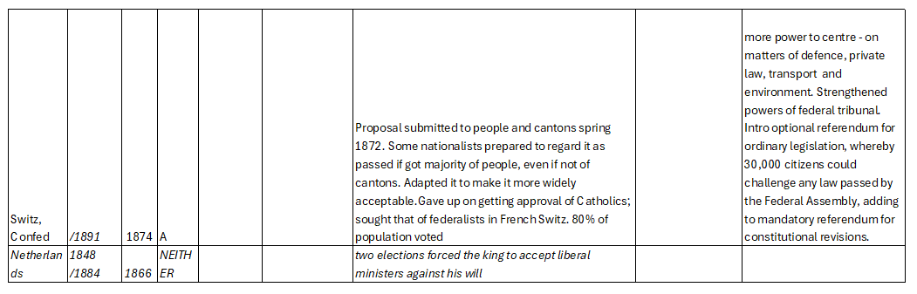
Day 2 morning: Institutionalised participation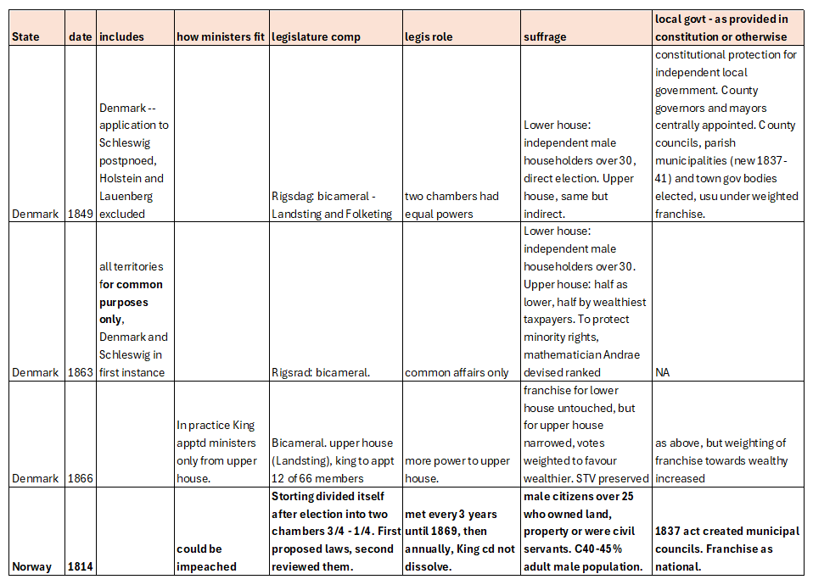 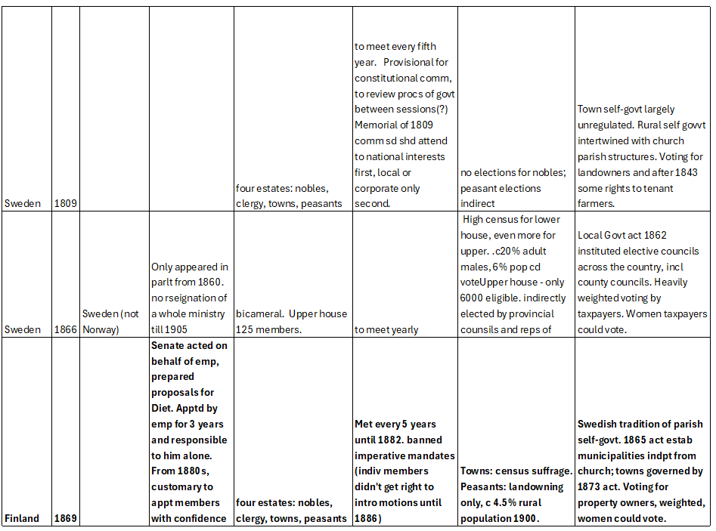
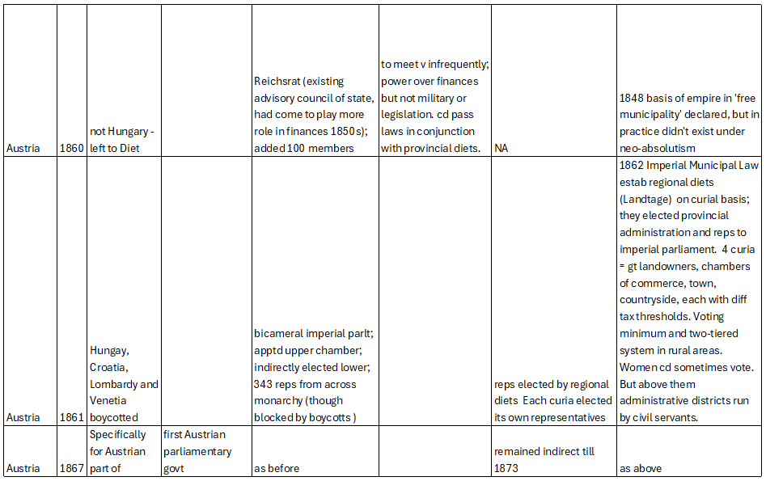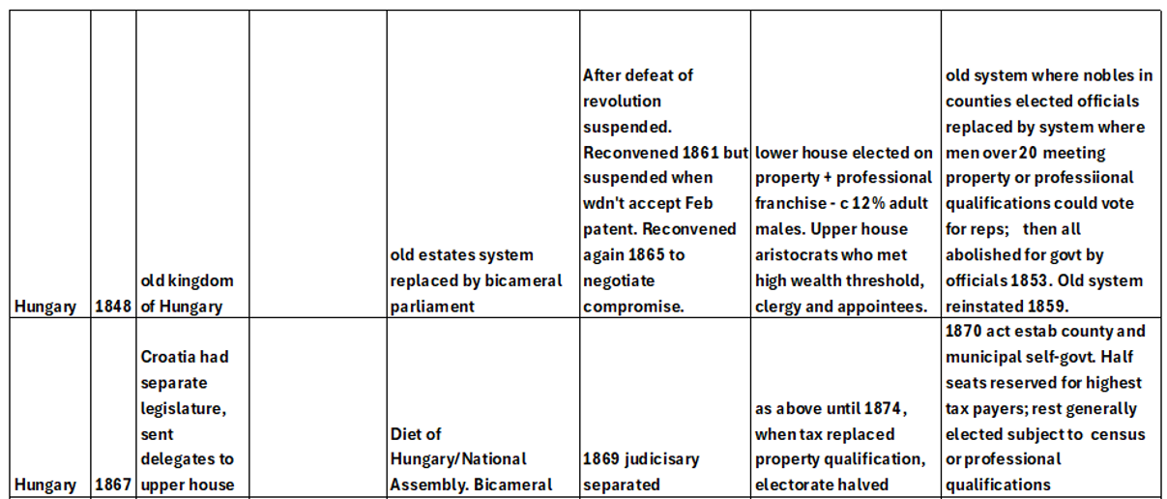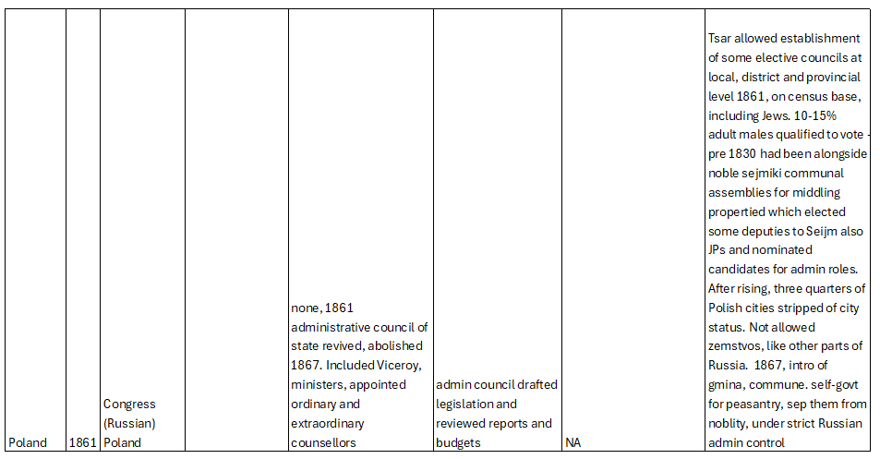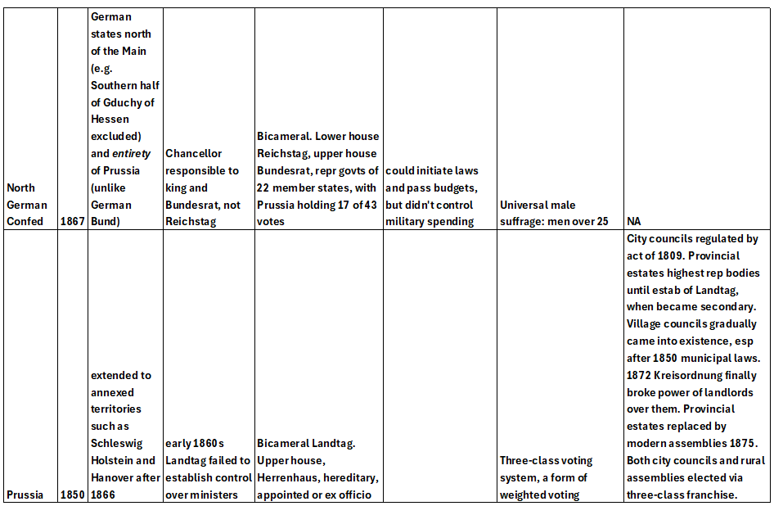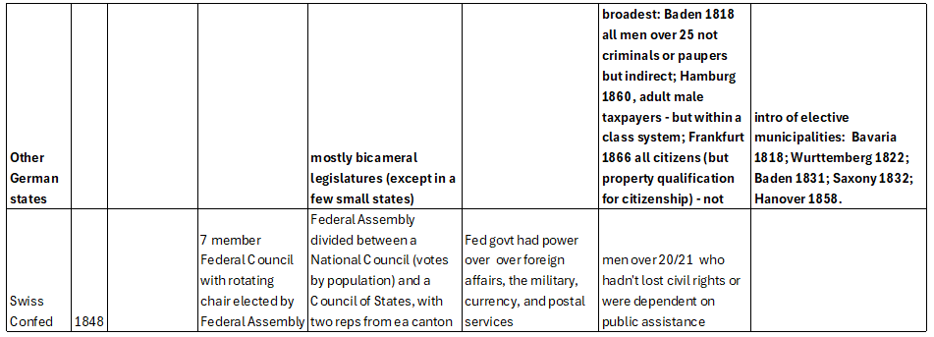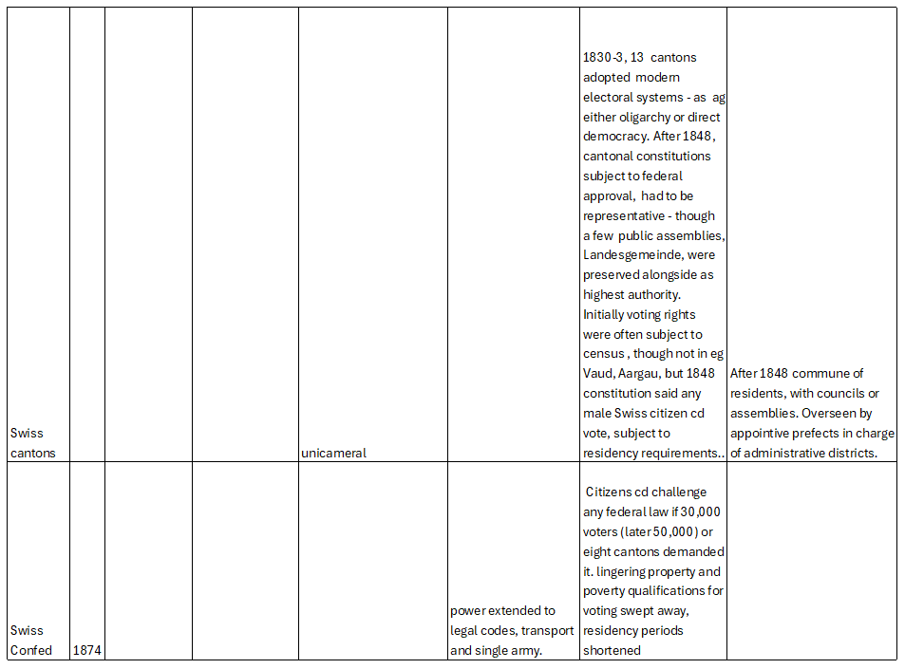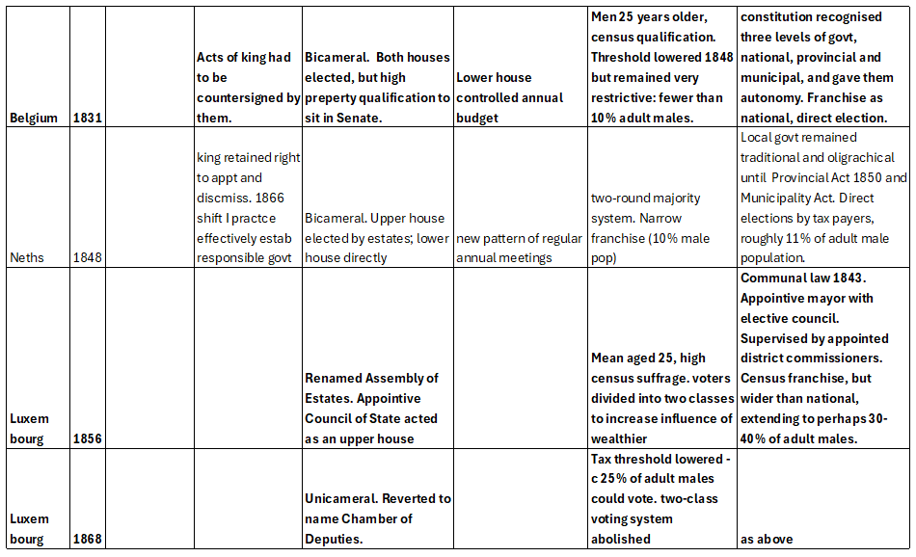

Day 2 Organising at the grassroots
Atterving-Blomgren

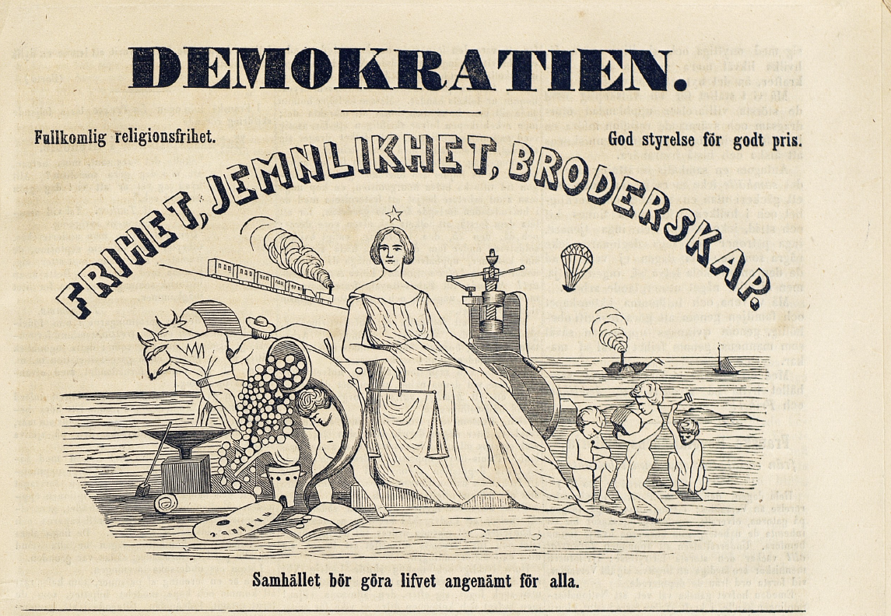
Figure 1. Vignette used by The Democrat. The slogan of the 1848 French revolution ‘Liberty, equality, brotherhood’ sits above a hopeful image of a just and equal society in which the profits of new technology would benefit all. Digitised by the National Library of Sweden.
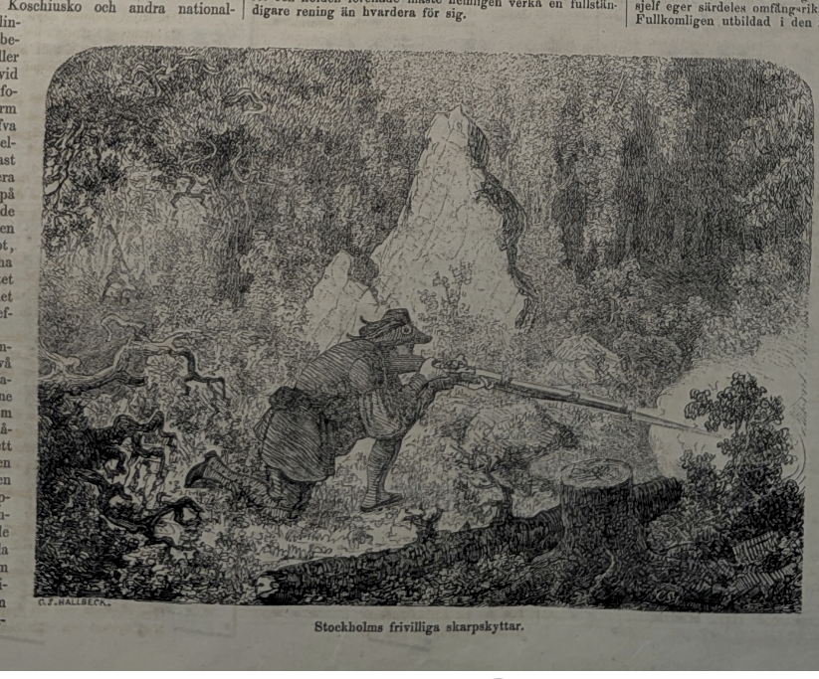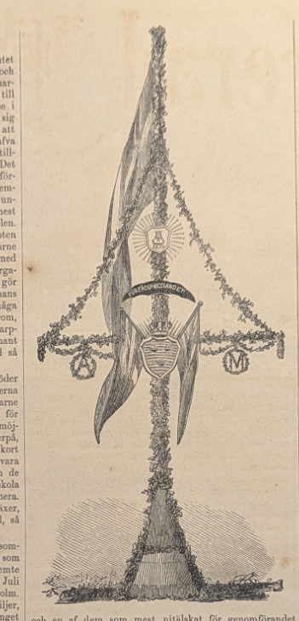
Figure 2. Stockholm's sharpshooters depicted in Ny Illustrerad Tidning 1861.
Figure 3 Maypole erected by members of the 5th and 6th sharpshooter companies, made up by members from Stockholm's Workers' Association.

Day 2, afternoon: Discourses of Democracy
Hungary and Slovakia (Gango)
(1)“We Upper-Hungarian Slavs are just as much a nation as the Hungarians, or any other nation of this common homeland; from which it follows of itself – unless national equality, together with civil liberty, is to remain a chimera – that as a nation we cannot possess fewer rights than any other nation of our country.” (Slovak Memorandum, 1861)
(2) “But even this does not complete our task, for there is a third consideration of which we must not lose sight – one which requires that, when we speak out in defence of our country’s constitutional liberty and lawful independence, we should at the same time reassure all the inhabitants of our homeland, of every rank, tongue and confession, that we do not forget their interests either, and that we intend to act towards them as well in accordance with the demands of democracy and the requirements of full equality of rights. (Hear, hear! Agreed!)” (House of Representatives Journal, 1861, Vol. I, 6 April – 1 June 1861, 16 May 1861, XXIII National Sitting, p. 126. Kálmán Tisza)
(3) “The guiding idea of the legislation of 1848 was that, when it bestowed liberty upon all the citizens of Hungary and introduced democratic institutions, it assumed that the entire population of Hungary – that is, the various nationalities – would assimilate into the nationality which claimed for itself the achievement of this liberty; and this was the Hungarian nationality. […] The consequence of democracy in Hungary can only be that it creates not a national state, but a nationality-based state.” (House of Representatives Journal, 1872–1875, Vol. XI, pp. 190–191.)
(4) “The word democracy – in Slovak národovláda (“rule of the people”) – denotes a condition in which the nation itself governs, not an individual or a privileged caste. In this sense, democracy is the opposite of absolute monarchy and aristocracy. Such democracy existed in the small Hellenic republics and in ancient Slavic tribes, where there was almost complete equality among all men. […] Thus Slovak democratism lies as far from Hungarian democratism as the aims of the Slovak nation lie from those of the Hungarian nation. From this it is clear that both cosmopolitanism and the idea of a universal national political party are gross nonsense. Politics draws its principles from state sciences and ethics, yet its results unfold in real life. Even the greatest tyrants can speak of freedom and equality in the abstract, while in reality they torture nations with despotism and tyranny. For example, in North America, those who wanted to preserve slavery also called themselves democrats.” (Daxner, Štefan M., ‘Slovenský demokratizmus,’ Pešťbudínske vedomosti, VIII, č. 36, dňa 5. mája 1868, 1.)
(5) “The freedom-minded party, which loves liberty and rights, carries many different names. The most common today are: liberal, national, radical, democratic, social-democratic, moderate-liberal, liberal-conservative, and so on. Already from this list one can see that many of these names are used both by the party of freedom and by the party of secret absolutists. This is because the secret absolutists, wishing to deceive many inexperienced and uneducated Slovak citizens and lure them to their side, misuse various names that normally belong to the liberal camp, even though their intentions do not match the true meaning of those names.” (Daxner, Štefan M., 'Strany politické', Pešťbudínske vedomosti, VIII, č. 42, zo dňa 26. mája 1868, 1.)
(6) “Originally meaning “rule of the people,” in contrast to aristocracy. Later it came to mean those who want to abolish aristocratic privileges and establish equality before the law. But again, everything depends on what one means by “equality.” Some call it equality when one citizen cannot vote at all while another has exclusive voting rights. Even Tisza’s party calls it equality when citizens are divided into categories like factory products. Thus the word democrat has no fixed meaning.” (Daxner, Štefan M., ‘Strany politické,’ Pešťbudínske vedomosti, VIII, č. 42, zo dňa 26. mája 1868, 1.)
(7) “The concept of distinct nationality rights – as everyone must recognise – stands in direct contradiction to the concept of equality and, consequently, to the democratic tendencies of our age.” (Draft Act on the Equality of Nationalities, 1868 (as worded by the Central Committee), note no. 6.)
(8) “In order to establish democracy (and I share Tocqueville’s view that this is the principal task of our age), it is necessary to change our institutions – not merely in the sense that the rights formerly enjoyed by the hereditary aristocracy should pass to the people, but in the very essence and scope of those institutions. For democracy to exert real influence, not merely in name but in fact, and for this influence to be regarded as secure, 1° we must provide for institutions through which the lower strata of the people – within the sphere where their interests are most directly involved – may exercise influence despite their limited circumstances and education; 2° we must also establish institutions through which the upper classes of the people may exercise the influence that naturally belongs to them upon the state, without having to restrict the rights of the lower classes or misuse them as instruments.” (Eötvös: Vallomások és gondolatok, ed. Miklós Bényei, Budapest, 1977, no. 2038)
(9) “the influence which, since our democratic transformation, all the inhabitants of this country – of every tongue and nationality – have gained upon public affairs” (Eötvös: The Nationality Question, 1865)

Switzerland (Hermann)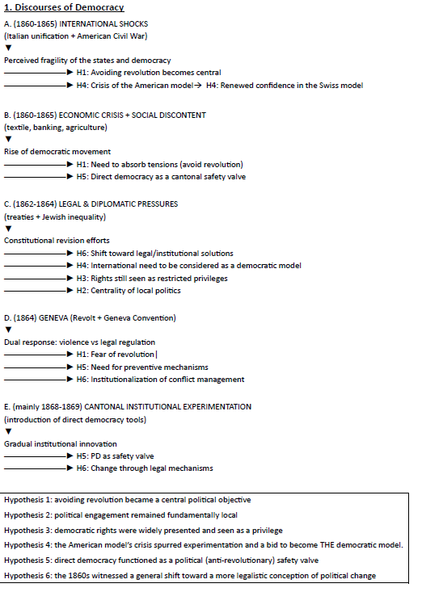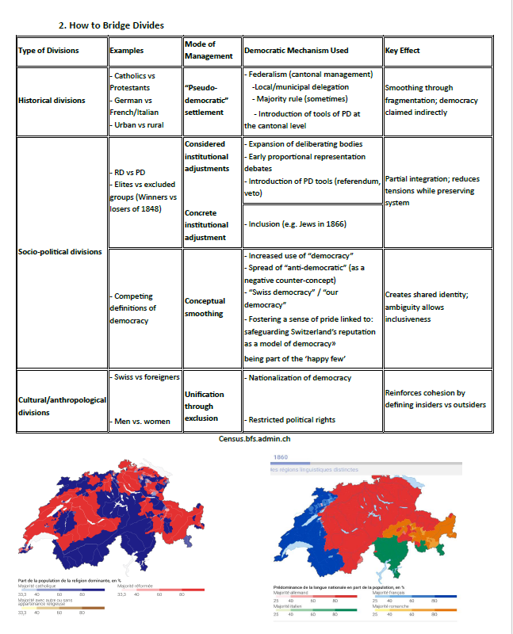

Day 2: multiplication of democratic options
Caesarism (McDaniel)
Definitions
Johann Caspar Bluntschli (c. 1865-69):
“However, this same [Caesarism] has a few characteristic features that are reminiscent of Caesar, but even more so of his successors the ancient Roman Emperors, especially the conjunction of an all-powerful, dictatorial state power entrusted to a single individual with democratic institutions, the absolute autocracy on the basis of the fourth estate, upon which the ruler relies and whose interests he takes care of. Caesarism is benevolent towards the masses who pay homage to it and is tyrannical towards any opposition which stands up to it.” (“Cäsar und Cäsarismus”, Bluntschli’s Staatswörterbuch in drei Bänden, 1870, I, p. 391).
Heinrich Ahrens:
“But if a state [Staatswesen] is divorced from its moral foundation and thrown back and forth between opposing parties, especially between monarchical and democratic Imperialism, then Caesarism develops, which is not simply absolutism or militarism, but rather a Janus-faced formation which seeks to unite opposites, on the one side presenting a popular [volksfreundliches] face, even seeking to satisfy many democratic and social demands, yet with democracy however serving only as a foil of emperorship [Imperatorenthums] and remaining a personal dictatorship in its innermost core.” (Naturrecht oder Philosophie des Rechts und des Staates, 2 vols. (1870-1870), I, p. 401).
“…this emperorship, which appeared primarily in the form of Caesarism as a result of moral decline, remained fundamentally an elective system, because the power of will, upon which the Roman state-form was built, could not escape its character as an elective power.” (Naturrecht oder Philosophie des Rechts und des Staates, 2 vols. (1870-1870), I, p. 397).
Julius Fröbel:
“French Imperialism has no other character than that of dictatorship; that is, it justifies itself through need and purpose, through time and conditions, and indeed the most consistent democratic party, that of social democracy, has made no secret of the fact that it holds dictatorship for unavoidable: – naturally – because the ultrademocracy sees that, with its success, it is immediately plunged into a state of social emergency, and dictatorship corresponds to a state of social emergency. European democracy is not individualism like American democracy, but is rather socialism, and in the sense of this European, that is, socialistic democracy, the French Kaisertum can be more democratic, and is in many respects more democratic, than a French republic would and could be.” (Amerika, Europa und die politischen Gesichtspunkte der Gegenwart, 1859, pp. 148-149).
“Even under its current ruler France is still named as a monarchy, although this ruler is elected by the people or is considered to be elected by the people; and at the same time the French Kaisertum, precisely because of its origins, is termed a disciplined democracy, although undoubtedly democracy is a subdivision or variant of republic.” (Theorie der Politik, 2 vols., 1861-1864, I, p. 211).
Friedrich von Hellwald:
“In Rome especially the emperorship [Kaisertum] did not lack a democratic foundation, since it derived all its power solely from the people and received it from the people.” (Culturgeschichte in ihrer natürlichen Entwickelung bis zu Gegenwart, 1875, p. 366)
German politics: critics of Caesarism
- militarism and Annexionspolitik (Jacob Venedey; Georg Friedrich Kolb)
- universal suffrage as cynical manoeuvre (Social Democracy; Wilhelm Liebknecht)
- social structure and the social question (Wilhelm Kiesselbach; Johann Karl Rodbertus-Jagetzow)
- Scheinparlamentarismus, financial power and bankocracy (esp. Wilhelm Rüstow)

German originals
Johann Caspar Bluntschli:
“Allerdings hat derselbe [Cäsarismus] einige charakteristische Züge, welche an Cäsar, mehr aber noch an dessen Nachfolger, die altrömischen Kaiser erinnern, insbesondere die Verbindung der Alles beherrschenden, einem einzelnen Individuum überlassenen zur Diktatur geneigten Staatsgewalt mit demokratischen Institutionen, der absoluten Autokratie auf der Basis der vierten Standes, auf den sich der Herrscher stützt und dessen Interessen er besorgt. Der Cäsarismus hat Wohlwollen für die Menge, die ihm huldigt, und ist tyrannisch gegen jede Opposition, die ihm entgegentritt.“ (“Cäsar und Cäsarismus”, Bluntschli’s Staatswörterbuch in drei Bänden, 1870, I, p. 391).
Heinrich Ahrens:
„Wird aber ein Staatswesen von seinem sittlichen Grunde abgehoben und zwischen entgegengestzten Parteien, insbesondere zwischen monarchischem und demokratischem Imperialismus hin und her geworfen, so entwickelt sich der Cäsarismus, welcher nicht einfach Absolutismus oder Militarismus, sondern eine Janus-Gestalt ist, die Gegensätze zusammen zu kuppeln sucht, nach der einen Seite ein volksfreundliches Gesicht herauskehrt, auch manche demokratische und sociale Forderungen zu befriedigen strebt, die Demokratie jedoch nur zur Folie des Imperatorenthums macht und in seinem innersten Kerne persönliche Dictatur bleibt.“ (Naturrecht oder Philosophie des Rechts und des Staates, 2 vols. (1870-1870), I, p. 401).
“dieses Imperatorenthum, welches hauptsächlich in Folge des sittlichen Verfalls auch in der Gestalt des Cäsarismus auftrat, blieb grundsätzlich eine Wahlherrschaft, weil die Willensmacht, auf welcher das römischer Staatswesen erbaut war, sich ihres Charakters als Wahlvermögen nicht entschlagen konnte” (Naturrecht oder Philosophie des Rechts und des Staates, 2 vols. (1870-1870), I, p. 397).
Julius Fröbel:
“Der französische Imperialismus hat keinen anderen Charakter als den der Dictatur, d.h. er rechtfertigt sich durch Bedürfniß und Zweck, durch Zeit und Umstände, und gerade die consequenteste demokratische Partei, die der socialen Demokratie, hat kein Hehl daraus gemacht daß sie selbst die Dictatur für unvermeidlich hält: – natürlich – denn die Ultrademokratie sieht sich mit ihrem Erfolge auch sogleich in den Nothstand der Gesellschaft versetzt, und dem Nothstande der Gesellschaft entspricht die Dictatur. Die europäische Demokratie ist nicht der Individualismus wie die amerikanische, sondern sie ist der Socialismus, und im Sinne dieser europäischen, also dieser socialistischen Demokratie, kann das französische Kaiserthum demokratischer sein, und ist in mancher Beziehung demokratischer, als eine französische Republik es sein würde und sein könnte.” (Amerika, Europa und die politischen Gesichtspunkte der Gegenwart, 1859, pp. 148-149).
“Frankreich nennt man auch unter seinem jetzigen Herrscher eine Monarchie, obschon dieser Herrscher von Volke erwählt ist oder als vom Volke erwählt gilt; und zugleich wird das französische Kaiserthum, eben dieses seines Ursprungs wegen, die disciplinirte Demokratie gennant, während doch ohne allen Zweifel die Demokratie eine Unterabtheilung oder Nebenform der Republik ist.” (Theorie der Politik, 2 vols., 1861-1864, I, 211)
Friedrich von Hellwald:
“In Rom insbesondere fehlte dem Kaiserthume eine demokratische Grundlage nicht, indem es seine ganze Macht lediglich aus dem Volke zog und durch das Volk erhielt.” (Culturgeschichte in ihrer natülichen Entwickelung bis zu Gegenwart, 1875, p. 366).

Day 3 – Multiplication of democratic options
Bugge: Democracy and nationality
Austrian Constitutions on the equality of ‘nationalities’
Verfassungsurkunde des österreichischen Kaiserstaates vom 25. April 1848 geändert durch die Proclamation vom 16. Mai 1848
I.
Allgemeine Bestimmungen
§ 1. Sämmtliche zum österreichischen Kaiserstaate gehörende Länder bilden eine untrennbare constitutionelle Monarchie.
§ 2. Die Verfassungsurkunde hat auf folgende Länder des Kaiserreiches Anwendung, nähmlich: auf die Königreiche Böhmen, Galizien, Lodomerien mit Auschwitz und Zator und der Bucowina, Illyrien (bestehend aus den Herzogthümern Kärnthen und Krain und dem Gubernial-Gebiete des Küstenlandes), auf das Königreich Dalmatien, auf das Erzherzogthum Oesterreich ob und unter der Enns, die Herzogthümer Salzburg, Steiermark, Ober- und Nieder-Schlesien, das Markgrafthum Mähren, die gefürstete Grafschaft Tyrol mit Vorarlberg.
§ 3. Die Gebiethseintheilung der einzelnen Provinzen bleibt in ihrer gegenwärtigen Ausdehnung unberührt, und kann nur durch ein Gesetz abgeändert werden.
§ 4. Allen Volksstämmen ist die Unverletzlichkeit ihrer Nationalität und Sprache gewährleistet.
(https://www.verfassungen.at/at-18/verfassung48.htm)

Entwurf des Österreichischen Reichstages welcher in der Zeit vom 22. Juli 1848 bis 4. März 1849 getagt hat, zuerst in Wien, ab dem 22. November 1848 in Kremsier (Mgft. Mähren)
("Kremsier Entwurf")
§ 1. Das Kaiserthum Oesterreich ist eine untheilbare constitutionelle Erbmonarchie.
§ 3. Galizien und Lodomerien sammt Krakau wird in zehn, Böhmen in neun, Mähren in vier, Oesterreich unter der Enns in drei, Tirol sammt Vorarlberg in drei (Deutschtirol, Wälschtirol, Vorarlberg), Steiermark in zwei Kreise eingetheilt. Die Abgränzung dieser Kreise wird mit möglichster Rücksicht auf Nationalität durch ein Reichsgesetz festgestellt. ein jedes der übrigen Reichsländer bildet einen Kreis.
§ 4. Die Reichsländer stehen zu einander im Verhältnisse der vollen Gleichberechtigung zum ganzen Kaiserstaate aber im Verhältnisse untrennbarer organischer Bestandtheile.
§ 5. Jedem Reichslande bleibt die Autonomie innerhalb der durch diese Constitution festgesetzten Schranken und die Integrität seines Gebietes gesichert.
(https://www.verfassungen.at/at-18/kremsier49.htm)
Grundrechte
Die Grundrechte nach §§ 1 bis 13 sind von der Plenarversammlung des Reichstages beraten und angenommen worden; die nachfolgenden Grundrechte wurden vom Constitutions-Ausschuß verabschiedet. Sie wurden vom Reichstag noch nicht an die vorgesehene Stelle in der Constitution (II. Abschnitt) eingestellt, weshalb sie stets erst im Anhang zum Constitutionsentwurf zu finden sind.
§ 1. Vor dem Gesetze sind alle Staatsbürger gleich.
Die Constitution und das Gesetz bestimmen, unter welchen Bedingungen die österreichische Staatsbürgerschaft erworben, ausgeübt und verloren wird.
Die Gesammtheit der Staatsbürger ist das Volk.
Alle Standesvorrechte sind abgeschafft. Adelsbezeichnungen jeder Art werden vom Staate weder verliehen noch anerkannt.
§ 19. Alle Volksstämme des Reiches sind gleichberechtigt. Jeder Volksstamm hat ein unverletzliches Recht auf Wohnung und Pflege seiner Nationalität überhaupt und seiner Sprache insbesondere.
Die Gleichberechtigung aller landesüblichen Sprachen in Schule, Amt und öffentlichem Leben wird vom Staate gewährleistet.
(https://www.verfassungen.at/at-18/kremsier49.htm#grundrechte)

Kaiserliches Patent vom 4. März 1849, die Reichsverfassung für das Kaiserthum Oesterreich
enthalten aufgehoben durch das Kaiserliche Patent vom 31. Dezember 1851, womit die Verfassungs-Urkunde vom 4. März 1849, Nr. 150 des R. G. B., außer Gesetzeskraft erklärt, jedoch die Gleichheit aller Staats-Angehörigen vor dem Gesetze, sowie die Unzulässigkeit und die Abstellung jedes bäuerlichen Unterthänigkeits- oder Hörigkeits-Verbandes und der damit verbundenen Leistungen ausdrücklich bestätiget, ferner für die zunäcshst wichtigsten und dringendsten Richtungen der organischen Gesetzgebung eine Reihe von Grundsätzen festgestellt bis zur Kundmachung der hiernach auszuarbeitenden Gesetze aber die Beobachtung der dermalen in Wirksamkeit bestehenden Gesetze angeordnet wird („Silvesterpatent“).
I. Abschnitt.
Von dem Reiche
§ 1. Das Kaiserthum Oesterreich besteht aus folgenden Kronländern: …
§ 2. Diese Kronländer bilden die freie, selbstständige, untheilbare und unauflösbare konstitutionelle österreichische Erbmonarchie...
§ 4. Den einzelnen Kronländern wird ihre Selbständigkeit innerhalb jener Beschränkungen gewährleistet, welche diese Reichsverfassung feststellt.
§ 5. Alle Volksstämme sind gleichberechtigt, und jeder Volksstamm hat ein unverletzliches Recht auf Wahrung und Pflege seiner Nationalität und Sprache.
(https://www.verfassungen.at/at-18/verfassung49-i.htm)

Staatsgrundgesetz vom 21. December 1867, über die allgemeinen Rechte der Staatsbürger für die im Reichsrahe vertretenen Königreiche und Länder
(Wirksam für Böhmen, Dalmatien, Galizien und Lodomerien mit Krakau, Oesterreich unter und ob der Enns, Salzburg, Steiermark, Kärnthen, Krain, Bukowina, Mähren, Schlesien, Tirol. Vorarlberg, Istrien, Görz und Gradiska, dann die Stadt Triest mit ihrem Gebiete.)

Mit Zustimmung beider Häuser des Reichsrathes finde Ich das nachstehende Staatsgrundgesetz über die allgemeinen Rechte der Staatsbürger zu erlassen und anzuordnen, wie folgt:
Artikel 1. Für alle Angehörigen der im Reichsrathe vertretenen Königreiche und Länder besteht ein allgemeines österreichisches Staatsbürgerrecht.
Das Gesetz bestimmt, unter welchen Bedingungen das österreichische Staatsbürgerrecht erworben, ausgeübt und verloren wird.
Artikel 2. Vor dem Gesetze sind alle Staatsbürger gleich.
Artikel 3. Die öffentlichen Ämter sind für alle Staatsbürger gleich zugänglich.....
Artikel 19. Alle Volksstämme des Staates sind gleichberechtigt, und jeder Volksstamm hat ein unverletzliches Recht auf Wahrung und Pflege seiner Nationalität und Sprache.
Die Gleichberechtigung aller landesüblichen Sprachen in Schule, Amt und öffentlichem Leben wird vom Staate anerkannt.
In den Ländern, in welchen mehrere Volksstämme wohnen, sollen die öffentlichen Unterrichtsanstalten derart eingerichtet sein, daß ohne Anwendung eines Zwanges zur Erlernung einer zweiten Landessprache jeder dieser Volksstämme die erforderlichen Mittel zur Ausbildung in seiner Sprache erhält.
(https://www.verfassungen.at/at-18/)

The relevant Hungarian legislation of 1860
Gesetzesartikel XLIV v. J. 1868, über die Gleichberechtigung der Nationalitäten
Nachdem sämmtliche Staatsbürger Ungarns nach den Grundsätzen der Verfassung auch in politischer Beziehung eine Nation bilden, die untheilbare, einheitliche ungarische Nation, deren Mitglied jeder Bürger des Vaterlandes, gleichviel welcher Nationalität er angehört, ist;
nachdemferner diese Gleichberechtigung lediglich im Hinblick auf den amtlichen Gebrauch der verschiedenen im Lande üblichen Sprachen und nur insoferne unter besondere Normen fallen kann, als dies die Einheit des Landes, die praktische Möglichkeit der Regierung und Verwaltung nothwendig machen,
so werden, während hinsichtlich aller anderen Verhältnisse die volle Gleichberechtigung der Staatsbürger unberührt bleibt, in Bezug auf den amtlichen Gebrauch der verschiedenen Sprachen die folgenden Normen als Richtschnur dienen:
§. 1. Da kraft der politischen Einheit der Nation die Staatssprache Ungarns die ungarische ist, so ist die Berathungs- und Geschäftssprache des ungarischen Reichstages auch künftighin die ungarische; die Gesetze werden in ungarischer Sprache erlassen, sind aber auch in den Sprachen aller anderen das Land bewohnenden Nationalitäten in beglaubigter Uebersetzung hinauszugeben; die Amtssprache der Regierung des Landes ist auch künftig in allen Zweigen der Verwaltung die ungarische.

Guesnet: Democracy and confessional divides
Quotes
- Henryk Schmidt, Galician historian, on a proposal of Jewish emancipation, 1859
Jews “restlessly roamed western Europe, expelled from one place to the other, and earning their livelihoods of repugnant slave trade […] The Jews gained more from the rights which Bolesław [the Pious, in 1264] offered them than the society [Pol. społeczeństwo] among which they settled […] The Jews had negotiated these rights with the prince unbeknownst by and against the will of the society, and thus stood in confrontation with it […] If society objects, the Jews cannot claim any rights, even not on the basis of the most generous privilege, as one can challenge this privilege which, upholding the rights of some, undermines the rights of the population which has equal standing, or is even more relevant.
- Dov Baer Meisels, Chief rabbi Warsaw, February 1861
‘And we too feel that we are Poles and we love the Polish land as you do’
- Markgrave Alexander Wielopolski, head of government Kingdom of Poland, March 1861, speaking to a Jewish delegation:
Do not fear, gentlemen, that I share the contemporary view of those who call on you […] to turn to agriculture. The agricultural sphere is an honourable one to which you may also want to aspire […] but we already have too many farmers. What our country lacks is a ‘third estate’, whose seed has been planted by Providence in you and which will perish if neglected. Let us work together to foster and develop that seed.
- (Insurrectionist) National Government, June 1863:
You [the Jews in the Kingdom of Poland] and your children will enjoy all civil rights without exceptions and restrictions, while the National Government will ask, not about faith or descent, but about place of birth, Are you a Pole?
- Prince I.Vasilchikov, General-Governor South-Western Province of the Russian Empire, November 1863
In Jewry, numerous, educated, and liberated from restrictions, the government may find an oppositionary force against the tempestuous Poles. Polish nationalism, which is strong in the state not because of numbers but because of education, the privileges of brith and chiefly bcause of the restrictions placed on the rights of other estates, cannot be neutralized and balanced by physical force alone … The whole secret consists in bestowing an advantage on the other, apparently insignificant, Jewish element, which contains resources of vital strength which can be nurtured and strengthened at the expense of other forces hostile to the government.
- Józef Ignacy Kraszewski (1812-1887), author, editor, in 1868
The insurrection collapsed in a welter of blood and the Jews, making use of their thousand-year-old experience, raised themselves over our corpses. But when they sacrificed us and abandoned us in an evil hour, only to save themselves, they shook our faith in them and dampened our love. The fact is that in the Kingdom none of those who were rescued reached out their hands to help the drowning. What is involved here is a deal made with the [Russian] government, a commitment met with an unnecessary zeal. The country is in the hands of the Jews, who enjoy the government's backing. Only memories, embarrassing to both sides, remain of the brotherhood of 1861. Today, if we were to ask for equal rights with the Jews, there is no doubt we should not achieve our goal. When we who are perishing complain to the Jews, they reply coldly, ‘You can perish’.

Gango: Democracy and internationalism (sources)
(1)”During the 1850s and the 1860s, networks of activists related to those London based organizations were highly motivated to debate among themselves the challenges democracy presented and how these could be overcome. […] These networks and activities contributed to make ‘democracy’ a keyword within an international political culture. While ‘democracy’ as a principle continued to be disputed, its association with a political movement and an identity was consolidated. The term ‘European democracy’ was constantly used in letters and manifestos, and not only in exile circles. (F. Peyrou and J. L. Simal: Exile, Secret Societies, and the Emergence of an International Democratic Culture.” In Re-imagining Democracy in the Mediterranean 1780–1860, ed. by J. Innes and M. Philp. Oxford, 2018, 224.)
(2) „Respectant en vous le premier champion de la Démocratie Européenne j’ai écrit franchement” (Adriano Lemmi to Kossuth, Constantinople, 18.11.1850); „que nous sommes, nous deux, regardés comme les chefs de la démocratie européenne active” (Mazzini to Kossuth, 24.4.1852); „der Dienst den der H[err] Gouverneur der europäischen Democratie […] erweist” (Pietro Fortunato Calvi to Kossuth, Torino, 22.10.1852); „Le moment nous paraît venu pour la Démocratie Européenne de se reconstituer en une puissante unité, de se poser en face de ses ennemis et d’agir.” (Kossuth, Ledru-Rollin, and Mazzini, Manifesto to the Republicans, 26.9.1855). É. Nyulásziné Straub (ed.): A Kossuth-emigráció olaszországi kapcsolatai 1849–1866. Budapest 1999, 112, 211, 239, 254.
(3) „The chiefs are Kossuth, Klapka, Garibaldi, and Mazzini. Kossuth is currently in Maastricht organizing shipments of weapons with two other agents. Klapka is in Geneva, where a Hungarian committee has deposited money for revolutionary propaganda in the Swiss Bank. Mazzini is in London, where two days ago he talked to Garibaldi at Brook House. […] Mazzini has ordered the purchase of one thousand rifles; we do not know yet for whom, maybe Matturo, Venaro, Nulis ... Kossuth has also bought arms for the Hungarian revolution.” (Quoted in Peyrou and Simal, Exile: Secret Societies, 224.)
(4) “Democracy – and nothing other than democracy – is identical with liberty. Institutions that are more or less free may also be found outside democracy, yet they invariably entail inequalities in obligations and rights, granting privileges and exemptions to some while excluding others. Liberties may exist beyond democracy, but liberty itself cannot.” [Re-translated into English from a Hungarian translation.]
(5) „[…] Italy, from the extreme Sicily to the Alps, including the Italian Tyrol, the Ticino, Corsica etc. – one. […] Austria to disappear. A great Danubian confederation – Hungary, the Roumanian race (Wallachia, Moldavia, Transylvania, Herzegovina etc.), Bohemia etc. […] Russia and Poland dividing the rest between themselves – two distinct associated nationalities.” (1857) Quoted in: Denis Mack Smith: Mazzini. New Haven and London, 1994, 156.
(6) „La Constituante posera les principes de liberté de conscience, de presse, d’association etc. comme formant partie du droit public de tous les États fédéraux.” (Gábor Pajkossy: Az 1862. évi Duna-konföderációs tervezet dokumentumai, in: Századok 2002, 945.)
(7) “Excepté pour les objets d'intérêt commun, qui seraient réglés par les autorités fédérales, chaque État jouirait d’une complète autonomie, législative, judiciaire et administrative. A l’aide d'une large décentralisation, d’une liberté étendue à accorder aux communes et aux provinces, toutes les races habitant le sol de la Confédération pourraient se développer sans entraves; chacun de ces peuples pourrait prendre dans la grande famille humaine la place qui lui appartient.” (Ibid., 946.)
(8) “Having demonstrated the need for social reform, the Society, in accordance with its founding charter of 17 March 1832, decided to work in the spirit of democratic principles to regain the independence of the country and to bring emancipation to its people.” (1836 Manifesto of the Polish Democratic Society)
(9) “On the very first day of open uprising, in the first moment of the sacred struggle, the Central National Committee proclaims all sons of Poland, without distinction of faith or lineage, origin or estate, to be free and equal citizens of the country. The land which the peasantry has hitherto held under the obligations of rent or serfdom becomes from this moment their unconditional property, an eternal inheritance. Landowners who suffer loss shall be compensated from the general funds of the State. All cotters and labourers who enter the ranks of the defenders of the country, or whose families are bereaved by an honourable death on the field of glory, shall receive from the national estates a portion of the soil defended from the enemy.” (Proclamation of the 1863 January uprising)
(10)“This cool reception of the situation [namely Marx’s and Engels’s view that ‘all the moral indignation and all the fervent exhortations of the democrats’ were in vain] appeared to many at the time as outright heresy, at a moment when Ledru-Rollin, Louis Blanc, Mazzini, Kossuth, and, among the lesser German luminaries, Ruge, Kinkel, Goegg and whatever their names may be, were gathering in London in droves to form prospective provisional governments not only for their own countries but for the whole of Europe. And when, for the European revolution to be realised immediately, together with the self-evident republics, nothing more seemed necessary than to raise the requisite funds in America as a revolutionary loan.” (Engels, To the History of the Communist League, 1885)
(11) “[At the founding meeting of the First International,] the good Le Lubez read out a dreadfully bombastic, poorly written and wholly immature introduction, intended as a declaration of principles, from beneath whose veil – woven from the most confused fragments of French socialism – Mazzini kept peeping out at every turn. In addition, the Italian statutes had been more or less accepted, although, quite apart from all their other shortcomings, they set forth a truly impossible aim: a kind of central government for the European working classes (with Mazzini, of course, lurking in the background).” (Marx to Engels, 4 November 1864)

How to bridge divides
Lauret: the Netherlands 1860s
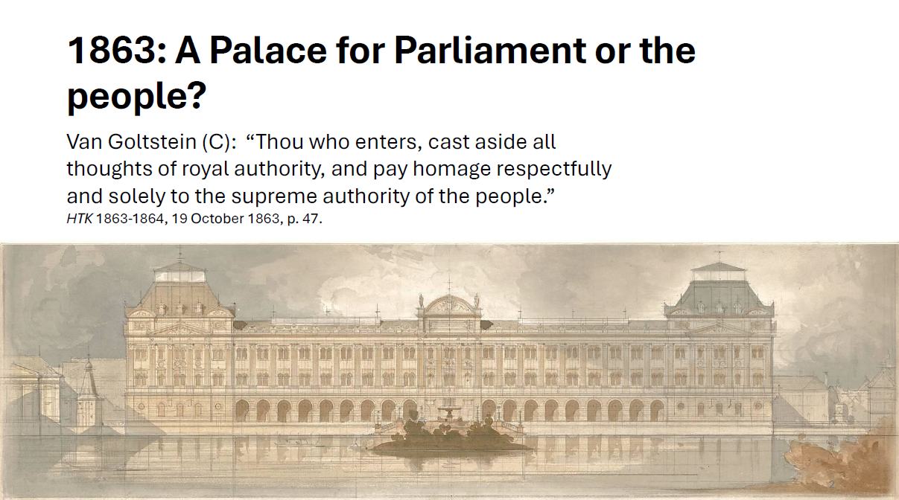
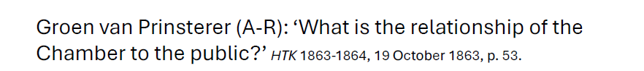
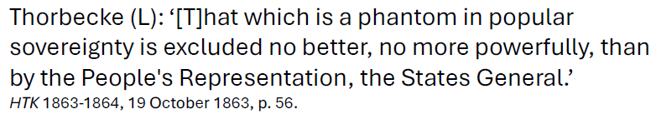
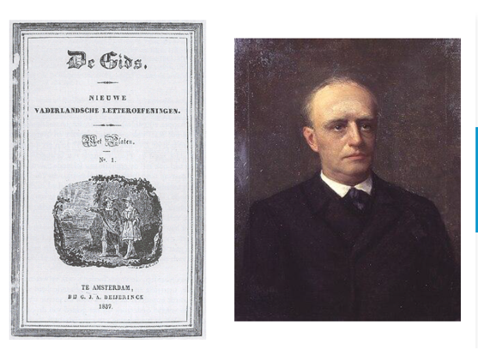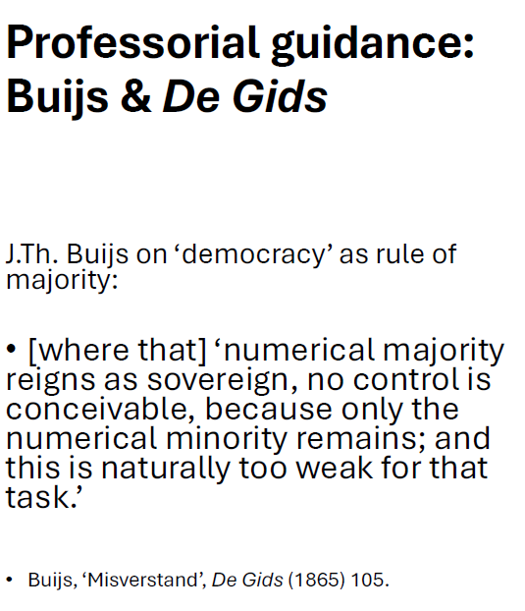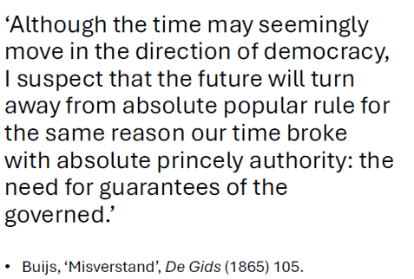

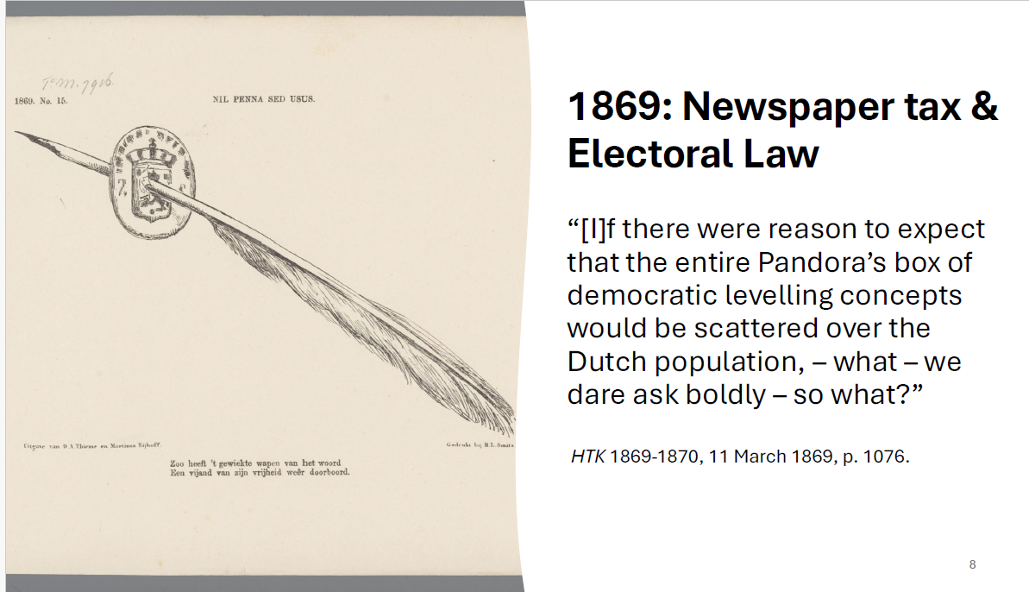
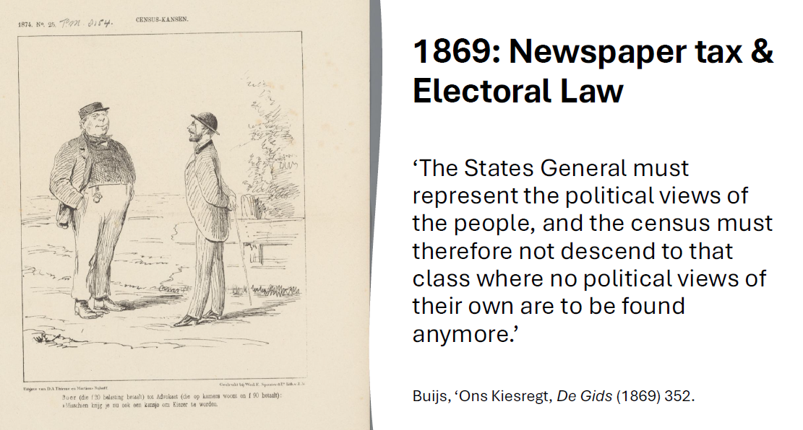

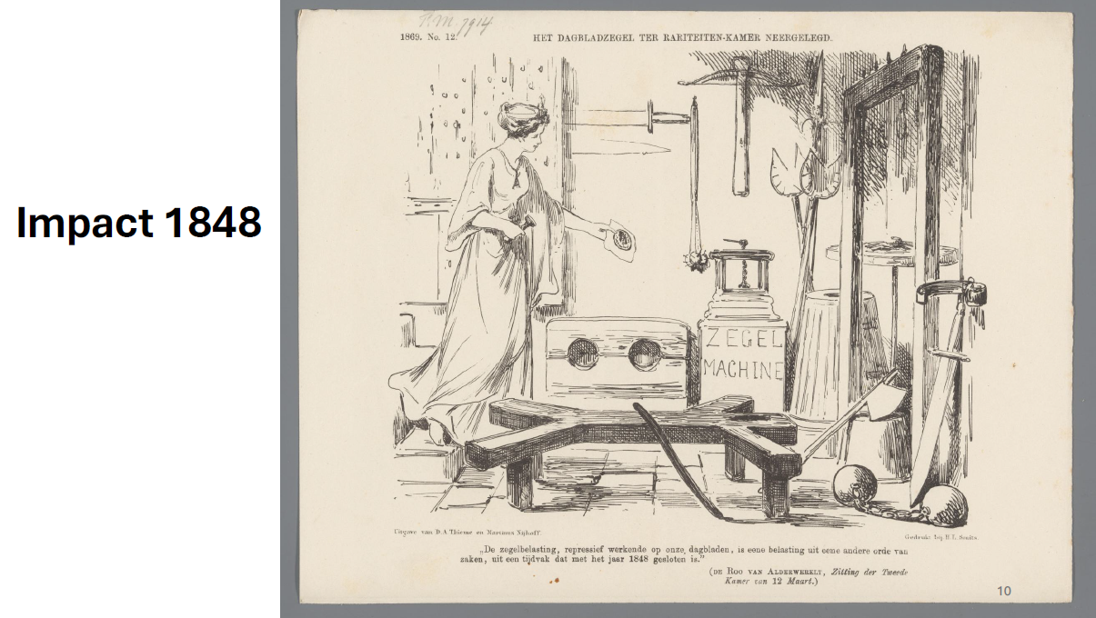
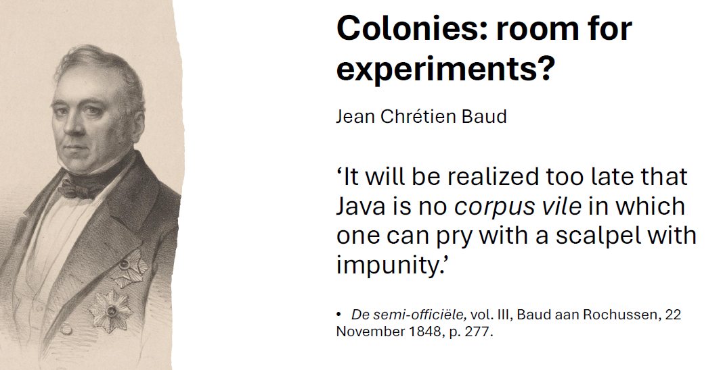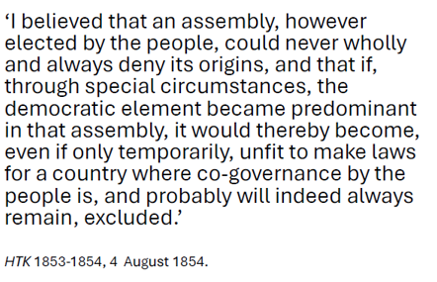

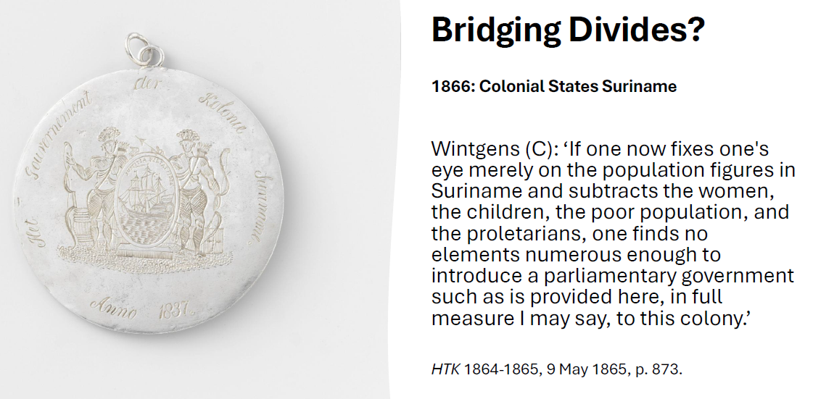
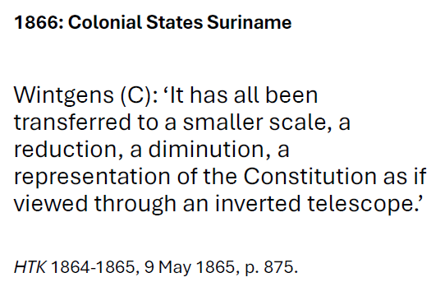

Henryk Schmitt, Rzut oka na nowy projekt bezwarunkowego równouprawnienia Żydów oraz odpowiedź na zarzuty, z któremi dzisiejsi ich obrońcy przeciw narodowi polskiemu wystepują (Lwów: Wilde, 1859), 14-17 (translation mine, FG)
Quoted after Antony Polonsky, The Jews in Poland and Russia, vol. 1, 309.
Ibid., 310.
Quoted after John D. Klier, Russia’s Imperial Question, 152-3.
Quoted after Polonsky, The Jews in Poland and Russia, vol. 1, 315.
Karen Offen, European Feminisms, 1700-1950 (Stanford 2000) 122-123.
F. Gross, Die Demokratie und die Frauen. In: Illustrirtes Wiener Extrablatt 10. Oktober 1872, 4.

